BARANGAY SOUTH SIGNAL VILLAGE WEB APP

Project Documentation Submitted to the Faculty of the

School of Computing and Information Technologies

Asia Pacific College

In Partial Fulfillment of the Requirements for

Software Development for IT

SOFTDEV

By

|  |  |
| --- | --- |
| Rark Mowen L. Alcantara | Mikedale B. Dellera |
| Jakerson B. Bermudo | Princess Joy H. Ferrer |
| Wilkins V. Caducio | Carl James A. Garcia |
|  |  |
|  |  |

ASIA PACIFIC COLLEGE

Approval Sheet

BARANGAY SOUTH SIGNAL VILLAGE WEB APP

Prepared and submitted by

|  |  |
| --- | --- |
| Rark Mowen L. Alcantara | Mikedale B. Dellera |
| Jakerson B. Bermudo | Princess Joy H. Ferrer |
| Wilkins V. Caducio | Carl James A. Garcia |

In Partial Fulfillment of the Requirements for the Degree of

Bachelor of Science in Information Technology

Examined and Recommended for Acceptance and Approval for

Research/Capstone Presentation

___________________________

<Name>, Adviser

Panelists

___________________________

<Name>, Chairperson

|  |  |
| --- | --- |
| ___________________________ | ___________________________ |
| <Name>, Panel Member | <Name>, Panel Member |

Acceptance and Approved in Partial Fulfillment of the Requirements for the Degree of

Bachelor of Science in Information Technology

___________________________

Rhea-Luz R. Valbuena

Executive Director

School of Computing and Information Technologies

**Table of Contents**

Executive Summary i

List of Figures ii

List of Table iv

1 Introduction 1

1.1 Project Context 1

1.2 Statement of the Problem 2

1.3 Objectives 3

1.4 Significance of the Project 4

1.5 Scope and Limitations 4

2 Review of Related Literature / Systems 6

2.1 Related System 6

2.2 Related Literature 7

2.3 Synthesis 10

3 Technical Background 11

3.1 Current System 11

3.2 Proposed System 11

4 Methodology 15

4.1 Requirements Analysis 18

4.1.1 Product Backlog / User Storie 18

4.1.2 Event Tables 21

4.1.3 Use Case Diagrams 24

4.1.4 Use Case Full Description 25

4.2 Gap Analysis 58

4.3 System Analysis and Design 59

4.3.1 Context Diagram 59

4.3.2 Data Flow Diagrams 60

4.3.3 Entity-Relationship Diagrams 64

4.3.4 Activity Diagram 65

4.3.5 Object Diagrams 66

4.3.6 Class Diagrams 68

4.3.7 Sequence Diagrams 69

4.3.8 State Diagram 73

4.3.9 Use Case Package Diagram 77

4.3.10 Component Diagram 78

4.3.11 Deployment Diagram 79

5 Results and Discussion 80

5.1 Release Plan 80

5.2 Prototype 82

5.3 Use Classes and Characteristics 96

6 Conclusion 98

7 References 101

8 Appendices 104

Appendix A: Project Vision 104

Appendix B: Schedule 105

Appendix C: Product Roadmap 110

Appendix D: Users’ Manual 111

Appendix E: Team Meetings 112

Appendix F: Test Plan and Test Cases 119

Appendix G: Source Code 120

Appendix H: Project Sway 121

Appendix I: Data Dictionary 122

Appendix J: Contingency Plan 128

Appendix K: Curriculum Vitae 129

Appendix L: Project Hosting 133

# Executive Summary

**Product or Service:**

The Barangay South Signal Village Web Application is an innovative online platform designed to streamline document requests and community inquiries within the Barangay. This comprehensive web application will serve as a centralized hub of information, featuring crucial details about the barangay's organizational structure, historical background, demographics, mission, vision, and a hazard map for reference.

**Target Customers:**

Exclusively catering to the residents of Barangay South Signal Village, the web application will provide a tailored, accessible, and user-friendly experience for the local community.

**Problem Statement:**

Barangay South Signal Village currently grapples with a reliance on traditional paper-based systems, leading to inefficiencies in document retrieval and storage. This reliance on physical filing cabinets not only causes delays in client services but also poses a security risk for sensitive data.

**Proposed Solution:**

Our solution involves a seamless transition from the traditional paper-based system to a cutting-edge web application. By leveraging digital technology, we aim to offer the Barangay South Signal Village community a more efficient, effective, and secure means of accessing information and services.

**The Team:**

Our team comprises six (6) dedicated members, all pursuing Bachelor of Science degrees in Information Technology at Asia Pacific College. With a shared passion for technology and a solid educational background, we are poised to deliver a high-quality, and innovative solution.

# List of Figures

Fig. 1 SDLC (Agile Methodology) 20

Fig. 2 MVC [23] 22

Fig. 3 Use Case Diagram 29

Fig. 4 Context Flow Diagram 64

Fig. 5 Data Flow Diagrams Level 0 65

Fig. 6 DFD Manage Account level 1 65

Fig. 7 DFD Manage Request level 1 66

Fig. 8 DFD Manage Concern level 1 66

Fig. 9 DFD Process Request level 1 66

Fig. 10 DFD Manage Concern level 1. 67

Fig. 11 DFD Payment level 1 67

Fig. 12 DFD Manage Barangay Secretary Account 68

Fig. 13 DFD Manage Employee Account 68

Fig. 14 Entity-Relationship Diagrams 69

Fig. 15 Activity Diagram 71

Fig. 16 Object Diagram 72

Fig. 17 Class Diagram 73

Fig. 18 Sequence Diagram: Manage Resident Account 74

Fig. 19 Sequence Diagram: Manage Request 74

Fig. 20 Sequence Diagram: Manage Concern 75

Fig. 21 Sequence Diagram: Manage Barangay Employee Accounts 75

Fig. 22 Sequence Diagram: Manage Barangay Secretary Account 76

Fig. 23 Sequence Diagram: Process Request 76

Fig. 24 Sequence Diagram: Process Concern 77

Fig. 25 Sequence Diagram: Online Payment 77

Fig. 26 State Machine Diagram: Manage Resident Account (Create) 78

Fig. 27 State Machine Diagram: Manage Resident Account (Log-in) 78

Fig. 28 State Machine Diagram: Manage Resident Account (Edit) 78

Fig. 29 State Machine Diagram: Manage Request 79

Fig. 30 State Machine Diagram: Manage Concern 79

Fig. 31 State Machine Diagram: Manage Employee Account 79

Fig. 32 State Machine Diagram: Manage Barangay Secretary Account. 80

Fig. 33 State Machine Diagram: Manage Barangay Secretary Account Edit 80

Fig. 34 State Machine Diagram: Process Request 80

Fig. 35 State Machine Diagram: Process Concern 81

Fig. 36 State Machine Diagram: Manage Employee Account (Log-in) 81

Fig. 37 State Machine Diagram: Manage Employee Account (Edit) 81

Fig. 38 Online Payment 81

Fig. 39 Use Case Package Diagram 82

Fig. 40 Component Diagram 83

Fig. 41 Deployment Diagram 84

Fig. 42 Home Page 87

Fig. 43 Safety Section Page 87

Fig. 44 Safety Protocol 88

Fig. 45 About Us Page 89

Fig. 46 Contact Page 90

Fig. 47 Requirements Page 90

Fig. 48 Login Page 91

Fig. 49 Resident Dashboard 91

Fig. 50 Resident Dashboard (sidebar) 92

Fig. 51 My Profile Page (Resident Dashboard) 92

Fig. 52 Transaction Page (Request) 93

Fig. 53 Transaction Page (Concern) 93

Fig. 54 Payment Page 94

Fig. 55 Paymongo Gateway Interface 94

Fig. 56 Confirm Age Requirements Modal 95

Fig. 57 Privacy Policy Modal 95

Fig. 58 Registration Page (Id Analyzer) 96

Fig. 59 Registration Page 96

Fig. 60 Login Page 97

Fig. 61 Admin Portal Login Page 97

Fig. 62 Administrator Dashboard page 98

Fig. 63 Barangay Captain Dashboard 99

Fig. 64 Barangay Secretary Dashboard 99

Fig. 65 Request Manager Dashboard Page 100

Fig. 66 Concern Manager Dashboard Page 100

Fig. 67 Barangay Treasurer Dashboard 101

Fig. 68 Product Backlog 105

# List of Table

TABLE 1 USER STORIES WITH ACCEPTANCE CRITERIA 23

TABLE 2 RESIDENT'S EVENT TABLE 26

TABLE 3 BARANGAY EMPLOYEE'S EVENT TABLE 27

TABLE 4 USE CASE DESCRIPTION REGISTRATION 30

TABLE 5 LOGIN RESIDENT ACCOUNT 31

TABLE 6 UPDATE RESIDENT ACCOUNT 32

TABLE 7 CREATE NEW REQUEST 33

TABLE 8 TRACK REQUEST STATUS 34

TABLE 9 RESET PASSWORD 35

TABLE 10 SUBMIT NEW CONCERN 36

TABLE 11 TRACK CONCERN STATUS 38

TABLE 12 LOG-IN BARANGAY EMPLOYEE ACCOUNT 39

TABLE 13 ADMIN- CREATE EMPLOYEE ACCOUNT 40

TABLE 14 DEACTIVATE EMPLOYEE ACCOUNT 41

TABLE 15 REACTIVATE BARANGAY EMPLOYEE ACCOUNT 42

TABLE 16 ADMINISTRATOR EDITS EMPLOYEE ACCOUNT 43

TABLE 17 EMPLOYE EDITS EMPLOYEE ACCOUNT 44

TABLE 18 DEACTIVATE BARANGAY RESIDENT ACCOUNT 45

TABLE 19 REACTIVATE BARANGAY RESIDENT ACCOUNT 46

TABLE 20 EDIT HOMEPAGE BANNER 47

TABLE 21 EDIT DEMOGRAPHY 48

TABLE 22 EDIT CONTACTS 49

TABLE 23 UPDATE BARANGAY OFFICIALS 50

TABLE 24 MANAGE SERVICES 51

TABLE 25 VIEW DOCUMENT REQUEST 52

TABLE 26 PROCESS DOCUMENT REQUEST 53

TABLE 27 APPROVE DOCUMENT REQUEST 54

TABLE 28 DENY DOCUMENT REQUEST 55

TABLE 29 APPROVE DOCUMENT REQUEST 56

TABLE 30 PROCESS CONCERN 57

TABLE 31 UPDATE CONCERN 58

TABLE 32 DENY CONCERN 59

TABLE 33 CLOSE CONCERN 60

TABLE 34 BARANGAY DATA REPORT 61

TABLE 35 GAP ANALYSIS 63

TABLE 36 USE CLASSES AND CHARACTERISTICS 101

TABLE 37 PROJECT VISION 109

TABLE 38 SCHEDULE TABLE 110

TABLE 39 PRODUCT ROADMAP 115

TABLE 40 RESIDENT'S EVENT TABLE 21

TABLE 41 BARANGAY EMPLOYEE'S EVENT TABLE 22

TABLE 42 USE CASE DESCRIPTION REGISTRATION 25

TABLE 43 LOGIN RESIDENT ACCOUNT 26

TABLE 44 UPDATE RESIDENT ACCOUNT 27

TABLE 45 CREATE NEW REQUEST 28

TABLE 46 TRACK REQUEST STATUS 29

TABLE 47 RESET PASSWORD 30

TABLE 48 SUBMIT NEW CONCERN 31

TABLE 49 TRACK CONCERN STATUS 33

TABLE 50 LOG-IN BARANGAY EMPLOYEE ACCOUNT 34

TABLE 51 ADMIN- CREATE EMPLOYEE ACCOUNT 35

TABLE 52 DEACTIVATE EMPLOYEE ACCOUNT 36

TABLE 53 REACTIVATE BARANGAY EMPLOYEE ACCOUNT 37

TABLE 54 ADMINISTRATOR EDITS EMPLOYEE ACCOUNT 38

Table 55 Employe Edits Employee Account 39

TABLE 56 DEACTIVATE BARANGAY RESIDENT ACCOUNT 40

TABLE 57 REACTIVATE BARANGAY RESIDENT ACCOUNT 41

TABLE 58 EDIT HOMEPAGE BANNER 42

TABLE 59 EDIT DEMOGRAPHY 43

TABLE 60 EDIT CONTACTS 44

TABLE 61 UPDATE BARANGAY OFFICIALS 45

TABLE 62 MANAGE SERVICES 46

TABLE 63 VIEW DOCUMENT REQUEST 47

TABLE 64 PROCESS DOCUMENT REQUEST 48

TABLE 65 APPROVE DOCUMENT REQUEST 49

TABLE 66 DENY DOCUMENT REQUEST 50

TABLE 67 APPROVE DOCUMENT REQUEST 51

TABLE 68 PROCESS CONCERN 52

TABLE 69 UPDATE CONCERN 53

TABLE 70 DENY CONCERN 54

TABLE 71 CLOSE CONCERN 55

TABLE 72 BARANGAY DATA REPORT 56

TABLE 73 GAP ANALYSIS 58

TABLE 74 USE CLASSES AND CHARACTERISTICS 94

TABLE 75 PROJECT VISION 102

TABLE 76 SCHEDULE TABLE 103

TABLE 77 PRODUCT ROADMAP 108

# Introduction

## Project Context

Barangay is the smallest political unit in the country [1]. It is composed of elective officials called the Punong Barangay, the Sangguniang Barangay members, and the Sangguniang Kabataan Chairman. The primary requisite for creating a barangay is at least 2000 in population; as of 2021, there are about 42,046 barangays in the Philippines [2]. Each barangay maintains a database holding different information about their barangay, like population, houses built in the community, records of their funds, cases filed, and the resident's socio-economic profile. The Punong Barangay cannot carry these tasks alone, which is why they appointed their own Barangay Secretary and Barangay Treasurer to serve as their hands in terms of dealing with fiscal and administrative relations.

The Barangay South Signal Village is one of the 28 barangays of Taguig City, Philippines. South Signal was formerly a part of Barangay Signal Village before being divided into four other barangays. The South Signal Village is composed of segregated areas from other barangays of Signal Village. The COMELEC Board of Canvassers duly confirmed the Barangay South Signal Village on December 19, 2008.

The Barangay South Signal Village heavily relies on papers, and most of its records and documents are stored in its physical filing cabinets. With the advancement of technology, selected barangays are already using computers and electronic devices to provide service and carry out official transactions. However, most barangays are still stuck with manual-based operations. Every request made by their client would take minutes to perform because of the tedious search for records stored in their physical file cabinets, which delays client service. All the essential and relevant information is encoded into a spreadsheet or a logbook, which uses many papers. The team would like to introduce the document management system to keep track of records, providing services and complaints in a modern approach with the use of computers as a primary medium that can speed up the process and reduce the consumption of paper.

Their Facebook page is the only platform they use to spread information, such as announcements, barangay news, and events. As of this moment, the barangay is still manually recording every request and transaction through pen and paper using only their logbook. The barangay wants to integrate its current system into the digital setting, but they need to know where to begin since they do not have an allocated budget. That is why the team proposed a new system that will digitize transactions and create a database on their servers or clouds.

## Statement of the Problem

In this chapter, the identified problems with the current system of Barangay South Signal Village will be discussed. Below are the main problems that the team is going to address:

1. **Long Processing Time** - The minimum number of processes the barangay can cater for per day is 50. An average of 15 to 20 minutes is the processing time for the documents in the barangay, according to the barangay secretary. Considering the time to fill out the application form and get in line, the processing time can increase from 30 minutes to 1 hour, depending on how long the line is.
2. **Risk of acquiring disease/s** – To request documents in the barangay, the residents will need to go to the barangay to request the needed documents personally. Personal requests will put the client and the residents at risk of contracting a disease due to social distancing concerns.
3. **Common errors using manual input** - The barangay secretary estimated that 4 out of 10 recorded data have errors. She identified that the causes of these errors are due to the input of the residents. Manual input of the residents in the application form is prone to typographical errors and illegible handwriting.
4. **A manual search of records in the database** – Due to having a physical file storage/database, the barangay has no way to automatically search records within the barangay. The barangay secretary and her department will need to manually dig into the physical file storage to find a single record that they need.
5. **Unsecured data** – The barangay does not have a secured database in the cloud; instead, they have multiple physical file storage. This makes it prone to many workplace hazards making the data unsafe/unsecured and exposed to danger.

## Objectives

The "Barangay South Signal Village Web App" proposed solution aims to provide online services to the barangay community. It will also contain substantial information about the barangay, including its current officials and location. Below are its general and specific objectives:

**General Objectives:**

To develop a web app that provides information about the barangay and online service/s for their community more efficiently, effectively, and transparently.

**Specific Objectives:**

1. To create a web application that can handle online document requests that will reduce the barangay residents’ processing time and time consumption by up to 80%.
2. To help the community, especially the vulnerable residents such as PWDs and senior residents, to lessen the risk of acquiring contagious diseases such as COVID-19 by requesting barangay documents by applying through the web app that lessens their direct contact with other people.
3. To create online forms to remove errors regarding illegible handwriting and reduce manual input errors by up to 90% through proper guidance in each part of the information to be filled out on the form.
4. To provide barangay staff with real-time insights regarding the number of requests per day, number of pending requests/s, number of online requests, and number of registered accounts by going through a statistics dashboard/page.
5. To build a secure and safe storage location for data using the cloud, which saves data over the internet, and this can only be accessed by the administrator, or the barangay staff itself by logging in to the account, making it 90% more secure than using filing cabinet/s.
6. To improve user convenience by integrating online payment methods through the Paymongo gateway, including options like Gcash, Maya, and Grabpay, aiming to reduce payment errors by up to 98% within the next 3 months.
7. To develop a web application that provides timely, accurate, and trustworthy information verified and approved by the barangay and its officials to the community.

## Significance of the Project

The direct beneficiaries of this project are the Barangay South Signal Village Officials, Barangay South Signal Village Residents, and Future Researchers.

1. **Barangay South Signal Village Officials** – They will benefit from this project because it will help them to digitize their organization by sharing valuable information about their barangay. It will also help them to have a new and easier way to process and record barangay transactions online.
2. **Barangay South Signal Village** **Residents** – Barangay South Signal Village residents will benefit from this project because they will have a new and effortless way to access public information about their barangay. It will also help them to have a new and easier way to request barangay documents ahead of time without having to wait in line and spend time requesting at the barangay.
3. **Future Researchers** – This project will also benefit other future researchers as they can use this project as a reference to any similar or related project.

This project focuses primarily on three Sustainable Development Goals (SDG), namely Goal 8, Goal 11, and Goal 16.

1. **SDG 8** is about inclusive and sustainable economic growth that can drive progress, create decent jobs for all, and improve living standards [3].
2. **SDG 11** is all about sustainable cities and communities which aim to give inclusive, safe, resilient, and sustainable cities and residences [4].
3. **SDG 16** is about promoting peace, justice, and strong institutions that address public access to information and accountable, effective, and transparent governance [5].

## Scope and Limitations

The project's scope will be focused only on creating a web-based application and implementing the limited features provided by the client. The wireframe for the web-based application will be created using Figma. For the front end, the team will use Hypertext Markup Language (HTML), Cascading Style Sheets (CSS), and JavaScript (JS) for the UI/UX design. As for the backend, the team will employ Laravel, a PHP framework, and MySQL for the database.

Barangay South Signal Village residents can quickly request the following: (1) Barangay documents that fit their needs, (2) Help for community problems (sewage blockage, electricity pole that fell out of place, or a fallen tree).

The residents can use the web app using the internet and their cell phones, computers, and tablets to access their needs. The residents can quickly know the details, information, and other services that the barangay can accommodate based on the needs of the residents.

The web app is limited to the following: (1) The Online Document Request Feature which will only be processed for the verified users/residents of the barangay. (2) The web app will provide a soft copy of the request form and documents when making an online request. The constituents will still claim the document through the barangay office, where the original copy of the stated requirements will be presented for verification. (3) The web app will initially verify the users; however, the administrator/staff that oversees the document request will do the manual verifications. (4) The web app is linked to bill payments and other financial transactions. These transactions can be completed either through the barangay office or online payments using a third-party API, namely Paymongo. (5) All residents without an internet connection cannot access the online barangay services; hence, all requests and complaints in the case must be filed personally at the barangay office. The requested online documents are only limited to Barangay ID, Community Tax Certificate, Barangay Clearance, Barangay Certificate, and Business Clearance.

# Review of Related Literature / Systems

This chapter contains ideas, conclusions, methodologies, and information that may be related to the results and features of our proposed solution, “Barangay South Signal Village Web-app” Which is composed of related systems and literature that talks about its similarities and goals for the barangay. This chapter is divided into two parts: (1) related systems, the existing barangay website, and systems; and (2) related literature, which uses research studies that provide information in this study.

## Related System

Below are some of the features that exist in other government websites that provide its citizens with the latest news and information that is currently happening in the barangay/city, barangay/city profile, and online services such as a request for ID/documents, and a database to hold and record every transaction.

**2.1.1 Advisory and Information System and Online Services**

A Hybrid Barangay Information Management System can rapidly gather, encode, store, and maintain data of the barangay. Modern technology opens a broader opportunity for barangays to serve their constituents better through computerization of the documents, as it provides certificates of indulgence, letters of recommendation, barangay clearance, and generating reports [6].

The Barangay Fort Bonifacio website provides information about the barangay profile. It shows the history, demography, mission, and vision, as well as the barangay officials. The main feature of the Barangay Fort Bonifacio Website is the Online Services; in this tab, the website allows the user to request documents such as Business Clearance, Barangay Clearance/Certificate, and Barangay ID [7].

The official website of Taguig City contains the latest news and information about the different events in the city. It also contains announcements about different issues to help the residents be aware of what to do and what to follow before the announcement. This feature of the websites allows the citizens to be informed about up-to-date information for the city of Taguig to achieve peace and order [8].

The official website of Pasig City provides different general information, including data, lists of city government, history, timeline, and past mayors of Pasig City. It also contains a city tour wherein it will find information about the historical places and tourist spots in the City of Pasig. Lastly, it includes a list of job openings helpful for citizens looking for job opportunities. That is why they can easily find out information about job openings [9].

## Related Literature

The following is a collection of existing literature that has contributed to strengthening the project's purpose. The literature consists of the importance of computerized systems in a barangay, their meaning, and how a barangay management information system functions and contributes to a barangay.

Based on the "Computerized Information System in Barangay Poblacion, Danao City, Cebu - CAPSTONE PROJECT [10], computerization is a control system that manages industrial operations. It reduces human errors and processing time, increasing productivity and product quality. This can result in a significantly faster and more accurate system than a manual one. This will also ensure that barangay staff and residents receive effective and efficient services.

As discussed by the System (BMIS) for Cities and Municipalities in the Philippines [11], the Barangay Management Information System for San Carlos City is a web-based and offline system for storing, processing, retrieving, and updating information about barangays and city halls over a secure network interface. It is meant to manage various data about barangay profiles, constituent profiles, barangay clearances, cases, activities, and City Hall reports. The barangay's functions, operations, and transactions are also included in this report. It is meant to provide comprehensive and accurate information to the barangay, city hall administrations, and stakeholders.

According to C. O. Carpio, "Barangay Management System," International Journal of Multidisciplinary Research and Publications [12] , the increasing trend for Information Technology has risen above the surface of development endeavors as the global environment ages. It is at the heart of simplifying procedures in public and private sectors as a process innovation. Computers play a critical role in supporting people in organizing, storing, and retrieving vast amounts of data, making them less of a choice and more of a necessity for individuals. It also serves as a tool that allows users to do more activities, making it a valuable commodity, particularly in professional contexts. Nonetheless, several barangays have already begun to employ computers and electrical devices.

On the other hand, most barangay still rely on manual processes to conduct official transactions. Clearances and certifications are created with little or no baseline data to ensure reliability. This exposes non-residents to the risk of exploiting the process fault. Hence, there is a need for a Barangay Management System. It is also known as e-barangay, a web-based management approach aiming to transform barangay management from a traditional and centralized entity to a more inclusive and resident-oriented system. Its primary goal is to simplify administrative operations such as requesting papers, submitting complaints, and generating appropriate and accurate local data.

As discussed by B. Jacobe, M. L. Pascua, B. J. Tumbali, M. C. Aquino and M. V. Gumabay, "Barangay Profiling System with Analytics," International Journal of Advanced Trends in Computer Science and Engineering [13], the necessity to focus on the societal issues of every barangay is a relevant aspect that needs awareness from the person in authority. They also said that using technology, managing, monitoring, and tracking the most critical information of each household in the barangay could be realized. They also added that profiling the information of each household using a system could make the person more productive and give a better service to the community.

Based on the study of J. K. P. Imus, E. D. Magleo, M. A. A. Soriano and R. L. Olalia, Jr., "Barangay Management Information System (BMIS) for," International Journal of Computer Applications [14], no one is left behind in using high technologies to make work or complex activities more accessible in the age of advanced operation technologies. They said it is a powerful and convenient builder for simultaneous growth in society and industries. Lastly, an information service provides a way to electronically access, retrieve, and transmit the information stated by them.

In the study of I. A. A. Cristobal, C. K. O. Cruz, J. M. P. Dela Cruz, J. H. Manalansan, B. S. Fabito, R. L. Rodriguez, and M. V. Octaviano. [15], to create a framework for an e-participation platform for Pasig City's 2nd District, Philippines; the e-participation platform is intended to be implemented in the various barangays that fall under its scope. The application will facilitate better and more convenient communication between the community and barangay officials. The platform expresses all opinions, issues, concerns, and requests.

Based on the "E-Barangay: A Framework for a Web-Based System for Local Communities and Its Usability," International Journal of Electronic Government Research [16], it was discovered that a mobile application that accepts residents' complaints, disseminates information, expedites the processing of government documents, and supports decision-making is essential to provide better public services. As a result, a mobile application called E-Barangay with such capabilities is being developed.

J. E. L. Caubang, "Barangay Resident Record Management and Certificate Issuance System of Barangay Ticol Sorsogon City [17] stated that the Barangay Residents Record Management and Certificate Issuance System aims to improve record management, certificate issuance, and residents' confidential records. This system is intended to provide efficient, reliable, fast, and accurate information to provide high-quality service, secure the client's file, and ensure that services and information are provided appropriately to meet the client's needs.

E-Government Master Plan (EGMP) focuses on the municipal or national setup, and due to the lack of a smaller community-level e-government framework like the barangay, the study entitled "E-Barangay: A Framework for a Web-Based System for Local Communities and Its Usability" promotes a solution to address those gaps by introducing the e-barangay framework, which focuses for more minor community-based online services. Based on their study about the e-barangay, four core elements will satisfy the barangay's needs and their people: submitting concerns or complaints, requesting documents, making comments, and disseminating announcements [18]. As mentioned in the study, the primary purpose of the e-barangay as a framework was to gather and generate insights and information, which is contemplated as a critical component for good governance as well as to have a more robust engagement between the barangay and the resident in the development of e-Governance in a smaller setup.

According to C. J. S. Santiago, M. L. P. Ulanday, Z. J. R. Centeno and M. C. D. Bayla [19], it is necessary to recognize the importance of Information and Communication Technology (ICT) in transforming the local government sector into an information-driven, contemporary, and competitive sector. They are required to provide information delivery and access methods that are both more modern and quicker. The way individuals conduct their businesses and their lives, in general, has continued to alter in tandem with developments in ICT. eGovernment symbolizes a large wave of technological innovation and the government's ongoing effort to reinvent itself alongside e-commerce. It is a tremendous chance to advance in the 21st century with better quality, more cost-effective government services, and tighter collaboration between the people and the government. However, there are a few roadblocks in the integration of ICT.

Literacy in information and communication technology (ICT) is vital for people to have for them to be able to utilize eGovernment programs. It is essential to the success of eGovernment that people have the knowledge and proficiency in using technologies such as desktops, laptops, and the internet, which plays a crucial role in Information and Communications Technology (ICT) for the staff. Investment in technological skills is highly significant, and the training of staff members is necessary for managing newly implemented systems. Based on the result of "Access, Skills and Constraints of Barangay Officials towards the Use of Information and Communications Technology (ICT)," [19] it was found that most of their respondents, barangay secretaries and barangay treasurers, are competent enough to handle their duties using their current system because their Local Government Unit (LGU) supported them in enhancing their knowledge and skills in Information and Communications Technology (ICT). However, on the same data, their ICT skills may be restricted by slow internet connections and limited funding resources [19].

In the study of C. J. S. Santiago, M. L. P. Ulanday, Z. J. R. Centeno and M. C. D. Bayla [19], the quality of services in the barangay is deteriorating due to manual transaction processing, which takes longer, is more prone to human mistakes and is less secure in retaining records. As a result, improving government transactions and public service delivery through digitization is vital, as modern technology provides new opportunities for barangays to serve their constituents better. Thus, a need to develop a new system, a web-based Barangay Information System, to reinvent the ways of Barangay Mangga in handling transactions and administrative processes.

## Synthesis

Websites are essential, especially for the government sector, such as cities and barangay. Not only does it provide a way for residents to be updated about the latest news and announcements, but it will also help them to know the barangay better by seeing its history included on the website, like the City of Taguig. Features such as online services are a great way to lessen the staff's workload in the barangay and the time spent requesting documents by the residents going to the barangay. The website will also help the barangay have safe and secured storage for data called "Database," which will reduce the risk of memory loss due to workplace hazards given by websites like the barangay website of Fort Bonifacio.

As mentioned in the studies above, computerization helps reduce human errors and processing time while increasing productivity and product quality which will soon lead to a faster, more accurate, efficient, and effective service.

# Technical Background

The proponents discussed the technical background of the project in this chapter, focusing on the current system of their client, Barangay South Signal Village, and the proposed system, Barangay South Signal Web App. The current system includes the process that the Barangay South Signal Village currently uses, especially in requesting barangay documents. The proposed system is the system that the proponents would develop to address and solve specific concerns and problems in Barangay South Signal Village using different functionalities on their proposed barangay web application.

## Current System

The barangay currently uses application forms and close monitoring to process requests for the residents. They are given a form in which they will fill out all the necessary information and submit a hard copy of the requirement with at least one photocopy of each. The forms will be submitted to the department of the barangay secretary, which will be processed. The resident will need to wait at the barangay to claim the document after the requirements are verified, and the document is printed. After the residents claim their documents, the submitted application form will be kept in a file that serves as their database. The information will be manually written in a logbook.

## Proposed System

The proposed solution of the team to the client is to build a centralized and live web application for their barangay residents that has distinct functions:

1. **Landing Page**
2. **About Us** – where the Barangay South Signal Village information will be posted, such as the barangay profile, including the history of the barangay, mission, vision, demography, and the organizational chart of the barangay officials.
3. **Safety Section** – where the safety guidelines are posted and the Map Book of the barangay (provided by the Philippine Red Cross), which includes the base map, capacity map, vulnerability map, land use map, historical hazard map, and flood hazard map. Additionally, this section outlines the safety protocols of the barangay in response to potential calamities that residents may experience. These protocols encompass the Early Warning System (EWS), which includes components such as siren warnings, public address systems, text brigades, the Barangay Roving Team, and designated evacuation areas.
4. **Contacts**– where the contact information of the barangay is displayed, such as the barangay hotlines and emergency hotline. It also includes the embedded Google map of the Barangay South Signal Village Office that can be used to track the barangay's location.
5. **Requirements Guidelines** – wherein all the available documents that can be requested are listed, including how much it will cost, instructions for manual request, estimated time of the process, and the requirements needed.

The web app will provide an alternative translation for each part of the application form, terms and conditions, and privacy policy in Filipino. This will help the residents to better comprehend the form and the regulations.

1. **ID Analyzer**

The team will integrate a feature into the registration process where residents will upload both the front and back images of their primary valid ID and their face photo. These uploaded images will be used to verify the authenticity of the ID, ensure that the IDs and photos match, and extract and verify data such as valid address, valid age, and expirations using an Identity Verification Web API. Once the API has verified the uploaded images, residents can proceed with the registration process.

The Identity Verification Web API is an eKYC Software that scans IDs such as passports, driver licenses, and any valid IDs from over 190 countries including the Philippines and uses high accuracy Optical Character Recognition to extract data and produce JSON that will be used for the web application. Those data can verify first names, middle names, surnames, dates of birth, age, ID expiries, addresses, ID numbers, and nationalities. It also uses biometrical facial recognition to verify if the photos uploaded and the photos in the ID are the same. [20]

1. **Resident Dashboard**

In the proposed project of the team, the resident can register in the web application wherein they will have their resident dashboard that will utilize the functions of the barangay's web app, such as:

1. **Online Request** – the registered residents can request barangay documents online without personally going to the barangay. After the resident submits their request online, the web app will send an email that will notify them and include the tracking key of their request.
2. **Submitting a Concern**: the registered residents can inquire and report any problem or incidents near the barangay.
3. **Track a Request** – the registered residents can track the status of their requested documents and submitted concerns by inputting the track key given by the system.
4. **Transaction History** - the registered residents can see all his/her transactions using their assigned barangay account.
5. **Online Payment –** the registered residents can conveniently make payments for requested documents online using various payment methods, including eWallet options such as Grab Pay, Maya, and Gcash, without being limited to Paymongo.

The web app will also send an email to the constituents requesting documents/submitted concerns for them to be updated on their request/query status. Additionally, it will send a digital copy of their requested documents once they have completed the online document request process.

1. **Barangay Employee Dashboard**

In our proposed solution, the team will also implement different roles for the barangay side, namely as the Barangay Secretary, Barangay Treasurer, Web-App Administrator, and the Barangay Captain, wherein they will have their dashboard with different tasks and functions such as

1. processing the online requests and concerns of the residents,
2. view and confirm online payments,
3. manage the barangay employee accounts and resident's accounts in the web application,
4. generating reports, and
5. managing web applications.

The team proposes to their client to upgrade their records from the manual into a database wherein the data for all online requests will be stored.

1. **Security**

Regarding security measures within the system, the web application will have reCAPTCHA for both resident and barangay employee login processes, as well as for every request and concern submitted by residents. reCAPTCHA is a free service of Google that defends websites against spam and abuse which uses effective risk analysis tools to distinguish between humans and bots. [21]

# Methodology

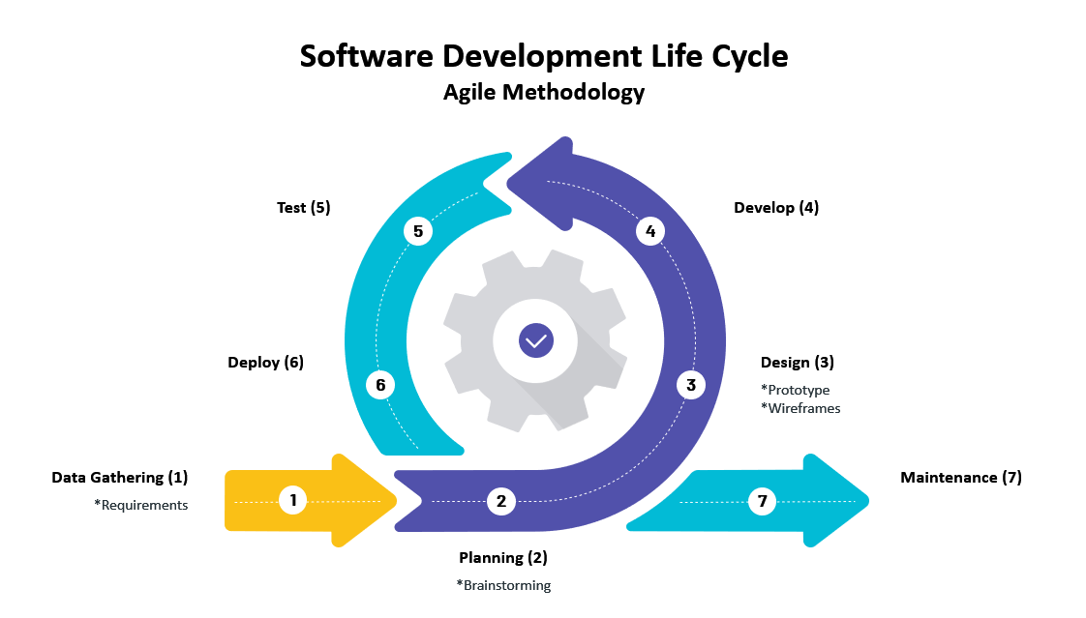

Fig. 1 SDLC (Agile Methodology)

Throughout this project, the team utilized an SDLC or Software Development Cycle to guide them, explicitly using the Agile Method. Software Development Cycle is one of the fundamental methods in developing software step-by-step. Using the Agile Method in the Software Development Cycle focuses attention on the team to respond to the changes that the clients demand throughout the development process [22]. This method emphasizes the efficient and effective collaboration between the team and the client. Fig. 1. SDLC (Agile Methodology) shows the model that the team used throughout software development.

* + - 1. **Data Gathering Phase**

The team gathered data that would fulfill their first requirements in software development. They used the technique in data gathering through several interviews, discussions, and meetings. In this phase, the team gathered data about the client’s current system, problem, desired system, features of the system, and background/profile.

* + - 1. **Planning Phase**

After gathering data from several meetings with their client, the team conducted several brainstorming phases to analyze the main problem and develop viable solutions. The team proposed an appropriate solution based on the problems that the client discussed. Further, the team discussed the solution with the client for them to understand it fully. After the approval of the proposed solution, the team went to another brainstorming phase to discuss technologies and software to be used in the creation of the prototype and, later, the completed system.

* + - 1. **Design Phase**

The team applied the discussed design, functions, and layout with the client through the proposed wireframe and prototype. Likewise, the team has provided the proper UI and UX design to meet the client’s standards and demands.

* + - 1. **Development Phase**

In this phase, the team developed the proposed solution that used the right technologies and software discussed in the planning phase. They also developed the front, database, and back end in this phase.

* + - 1. **Testing Phase**

In this phase, the team tested their software using the functionalities, performance, security, and overall system. They also followed one or more evolutionary development phases to put the most recent expansion into production.

* + - 1. **Implementation Phase**

In the deployment phase, the team has handed out the responsibilities over the web app and the ownership to the client based on the current agreement.

**Software Architecture**

To create the Barangay South Signal Village Web Application, the team will use LARAVEL, an open-source PHP web framework for developing a web application. Laravel is based on the MVC architecture design, which stands for Model, View, and Controller.

1. **Model** – supervises and controls the database of the Barangay South Signal Village Web Application. It uses queries to add, retrieve, modify, and delete records or tables in the database. The team will use MYSQL as their database for this web application, an open source that can store and retrieve data in a tabular form.
2. **View** - responsible for creating and rendering the web application's user interface (UI) and user experience (UX). In LARAVEL, the team will use Blade Templates, a solid templating engine included in the Laravel framework. Blade Templates uses PHP to write a script for HTML, CSS (Bootstrap), and JAVASCRIPT for front-end development.
3. **Controller** – oversees the web application's logic and processes user activities that engage with the model and view. It sends data from the model (database) to the view (front-end).
4. **Routing** – in addition to the MVC architecture for Laravel, routing is used to map URLs to the designated controller's actions.

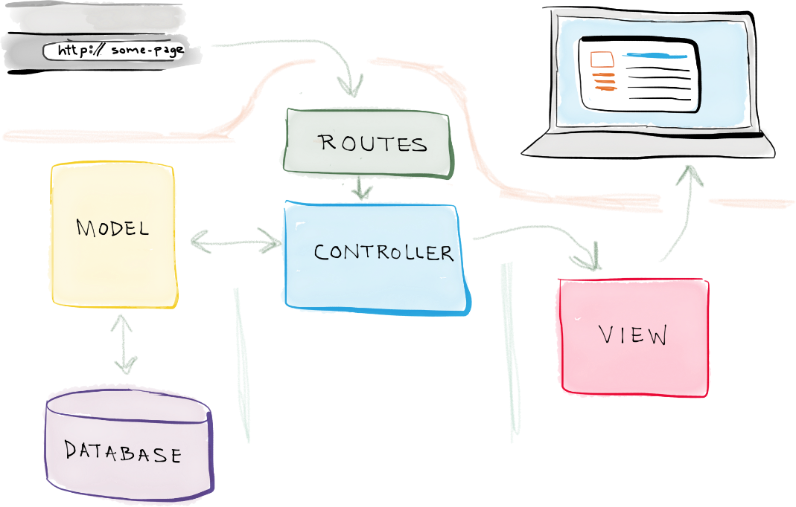

Fig. 2 MVC [23]

## Requirements Analysis

### Product Backlog / User Storie

TABLE 1   
USER STORIES WITH ACCEPTANCE CRITERIA

|  |  |  |  |  |
| --- | --- | --- | --- | --- |
| ID | TITLE | USER STORY | ACCEPTANCE | PRIORITY |
| 1 | Manage Resident Account | “As the Resident, I want to have my resident account, so that I can use the services offered by the web-app” | Ability to create a resident account.    Ability to login to the resident profile account using the resident account details.    Ability to modify/update resident account information such as valid ID information, email, password, address, and mobile number. | High |
| 2 | Manage Requests and Concerns | “As the Resident, I want to use online services of the barangay web-app, so that I can request document online, submit concerns, and track all my transactions” | Ability to use online services of the barangay web-app such as:   1. Document Request 2. Submit concerns.     Ability to track the status of the requested document and submitted concerns.    Ability to see all transaction history. | High |
| 3 | Payment | “As the Resident, I want to pay online for the requested documents through the Barangay Web App so that I am no longer required to pay face to face in the barangay.” | Ability to use eWallet for online payment in the web-app such as:   1. Gcash 2. Maya 3. Grab Pay | High |
| 4 | Process the requests of the residents | “As the Barangay Secretary and Barangay Request Manager, we want to manage the request of the residents, so that we can view and process the request submitted by the resident.” | Ability to have access to the Request Database.    Ability to see the list of requests from the resident’s profile.    Ability to receive requests from the resident’s profile.    Ability to validate requests and update the request’s status.    Ability to deny requests.    Ability to manually create a request for a face-to-face transaction.    Ability to add the manually created request to the requested database. | High |
| 5 | Process the concern of the residents. | “As the Barangay Secretary and Barangay Concern Manager, we want to process the submitted concern of the residents, so that we can view and manage the concerns submitted by the resident.” | Ability to have access to the Concern Database.    Ability to see the list of submitted concerns from the resident’s profile.    Ability to receive submitted concerns from the resident’s profile.    Ability to validate submitted concerns and update the concern’s status.    Ability to deny submitted concerns. | High |
| 6 | Manage the Barangay Resident Account | “As the Barangay Employees, we want to manage the accounts of the residents, so that we can view the information given by the residents and verify if it is legitimate or not.” | Ability to view resident’s account information.  Ability to change/update the password of the resident’s account.  Ability to identify if the uploaded IDs are legitimate and valid. | High |
| 7 | Manage the Barangay Employee Account | “As the Barangay Employees, we want to manage our own employee account, so that I can change/update information in the web-app” | Ability to log in to the admin portal of the barangay web app system.    Ability to change/update the email or password of the barangay employee account. | Medium |
| 8 | Manage the Barangay Employee Accounts | “As the Administrator, I want to manage the barangay employee accounts on the web-app, so that I can add, edit, and deactivate accounts to the web app system.” | Ability to have access to the Barangay Employee Database.    Ability to create/register barangay employee accounts to the system.    Ability to modify/update the profile of any barangay employee’s account in the system.    Ability to deactivate any barangay employee’s account to the system.    Ability to view the list of all barangay employees’ accounts. | Medium |
| 9 | View Reports | “As the Barangay Captain, I want to see all the generated reports, so that I can monitor the web-app and its transactions.” | Ability to view the generated report about:   1. List of Document Request 2. List of Submitted Concern 3. List of Resident Accounts 4. List of Barangay Employee Account | Medium |
| 10 | Manage the Web-Application | “As the Administrator, I want to manage the Barangay South Signal Village Web Application System, so that I can edit the content of the barangay web-app.” | Ability to have access to the Barangay Web-App Database.    Ability to modify the content of the barangay web-app system such as:   1. Banner on the home page 2. Contact list 3. Safety Section page 4. About Us page. 5. Requirements Guidelines | Medium |
| 11 | Process Payment | “As the Barangay Treasurer, I want to see the list of payments both online and onsite, so that I can process the payment of each resident.” | Ability to have access to the payment database.  Ability to see the list of payments and pending payments.  Ability to receive payment requests from the resident profile.  Ability to process payment from the treasurer dashboard. | High |

### Event Tables

TABLE 2  
RESIDENT'S EVENT TABLE

|  |  |  |  |  |  |
| --- | --- | --- | --- | --- | --- |
| Event | Trigger | Source | Use Case | Response | Destination |
| Residents want to manage their account information. | Manage Account | Barangay South Signal Village Resident | Manage Account | Updated account details | Barangay South Signal Village Resident |
| Residents want to manage requests and concerns | Manage requests and concerns | Barangay South Signal Village Resident | Manage Request and Concern | List of Documents Requests  Document Request Details  List of Concerns  Concern Details | Barangay Secretary    Barangay South Signal Village Resident |
| Residents wants to pay online transaction online | Payment | Barangay South Signal Village Resident | Payment | Payment Details    Updated Document Request Status    Updated Payment List | Barangay Secretary    Barangay South Signal Village Resident |

TABLE 3  
BARANGAY EMPLOYEE'S EVENT TABLE

|  |  |  |  |  |  |
| --- | --- | --- | --- | --- | --- |
| Event | Trigger | Source | Use Case | Response | Destination |
| Administrator wants to manage the employee accounts. | Manage the employee accounts | Administrator | Manage Employee Accounts | Updated Admin Account Details | Administrator |
| * Employees want to manage their admin accounts | Manage my admin account | Barangay Concern Manager    Barangay Secretary    Barangay Request Manager | Manage Barangay Secretary Account | Updated Admin Account Details | Barangay Concern Manager    Barangay Secretary    Barangay Request Manager |
| Administrator wants to manage web application. | Manage the Web-Application | Administrator | Manage Web-Application | Updated Web-Application details | Administrator |
| Barangay Captain wants to view the generated report for the document request. | End of Month |  | View Generated Report | Generated Report | Barangay Captain |
| *Employees want to manage document and concerns | Process the document and concerns | Barangay Request Manager    Barangay Secretary    Barangay Concern Manager | Process Request and Concerns | List of Document    Document Details    List of concerns    Concern Details | Barangay Request Manager    Barangay Secretary    Barangay Concern Manager |
| Barangay Treasurer wants to process payment | Process Payment | Barangay Resident | Process Payment | List of Payment  Payment Details | Barangay Resident  Barangay Secretary  Barangay Treasurer |

### Use Case Diagrams

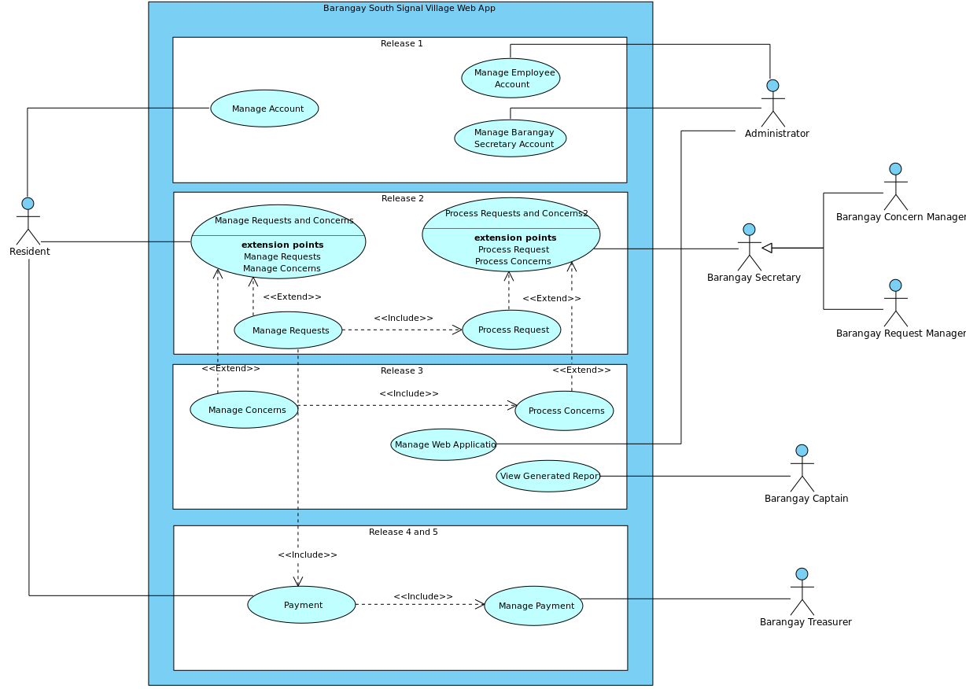

Fig. 3 Use Case Diagram

### Use Case Full Description

#### Resident Use Case Description

TABLE 4   
USE CASE DESCRIPTION REGISTRATION

|  |  |  |
| --- | --- | --- |
| **Use Case Number** | BSSVUC01 | |
| **Use Case** | Registration | |
| **Scenario** | Registration of resident | |
| **Triggering Event** | Manage Account | |
| **Brief Description** | The Resident registers an account which involves providing personal information. | |
| **Actors** | Resident | |
| **Related Use Cases** | Includes: | |
| **Stakeholders** | Barangay Captain: view the registered account | |
| **Preconditions** | Residents should reside in Barangay South Signal Village | |
| **Postconditions** | Resident account will be created | |
| **Flow of Activities** | **Actor** | **Flow of Activities** |
| 1. From the services tab click on register 2. Click Yes, I’m 18 years old and above. 3. Click Accept Data Privacy Notice 4. Fill out Personal Information/ Address/ Account Information 5. Check the box understood, and accepted Privacy Policy and Terms & Conditions 6. Click Submit 7. Go to your registered email account. 8. Click the link to verify your account. | 1.1 Show age confirmation.  2.1 Show Data Privacy Notice   3.1 Display Registration Form   6.1 Validate Inputted Form   6.2 Send email verification.   8.1 Add Resident Details into Resident Database.  8.2 Display confirmation of account |
| **Exception Conditions** | 2.1 If the resident did not click yes, do not redirect to the registration form.  3.1 If the resident did not accept the Data Privacy Notice, do not redirect to the registration form.  5.1 If the resident did not check the box, the account would not be registered.  8.1 If the resident did not click the verification link, the user would not be registered. | |

TABLE 5  
 LOGIN RESIDENT ACCOUNT

|  |  |  |
| --- | --- | --- |
| **Use Case Number** | BSSVUC02 | |
| **Use Case** | Login Resident Account | |
| **Scenario** | Resident Login Account | |
| **Triggering Event** | Manage Account | |
| **Brief Description** | When Residents log in to the account, the residents can use the functions of the Barangay South Signal Village Account such as requesting documents and submitting their concerns to the barangay online. | |
| **Actors** | Resident | |
| **Related Use Cases** | N/A | |
| **Stakeholders** | Barangay Captain: views the report from the resident. | |
| **Preconditions** | Resident must be logged-in | |
| **Postconditions** | Resident account should be verified as a member | |
| **Flow of Activities** | **Actor** | **Flow of Activities** |
| 1. Residents must go to the website and click Online Request. 2. Residents input credentials (email and password) and click log-in button | 1.1 Display Home Page  1.2 Display Log-in Page  2.1 Display Resident Account Dashboard |
| **Exception Conditions** | 2.1 If the Resident provided an incorrect email or password, then it will show a log-in error message. | |

TABLE 6   
UPDATE RESIDENT ACCOUNT

|  |  |  |
| --- | --- | --- |
| **Use Case Number** | BSSVUC03 | |
| **Use Case** | Update Resident Account | |
| **Scenario** | Resident Update Account | |
| **Triggering Event** | Manage Account | |
| **Brief Description** | When the Resident updates the account, the resident can use the limited functions of the Barangay South Signal Village such as being able to update their email address, mobile number, and change password. | |
| **Actors** | Resident | |
| **Related Use Cases** | Includes: Create Employee Account | |
| **Stakeholders** | Barangay Captain: views the generated report from the resident. | |
| **Preconditions** | Resident must be logged-in | |
| **Postconditions** | Residents must be present.  Requirement should be valid | |
| **Flow of Activities** | **Actor** | **Flow of Activities** |
| 1. Residents must go to the website and click Online Request. 2. Residents input credentials (email and password) and click the log-in button. 3. Residents click My Profile tab. 4. Residents click the edit button besides the information wanted to edit and input necessary information required in the form. 5. Resident clicks submit button. 6. Resident should see a confirmation from the web app | 1.1 Display Home Page  1.2 Display Log-in Page  2.1 Display Resident Account Dashboard  3.1 Display Account Information  3.2 Display form for changing information  4.1 Check for input validation  7.1 Update Resident Details    7.2 Display confirmation of the account |
| **Exception Conditions** | 2.1 If the Resident inputted the incorrect email or password, then show log in error message.  4.1 If the Resident does not fill in all the information properly and has the same existing email and phone number, then an error message appears, and the wrong form will be highlighted.  6.1 If the Resident fails to input the OTP three times, then the registration of the account will be denied. | |

TABLE 7   
CREATE NEW REQUEST

|  |  |  |
| --- | --- | --- |
| **Use Case Number** | BSSVUC04 | |
| **Use Case** | Create New Request | |
| **Scenario** | Create New Request | |
| **Triggering Event** | Manage Request | |
| **Brief Description** | When the residents want to use the Barangay South Signal Village Web App, they can create new requests for their documents or events. | |
| **Actors** | Barangay Residents | |
| **Related Use Cases** | Includes: Manage Concern | |
| **Stakeholders** | Barangay Captain: views the generated report from the resident. | |
| **Preconditions** | Residents must be present. Requested document must exist. Requirement should be valid. | |
| **Postconditions** | The barangay cashier must provide an official receipt to the Residents.  The requested barangay document should have a signature or dry seal stamp from the barangay.  The official receipt and request form should be recorded in the database. | |
| **Flow of Activities** | **Actor** | **Flow of Activities** |
| 1. Residents must go to the website and click Online Request 2. Residents input credentials (email and password) and click the log-in button. 3. Resident clicks the type of document being requested and uploads requirements. 4. Residents click the submit button to proceed. | 1.1 Display Home Page  1.2 Display Log-in Page  2.1 Display Resident Account Dashboard  3.1 Display document information  4.1 Save the Request Details to Request Database  4.2 Display details for submitted document request and the transaction key.  4.3 Send the confirmation by email. |
| **Exception Conditions** | 2.1 If the Resident provided the incorrect email or password, then show log-in error message.  4.1 If the Resident did not meet the requirements of the document, then the transaction will be terminated | |

TABLE 8   
TRACK REQUEST STATUS

|  |  |  |
| --- | --- | --- |
| **Use Case Number** | BSSVUC05 | |
| **Use Case** | Track Request Status | |
| **Scenario** | Track Request | |
| **Triggering Event** | Manage Request | |
| **Brief Description** | When the residents want to use the Barangay South Signal Village Web App, they can track request status to know the status of their request. | |
| **Actors** | Barangay Residents | |
| **Related Use Cases** | When the residents want to use the Barangay South Signal Village Web App, they can track request status to know the status of their request. | |
| **Stakeholders** | Barangay Captain: views the generated report from the resident. | |
| **Preconditions** | Residents must be present. Requested document must exist. Requirement should be valid. | |
| **Postconditions** | The barangay cashier must provide an official receipt to the residents.  The requested barangay document should have a signature or dry seal stamp from the barangay.  The official receipt and request form should be recorded in the database | |
| **Flow of Activities** | **Actor** | **Flow of Activities** |
| 1. Residents must go to the website and click Track Request 2. Residents input request key | 1.1 Display Home Page  1.2 Display Track Request Page  2.1 Display request information and status |
| **Exception Conditions** | 2.1 If the Resident provided the incorrect email or password, then show log in error message.  4.1 If the Resident did not meet the requirements of the document, then the transaction will be terminated. | |

TABLE 9   
RESET PASSWORD

|  |  |  |
| --- | --- | --- |
| **Use Case Number** | BSSVUC06 | |
| **Use Case** | Reset Password | |
| **Scenario** | Resident wants to reset their password | |
| **Triggering Event** | Resident password change | |
| **Brief Description** | The resident registers an account which involves providing personal information. | |
| **Actors** | Resident | |
| **Related Use Cases** | Includes: | |
| **Stakeholders** | Barangay Captain: view the registered account | |
| **Preconditions** | Residents should reside in Barangay South Signal Village | |
| **Postconditions** | Resident will change password | |
| **Flow of Activities** | **Actor** | **Flow of Activities** |
| 1. Click the side bar and locate My Profile 2. Click and Locate Change Password 3. Input Old and New Password   3.1 Click Save | 1. Login Page 2. Resident Personal Information Page 3. Change Password Tab |
| **Exception Conditions** | 2. Resident did not click Change Password.  3. Resident inputs wrong password.  3.1 Resident did not put the correct password requirements.   3.2 Resident did not click the Save button. | |

TABLE 10   
SUBMIT NEW CONCERN

|  |  |  |
| --- | --- | --- |
| **Use Case Number** | BSSVUC07 | |
| **Use Case** | Manage Concern | |
| **Scenario** | Submit New Concern | |
| **Triggering Event** | Manage Concern | |
| **Brief Description** | When the Resident wants to Manage Concerns about the account, the resident can use the functions of the Barangay South Signal Village Web App such as managing and submitting a concern. | |
| **Actors** | Barangay Residents | |
| **Related Use Cases** | Includes: Manage Request | |
| **Stakeholders** | Barangay Captain: views the generated report from the resident. | |
| **Preconditions** | Resident must be present Requested document must exist Requirement should be valid | |
| **Postconditions** | The barangay cashier must provide an official receipt to the Residents.  The requested barangay document should have a signature or dry seal stamp from the barangay.  The official receipt and request form should be recorded in the database. | |
| **Flow of Activities** | **Actor** | **Flow of Activities** |
| 1. Residents must go to the website and click Online Request 2. Residents input credentials (email and password) 3. Residents click the log-in button. 4. Residents click the Submit Concern Button and input necessary information about the concern. 5. Residents click the submit button to proceed. | 1.1 Display Home Page  1.2 Display Log-in Page   3.1 Display Resident Account Dashboard  4.1 Display information about the services concerned.  5.1 Save the Concern Details to the Concern Database  5.2 Display details for submitted concern and transaction key.  5.3 Send the confirmation through email. |
| **Exception Conditions** | 2.1 If the Resident provided the wrong email or password, then show log in error message.  4.1 If the Resident did not input the information properly, then the concern service will be terminated. | |

TABLE 11   
TRACK CONCERN STATUS

|  |  |  |
| --- | --- | --- |
| **Use Case Number** | BSSVUC08 | |
| **Use Case** | Track Concern Status | |
| **Scenario** | Track Concern | |
| **Triggering Event** | Manage Concern | |
| **Brief Description** | When the Resident wants to Track Concern Status, the residents can use the functions of the Barangay South Signal Village Web App if the residents want to know its status. | |
| **Actors** | Barangay Residents | |
| **Related Use Cases** | Includes: Manage Concern | |
| **Stakeholders** | Barangay Captain: views the generated report from the resident. | |
| **Preconditions** | Residents must be present. Requested document must exist. Requirement should be valid. | |
| **Postconditions** | The barangay cashier must provide an official receipt to the Residents.  The requested barangay document should have a signature or dry seal stamp from the barangay.  The official receipt and request form should be recorded in the database. | |
| **Flow of Activities** | **Actor** | **Flow of Activities** |
| 1. Residents must go to the website and click Track Request 2. Residents input concern key | 1.1 Display Home Page  1.2 Display Track Request Page  2.1 Display concern information and status |
| **Exception Conditions** | 2.1 If the Resident provided the wrong concern key, then it will show an error message. | |

#### Barangay Employee Use Case Description

TABLE 12  
 LOG-IN BARANGAY EMPLOYEE ACCOUNT

|  |  |  |
| --- | --- | --- |
| **Use Case Number** | UC1.1 | |
| **Use Case Name:** | Log-in Barangay Employee Account | |
| **Actors:** | Employee Account: Administrator, Barangay Secretary, Captain, Request Manager, Concern Manager | |
| **Preconditions:** | Must have barangay employee account to login in Admin Portal | |
| **Postconditions:** | account should be verified as Barangay Employee | |
| **Flow of Activities** | **Actor** | **Flow of Activities:** |
| 1. Barangay Employee must go to the website for Administrator portal  2. Barangay Employee input credentials (email and password) and click log-in button | 1.1 Display *Admin Portal*  2.1 Display Barangay Employee Account Dashboard |
| **Alternate Flow:** | 2.1 If the Barangay Employee provided an incorrect email or password, then it will show a log-in error message. | |

TABLE 13   
ADMIN- CREATE EMPLOYEE ACCOUNT

|  |  |  |
| --- | --- | --- |
| **Use Case Number** | UC2.1 | |
| **Use Case Name:** | Admin- Create Employee Account | |
| **Actors:** | Administrator | |
| **Preconditions:** | Administrator must be logged-in  Administrator must be in the “Create Employee Account tab” to create an Employee Account | |
| **Postconditions:** | Employee Accounts should be created after being created by the Administrator.  Information will be stored in the Barangay Employee Database; additionally, information should be valid. | |
| **Flow of Activities:** | **Actor** | **System** |
| 1. Administrator clicks add employee account tab.  2. Administrator inputs Barangay Employee details, Administrator clicks Create Account button. | 1.1 Display Add Barangay Employee Account Form.  2.1 Successfully added barangay employee account. |
| **Alternate Flow:** | **At Step 2.1** If the Administrator does not fill in all the information properly and has the same existing email and phone number within the database, then an error message appears, and the wrong form will be highlighted. | |
| **Special Requirements:** |  | |

TABLE 14   
DEACTIVATE EMPLOYEE ACCOUNT

|  |  |  |
| --- | --- | --- |
| **Use case Number** | UC2.2 | |
| **Use Case Name:** | Deactivate Employee Account | |
| **Actors:** | Administrator | |
| **Preconditions:** | Administrator must be logged-in  Administrator must be in “Active Barangay Employee Tab” to deactivate an Employee Account | |
| **Postconditions:** | Employee Accounts should be deactivated once the Administrator successfully performs account de-deactivation.  Employee account information will be stored in the Barangay Employee Database; additionally, information should be valid. | |
| **Flow of Activities:** | **Actor** | **System** |
| 1. Administrator clicks the “view” button.  2. Administrator clicks deactivate account button  3. Administrator inputs his/her account password for confirmation | 1.1 to display “Barangay Employee Information Tab”  2.1 Display password confirmation of admin to deactivate account.  3.1 Deactivates Barangay Employee Account to Barangay Employee Database |
| **Alternative flow** | Step 3: If the Administrator inputs the wrong password as the system prompts password confirmation, the barangay employee account will not be deactivated. | |

TABLE 15   
REACTIVATE BARANGAY EMPLOYEE ACCOUNT

|  |  |  |
| --- | --- | --- |
| **Use case Number** | UC2.3 | |
| **Use Case Name:** | Reactivate Barangay Employee Account | |
| **Actors:** | Administrator | |
| **Preconditions:** | Administrator must be logged in.  Must have a barangay employee deactivated account.  Administrator must be in the “Deactivated Barangay Employee Tab.” | |
| **Postconditions:** | Barangay Employee Account should be active once the Administrator successfully performs account reactivation.  Employee account information will be stored in the Barangay Employee Database; additionally, information should be valid. | |
| **Flow of Activities:** | **Actor** | **System** |
| 1. Administrator clicks the “view” button  2.Administrator clicks the Reactivate button.  3. Administrator inputs his/her account password for confirmation. | 1.1 to display “Barangay Employee Information  2.1 Display password confirmation of admin to Reactivate account.  3.1 Reactivates Barangay Employee account to Barangay Employee Database |
| **Alternative flow** | At Step 3: Administrator inputs the wrong password as the system prompts password confirmation, and the barangay employee account will not be Reactivated. | |

TABLE 16   
ADMINISTRATOR EDITS EMPLOYEE ACCOUNT

|  |  |  |
| --- | --- | --- |
| **Use Case Number** | UC2.4 | |
| **Use Case Name:** | Administrator Edits Employee Account | |
| **Actors:** | Administrator | |
| **Preconditions:** | Administrator must be logged in.  The administrator must be in the Active Barangay Employee Tab.  Must have an Active Barangay Employee Account to edit. | |
| **Postconditions:** | Changes made by the administrator to the barangay employee account should be recorded.  information which will be stored in the Barangay Employee Database; additionally, information should be valid. | |
| **Flow of Activities:** | **Actor** | **System** |
| 1. Administrator clicks the edit button on a certain employee from the list.  2. Administrator edits barangay employee information.  3. Administrator clicks the reset password button.  4. Administrator clicks the save button. | 1.1 Display barangay employee personal information  2.1 Display Barangay Employee editable account information  3.1 Display required password format.  4.1 Update Barangay Employee personal information to Barangay Employee Database |
| **Alternative flow** | **At Step 3** If the required password format for password reset is not met, a new password will not be recorded and updated in the barangay database.  **At Step 4** If the Administrator does not fill in all the information properly and has the same existing email and phone number within the database, then an error message appears, and the wrong form will be highlighted. | |

TABLE 17   
EMPLOYE EDITS EMPLOYEE ACCOUNT

|  |  |  |
| --- | --- | --- |
| **Use Case Number** | UC2.5 | |
| **Use Case Name:** | Employe Edits Employee Account | |
| **Actors:** | Barangay Employee | |
| **Preconditions:** | Barangay Employee must be logged in.  Employees must be in the Active Barangay Employee Tab.  Must have an Active Barangay Employee Account to edit. | |
| **Postconditions:** | Changes made by the administrator to the barangay employee account should be recorded.  information which will be stored in the Barangay Employee Database; additionally, information should be valid. | |
| **Flow of Activities:** | **Actor** | **System** |
| 1. Employee clicks the edit button on a certain employee from the list.  2. Employee edits barangay employee information.  3. Employee clicks the reset password button.  4. Employee clicks the save button. | 1.1 Display barangay employee personal information  2.1 Display Barangay Employee editable account information  3.1 Display required password format.  4.1 Update Barangay Employee personal information to Barangay Employee Database |
| **Alternative flow** | **Step 3:** If the required password format for password reset is not met, the new password will not be recorded and updated in the barangay database.  **Step 4: If** the Barangay Employee does not fill in all the information properly and has the same existing email and phone number within the database, then an error message appears, and the wrong form will be highlighted. | |

TABLE 18   
DEACTIVATE BARANGAY RESIDENT ACCOUNT

|  |  |  |
| --- | --- | --- |
| **Use case Number** | UC3.1 | |
| **Use Case Name:** | Deactivate Barangay Resident Account | |
| **Actors:** | Administrator | |
| **Preconditions:** | Administrator must be logged in.  Must have an existing Barangay Active Resident Account to deactivate.  The administrator must be in the Active Resident Account Tab. | |
| **Postconditions:** | Barangay resident account should be deactivated once the administrator deactivates it.  Employee account information will be stored in the Barangay Employee Database; additionally, information should be valid. | |
| **Flow of Activities:** | **Actor** | **System** |
| 1. The administrator clicks the deactivate button from the Active Resident Account Tab toggle or clicks “view” to display “Resident Employee Information to deactivate the account.  2. The administrator inputs his/her account password for confirmation. | 1.1 Display password confirmation of admin to deactivate account.  2.1 Deactivates Barangay Resident to Barangay Employee Database |
| **Alternative flow** | At Step 2: Administrator inputs the wrong password as the system prompts password confirmation, and the barangay resident account will not be deactivated. | |

TABLE 19   
REACTIVATE BARANGAY RESIDENT ACCOUNT

|  |  |  |
| --- | --- | --- |
| **Use case Number** | UC3.2 | |
| **Use Case Name:** | Reactivate Barangay Resident Account | |
| **Actors:** | Administrator | |
| **Preconditions:** | Administrator must be logged in.  Barangay Resident account must be listed as deactivated account.  The administrator must be in the Deactivated Resident Tab. | |
| **Postconditions:** | The administrator should be verified as a Barangay Employee Account.  Employee account information will be stored in the Barangay Employee Database; additionally, information should be valid. | |
| **Flow of Activities:** | **Actor** | **System** |
| 1. Administrator clicks the Reactivate button from Deactivated Resident Tab to toggle or click “view” to display “Barangay Employee Information to Reactivate account.  2. Administrator inputs his/her account password for confirmation. | 1.1 Display password confirmation of admin to Reactivate account.  2.1 Reactivates Barangay Resident to Barangay Employee Database |
| **Alternative flow** | Step 2: The administrator inputs the wrong password as the system prompts password confirmation, and the barangay employee account will not be Reactivated. | |

TABLE 20   
EDIT HOMEPAGE BANNER

|  |  |  |
| --- | --- | --- |
| **Use case Number** | UC4.1 | |
| **Use Case Name:** | Edit Homepage Banner | |
| **Actors:** | Administrator | |
| **Preconditions:** | The administrator must be logged in.  The administrator must be in the Manage Web Application Tab. | |
| **Postconditions:** | Changes made by the administrator should apply successfully and appear on the homepage.  Employee account information will be stored in the Barangay Employee Database; additionally, information should be valid. | |
| **Flow of Activities:** | **Actor** | **System** |
| 1. Administrator clicks the edit banner button.  2. Click Update Banner #  3. After choosing image Click “Done” | 1.1 Display password homepage banners and recommended banner dimension  2.1 Display Upload File  3. Notify Uploaded banner is posted |

TABLE 21   
EDIT DEMOGRAPHY

|  |  |  |
| --- | --- | --- |
| **Use case Number** | UC4.2 | |
| **Use Case Name:** | Edit Demography | |
| **Actors:** | Administrator | |
| **Preconditions:** | The administrator must be logged in.  The administrator must be in the Manage Web Application Tab. | |
| **Postconditions:** | Updated demography should apply after the administrator changes it and will reflect on the “About Us” page.  Employee account information will be stored in the Barangay Employee Database; additionally, information should be valid. | |
| **Flow of Activities:** | **Actor** | **System** |
| 1. The administrator clicks the Edit Demography button. 2. Edit the Demography Field Inputs | 1.1 Display Editable Form for Update Demography  2.2 Save Changes to Demography to barangay Database |
| **Alternative flow** | At Step 2: If inputs incorrect data type is in the input fields, it highlights the incorrect input and will not be saved. | |

TABLE 22   
EDIT CONTACTS

|  |  |  |
| --- | --- | --- |
| **Use case Number** | UC4.3 | |
| **Use Case Name:** | Edit Contacts | |
| **Actors:** | Administrator | |
| **Preconditions:** | Administrator must be logged-in  Administrator must be in Manage Web Application Tab | |
| **Postconditions:** | New contact information changes should be applied after the administrator changes it and shows a new contact update in the “Contact Page.”  Employee account information will be stored in the Barangay Employee Database; additionally, information should be valid. | |
| **Flow of Activities:** | **Actor** | **System** |
| 1. Administrators must click the edit contact information button. 2. Administrator edits contact information details. | 1.1 displays contact information  2.2 Save Changes Contact Information to barangay Database. |
| **Alternative flow** | At Step 2: If inputs incorrect data type is in the input fields, it highlights the incorrect input and will not be saved. | |

TABLE 23   
UPDATE BARANGAY OFFICIALS

|  |  |  |
| --- | --- | --- |
| **Use case Number** | UC 4.4 | |
| **Use Case Name:** | Update Barangay Officials | |
| **Actors:** | Administrator | |
| **Preconditions:** | Administrator must be logged-in  Administrator must be in Manage Web Application Tab | |
| **Postconditions:** | An updated barangay official list should be applied after the administrator edits it.  Employee account information will be stored in the Barangay Employee Database; additionally, information should be valid. | |
| **Flow of Activities:** | **Actor** | **System** |
| 1. Administrators must click the edit barangay official's button. 2. Administrator changes committee names and images. | 1.1 Name of barangay captain and list of barangays committee  2.2 Displays input field and attach image |

TABLE 24   
MANAGE SERVICES

|  |  |  |
| --- | --- | --- |
| **Use Case Number** | UC5.1 | |
| **Use Case Name:** | Manage Services | |
| **Actors:** | Barangay Secretary | |
| **Preconditions:** | The secretary must be logged in. | |
| **Postconditions:** | The secretary should be verified as Barangay Employee Account. | |
| **Flow of Activities:** | **Actor** | **System** |
| 1. Barangay Secretary clicks the “Manage services” tab.    2. Barangay Secretary sets a service as “active/inactive”.    3. Barangay Secretary clicks the “update” button.  4. Barangay secretary clicks “confirm”. | 1. Redirects to Manage services Page.  2. System prompts “active or inactive” choices in the dropdown column.  3. Displays a successful update prompt.  4. System reflects the changes. |

TABLE 25   
VIEW DOCUMENT REQUEST

|  |  |  |
| --- | --- | --- |
| **Use Case Number** | UC5.2 | |
| **Use Case Name:** | View Document Request | |
| **Actors:** | Barangay Secretary | |
| **Preconditions:** | The secretary must be logged in. | |
| **Postconditions:** | The secretary should be verified as Barangay Employee Account. | |
| **Flow of Activities:** | **Actor** | **System** |
| 1. Barangay Secretary clicks the “Document Request” tab.  2. Barangay Secretary downloads a file in PDF/Excel format.  3. The Barangay Secretary wants to view the information sent by the requestor.  4. Barangay secretary clicks “confirm”. | 1. Redirects to Document Request page    2.1 System automatically downloads the selected file.    3.1 Displays the information sent by the requestor.  4.1 System reflects the changes. |
| **Alternate flow:** |  | |

TABLE 26   
PROCESS DOCUMENT REQUEST

|  |  |  |
| --- | --- | --- |
| **Use Case Number** | UC5.3 | |
| **Use Case Name:** | Process document Request | |
| **Actors:** | Barangay Secretary | |
| **Preconditions:** | The secretary must be logged in. | |
| **Postconditions:** | The secretary should be verified as Barangay Employee Account. | |
| **Flow of Activities:** | **Actor** | **System** |
| 1. Barangay Secretary clicks the “Process Document” tab.    2. Barangay Secretary clicks a document from the list.    3. Barangay Secretary clicks the “reassign” button.  4. Barangay secretary clicks the “confirm reassign” request. | 1.Redirects to “Process Document” page    2. System displays the information sent by the requestor.    3. System prompts with “reassign confirmation.”  4. system prompts “request is reassigned to barangay employee logged in”. |
| **Alternate flow:** | 3.1 The Barangay Secretary cancels reassign request.  3.2 The system redirects to the system information page. | |

TABLE 27   
APPROVE DOCUMENT REQUEST

|  |  |  |
| --- | --- | --- |
| **Use Case Number** | UC 5.4 | |
| **Use Case Name:** | Approve Document Request | |
| **Actors:** | Barangay Secretary  Barangay Request Manager | |
| **Preconditions:** | The Secretary/Request Manager must be logged in. | |
| **Postconditions:** | The secretary should be verified as Barangay Employee Account.  Employee account information will be stored in the Barangay Employee Database. | |
| **Flow of Activities:** | **Actor** | **System** |
| 1. Barangay Secretary/ Barangay Request Manager click the Process Document Request.  2. Barangay Secretary/ Barangay Request Manager clicks the view of the request to be processed.  3. Barangay Secretary/ Barangay Request Manager changes the status of the Request Details. | 1. Display list of Request  2. Display Request Details  3.1 Update the Request Details  3.2 Send email for updates to the resident |
| **Alternate flow:** | 2.1 If the request is invalid, the status will be changed to denied.  2.2 If the request is valid, the status will be changed to approved. | |

TABLE 28   
DENY DOCUMENT REQUEST

|  |  |  |
| --- | --- | --- |
| **Use Case Number:** | UC 5.5 | |
| **Use Case Name:** | Deny Document Request | |
| **Actors:** | Barangay Secretary  Barangay Concern Manager | |
| **Preconditions:** | The Secretary/Concern Manager must be logged in. | |
| **Postconditions:** | The Secretary/Concern should be verified as Barangay Employee Account.  Employee account information will be stored in the Barangay Employee Database. | |
| **Flow of Activities:** | **Actor** | **System** |
| 1. Barangay Secretary/ Barangay Concern Manager click the Process Concern.  2. Barangay Secretary/ Barangay Concern Manager click the view of the concern to be processed.  3. Barangay Secretary/ Barangay Concern Manager forward the concern to necessary department.  4. Barangay Secretary/ Barangay Concern Manager change the status of the Concern Details. | 1. Display list of Concerns  2. Display Concern Details    3. Forwards and process’ the concern    4.1Update the Concern Details  4.2 Send email for updates to the resident. |
| **Alternate Flow:** | 2.1 If the concern is invalid, the status will be changed to denied.  2.2 If the concern is valid, the status will be changed to approved. | |

TABLE 29   
APPROVE DOCUMENT REQUEST

|  |  |  |
| --- | --- | --- |
| **Use Case Number** | UC 6.1 | |
| **Use Case Name:** | Approve Document Request | |
| **Actors:** | Barangay Secretary  Barangay Concern Manager | |
| **Preconditions:** | The Secretary/Concern Manager must be loggedin. | |
| **Postconditions:** | The Secretary should be verified as Barangay Employee Account. | |
| **Flow of Activities:** | **Actor** | **System** |
| **1.** Barangay Secretary clicks on “View Concern”.  **2.** Barangay Secretary downloads a file in PDF/Excel Format.  3. Barangay Secretary clicks on the “View” button below the “Action:” table. | 1. Redirects to View Concern Page.  2. System automatically downloads the selected file.  3. Redirects to the “Information” page. |
| **Alternate flow:** |  | |

TABLE 30   
PROCESS CONCERN

|  |  |  |
| --- | --- | --- |
| **Use Case Number** | UC 6.2 | |
| **Use Case Name:** | Process Concern | |
| **Actors:** | Barangay Secretary  Barangay Concern Manager | |
| **Preconditions:** | The Secretary/Concern Manager must be logged in. | |
| **Postconditions:** | The Secretary should be verified as Barangay Employee Account. | |
| **Flow of Activities:** | **Actor** | **System** |
| 1. The Barangay Secretary clicks on the “Process Concern” tab.  2. The Barangay Secretary clicks on the “Process” button below the “Action:” table.  3. The Barangay Secretary clicks “reassign” button  4. The Barangay Secretary clicks “confirm reassign” request. | 1. Redirects to Process Concern Page.  2. Redirects to the “Information” page  3. System prompts with “reassign confirmation.”  4. system prompts “request is reassigned to barangay employee logged in” |
| **Alternate flow:** | 3.1 The Barangay Secretary cancels reassign request.  3.2 The System redirects to system information page. | |

TABLE 31   
UPDATE CONCERN

|  |  |  |
| --- | --- | --- |
| **Use Case Number** | UC 6.3 | |
| **Use Case Name:** | Update Concern | |
| **Actors:** | Barangay Secretary  Barangay Concert Manager | |
| **Preconditions:** | The Secretary/Concern Manager must be logged in. | |
| **Postconditions:** | The Secretary/Concern Manager should be verified as Barangay Employee Account. | |
| **Flow of Activities:** | **Actor** | **System** |
| 1. Barangay Secretary clicks on “Process Concern” tab.  2. Barangay Secretary clicks on the “Process” button below the “Action:” table.  3. Barangay Secretary clicks the “process” button.  4. Barangay Secretary clicks on “Update Request” button.  5. Barangay Secretary clicks on “update concern.” | 1. Redirects to Process Concern Page.  2. Redirects to the “Information” page  3. System prompts show 3 choices.  4. System prompt shows “Update Concern”.  51 System prompts to enter password of barangay secretary. 5.2 redirects to the “information” page of the concern. |
| **Alternate flow:** |  | |

TABLE 32   
DENY CONCERN

|  |  |  |
| --- | --- | --- |
| **Use Case Number** | UC 6.4 | |
| **Use Case Name:** | Deny Concern | |
| **Actors:** | Barangay Secretary  Barangay Concern Manager | |
| **Preconditions:** | The Secretary/Concern Manager must be logged in. | |
| **Postconditions:** | The Secretary/Concern should be verified as Barangay Employee Account. | |
| **Flow of Activities:** | **Actor** | **System** |
| 1. Barangay Secretary clicks on “Process Concern” tab.  2. Barangay Secretary clicks on the “Process” button below the “Action:” table.  3. Barangay Secretary clicks the “process” button.  4. Barangay Secretary clicks on “Deny Request” button.  5. Barangay Secretary clicks on “save changes.” | 1. Redirects to Process Concern Page.  2. Redirects to the “Information” page  3. Redirects to “Information” Page.  4. System prompts shows “Deny Request”.  5.1 System prompts to enter the password of barangay secretary.  5.2 redirects to “process concerns” page. |
| **Alternate flow:** |  | |

TABLE 33   
CLOSE CONCERN

|  |  |  |
| --- | --- | --- |
| **Use Case Number** | UC 6.5 | |
| **Use Case Name:** | Close Concern | |
| **Actors:** | Barangay Secretary  Barangay Concern Manager | |
| **Preconditions:** | Secretary/Concern Manager must be logged-in | |
| **Postconditions:** | Secretary/Concern Manager should be verified as Barangay Employee Account | |
| **Flow of Activities:** | **Actor** | **System** |
| 1. Barangay Secretary clicks on “Process Concern” tab.  2. Barangay Secretary clicks on the “Process” button below the “Action:” table.  3. Barangay Secretary clicks the “process” button.  4. Barangay Secretary clicks on “Close Concern” button.  5. Barangay Secretary clicks on “save changes” | 1. Redirects to Process Concern Page.  2. Redirects to the “Information” page  3. Redirects to “Information” Page.  4. System prompts shows “Close Concern”.  5. System prompts to enter the password of barangay secretary.  5.2 Redirects back to the “Process Concern” Page. |
| **Alternate flow:** |  | |

TABLE 34   
BARANGAY DATA REPORT

|  |  |  |
| --- | --- | --- |
| **Use Case Number:** | UC 7.1 | |
| **Use Case Name:** | Barangay Data Report | |
| **Actors:** | Barangay Captain | |
| **Preconditions:** | The Barangay Captain must be logged-in | |
| **Postconditions:** | The Barangay Captain should be verified as Barangay Employee Account. | |
| **Flow of Activities:** | **Actor** | **System** |
| 1. Barangay Captain goes to the Admin Portal.  2. Barangay Captain inputs account credentials to login.  3. Barangay Captain clicks the tab to show the report (show request statics / show concerns). | 1.1 Display *Home Page*  2.1 Display Barangay Captain Dashboard  3.3 View the generated report. |
| **Alternative flow:** | 2.1 If the Barangay Captain provided the wrong credentials, then an error message appears. | |

## Gap Analysis

TABLE 35   
GAP ANALYSIS

|  |  |  |  |
| --- | --- | --- | --- |
| Product Backlog ID | Current System | Proposed Changes | Impact |
| 1 | Manual document request | Can request documents online | 1. Save time and effort in requesting documents. 2. Digitalized transaction |
| 2 | Manual input in forms | Can input data in online forms within the web app with guides | 1. Less typographical errors 2. More understandable data |
| 3 | Data stored in a physical file cabinet | Can store data in the cloud | 1. More security 2. Easier to search and navigate through the data 3. Less space consumption |
| 4. | A manual search of data | Can lookup available data be using a database | 1. Save time and effort in searching data |
| 5 | Physical transaction | Can request documents and submit concerns online.  Can pay transactions online for requested online documents. | 1. Less risk of having contagious disease/s 2. Save time going to barangay |
| 6 | Manual generation of report | Can generate reports based on the transaction online | 1. Efficient generation of needed report |

## System Analysis and Design

### Context Diagram

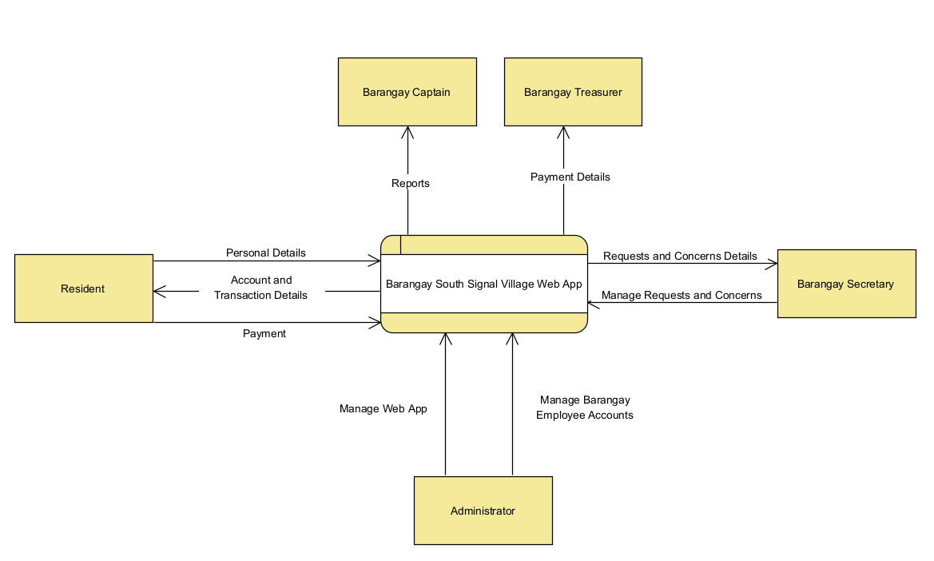

Fig. 4 Context Flow Diagram

### Data Flow Diagrams

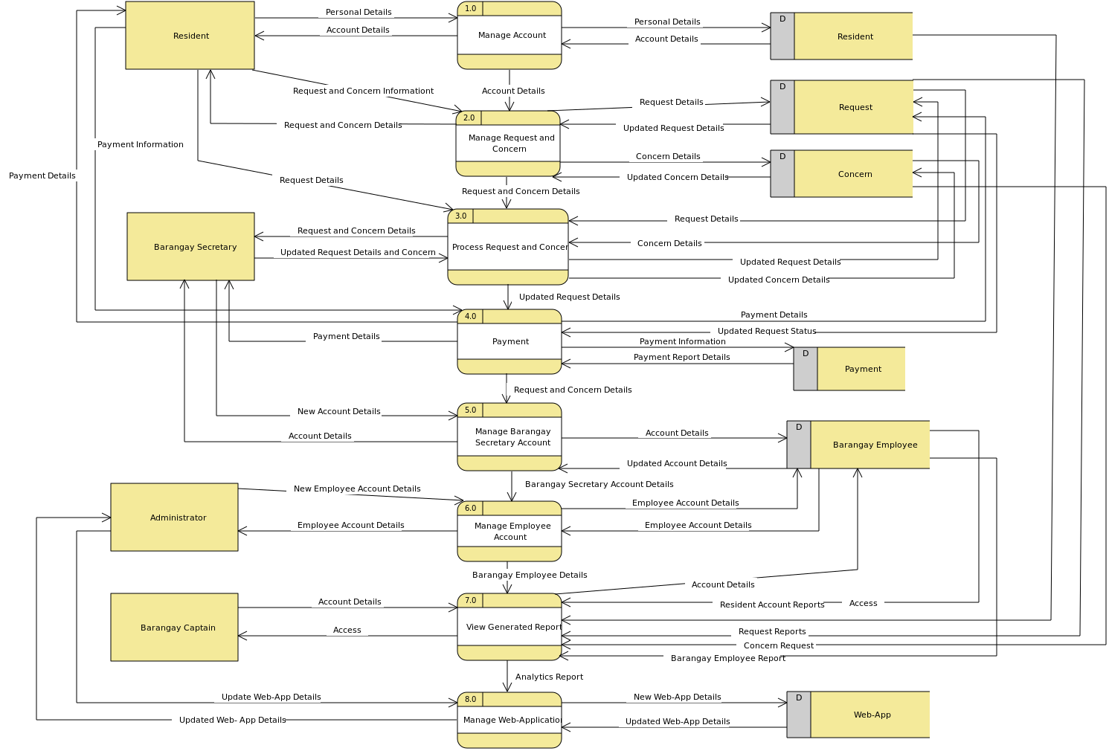

Fig. 5 Data Flow Diagrams Level 0

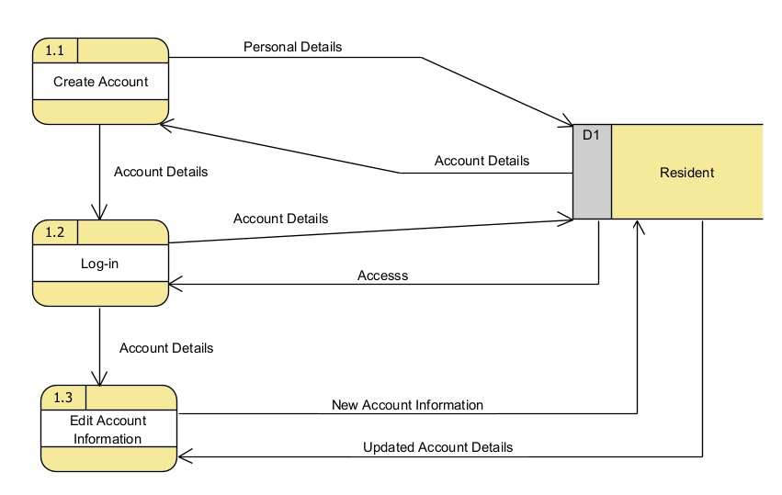

Fig. 6 DFD Manage Account level 1

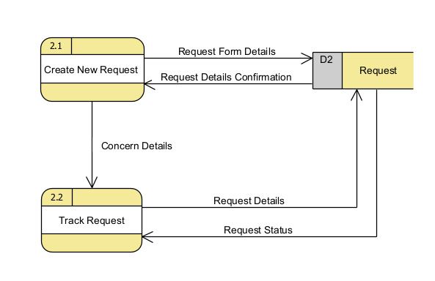

Fig. 7 DFD Manage Request level 1

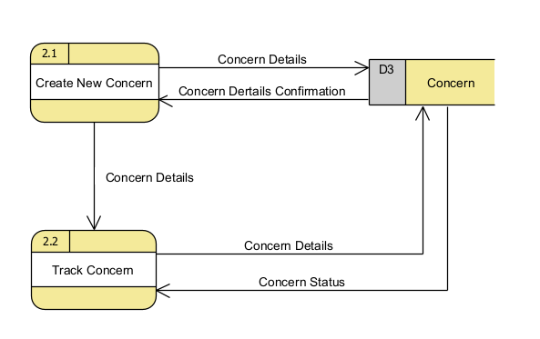

Fig. 8 DFD Manage Concern level 1

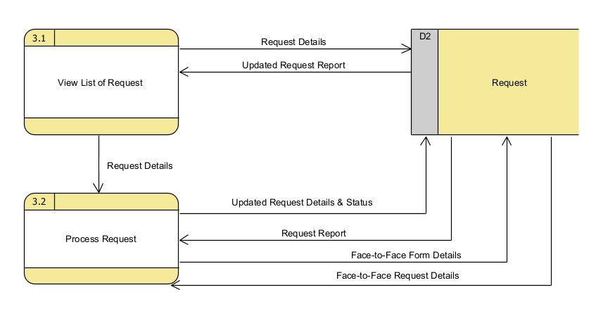

Fig. 9 DFD Process Request level 1

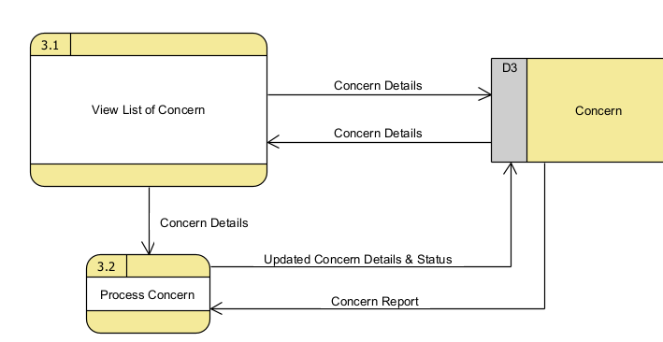

Fig. 10 DFD Manage Concern level 1.

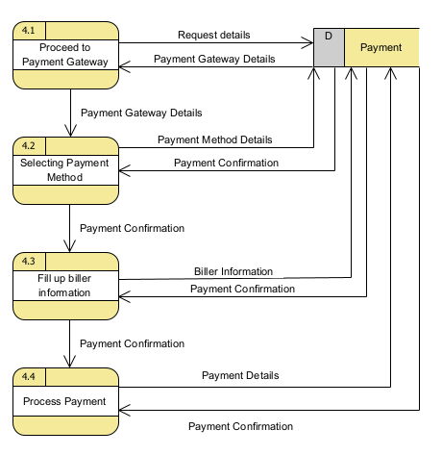

Fig. 11 DFD Payment level 1

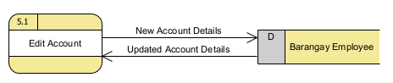

Fig. 12 DFD Manage Barangay Secretary Account

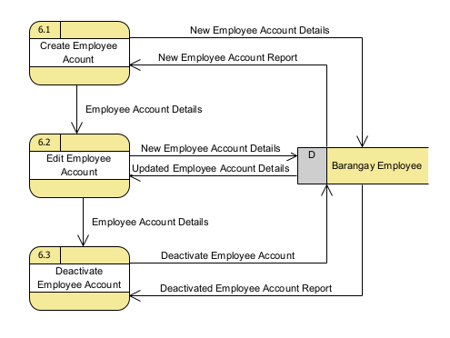

Fig. 13 DFD Manage Employee Account

### Entity-Relationship Diagrams

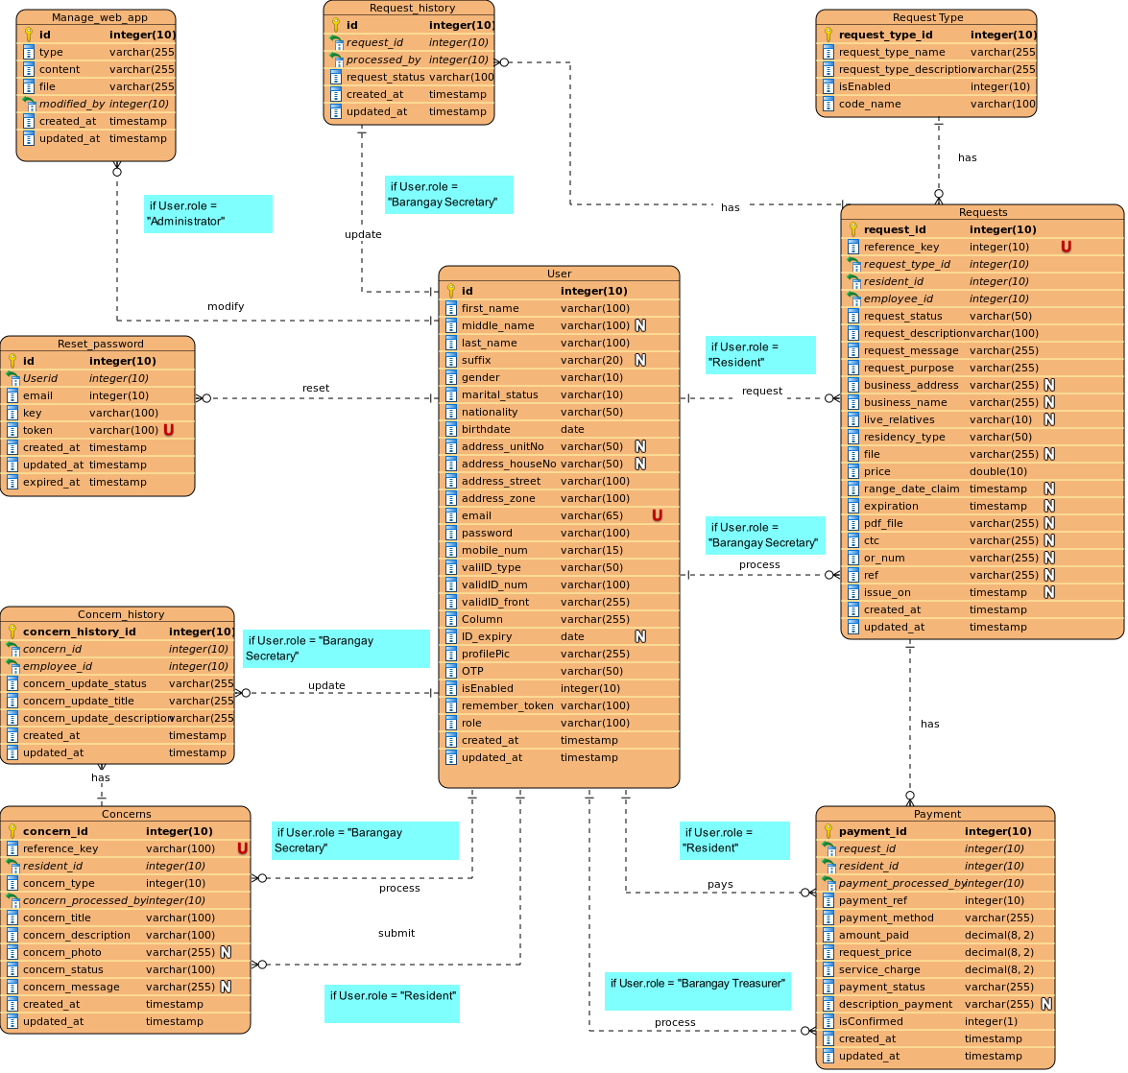

Fig. 14 Entity-Relationship Diagrams

### Activity Diagram

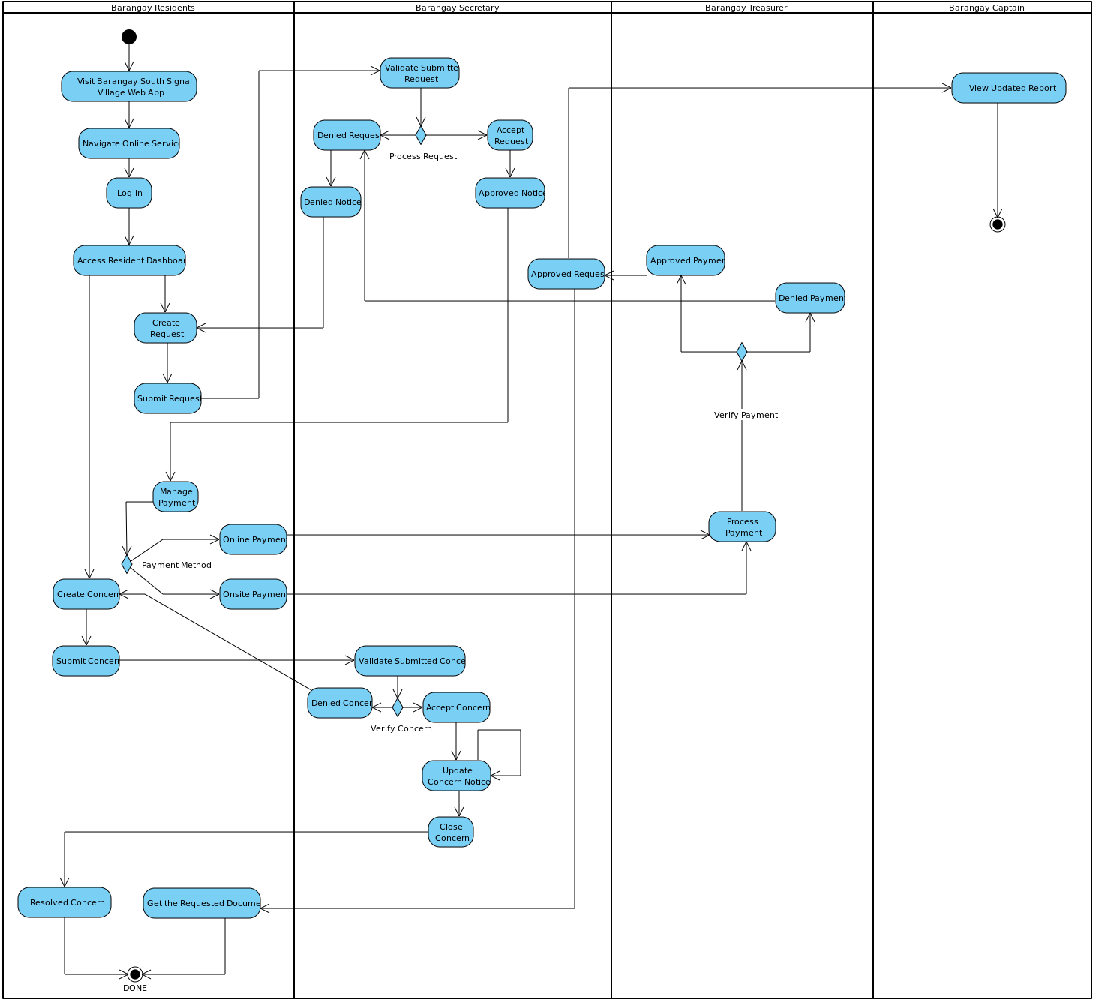

Fig. 15 Activity Diagram

### Object Diagrams

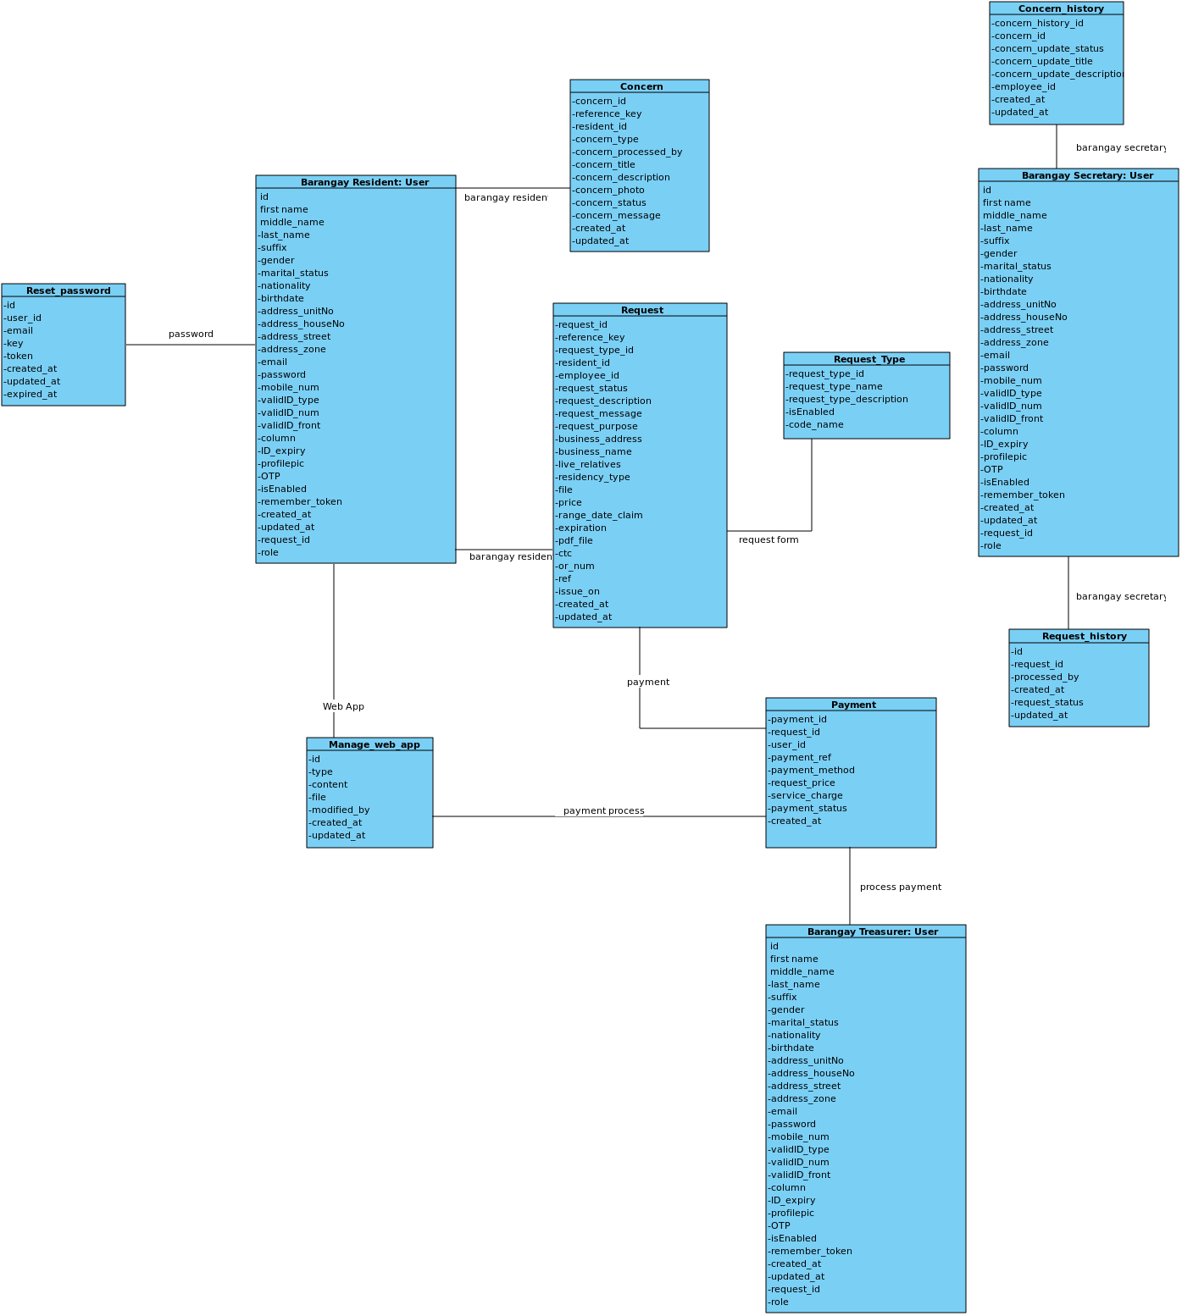

Fig. 16 Object Diagram

### Class Diagrams

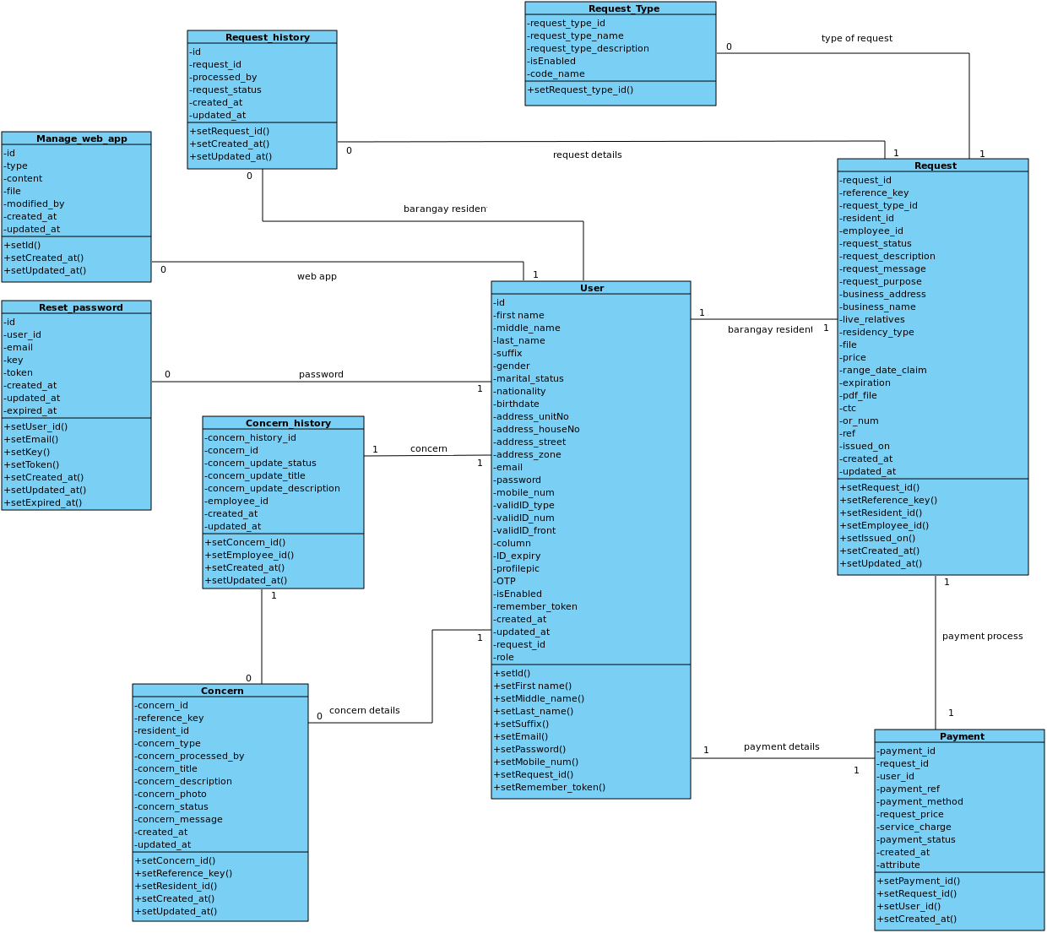

Fig. 17 Class Diagram

### Sequence Diagrams

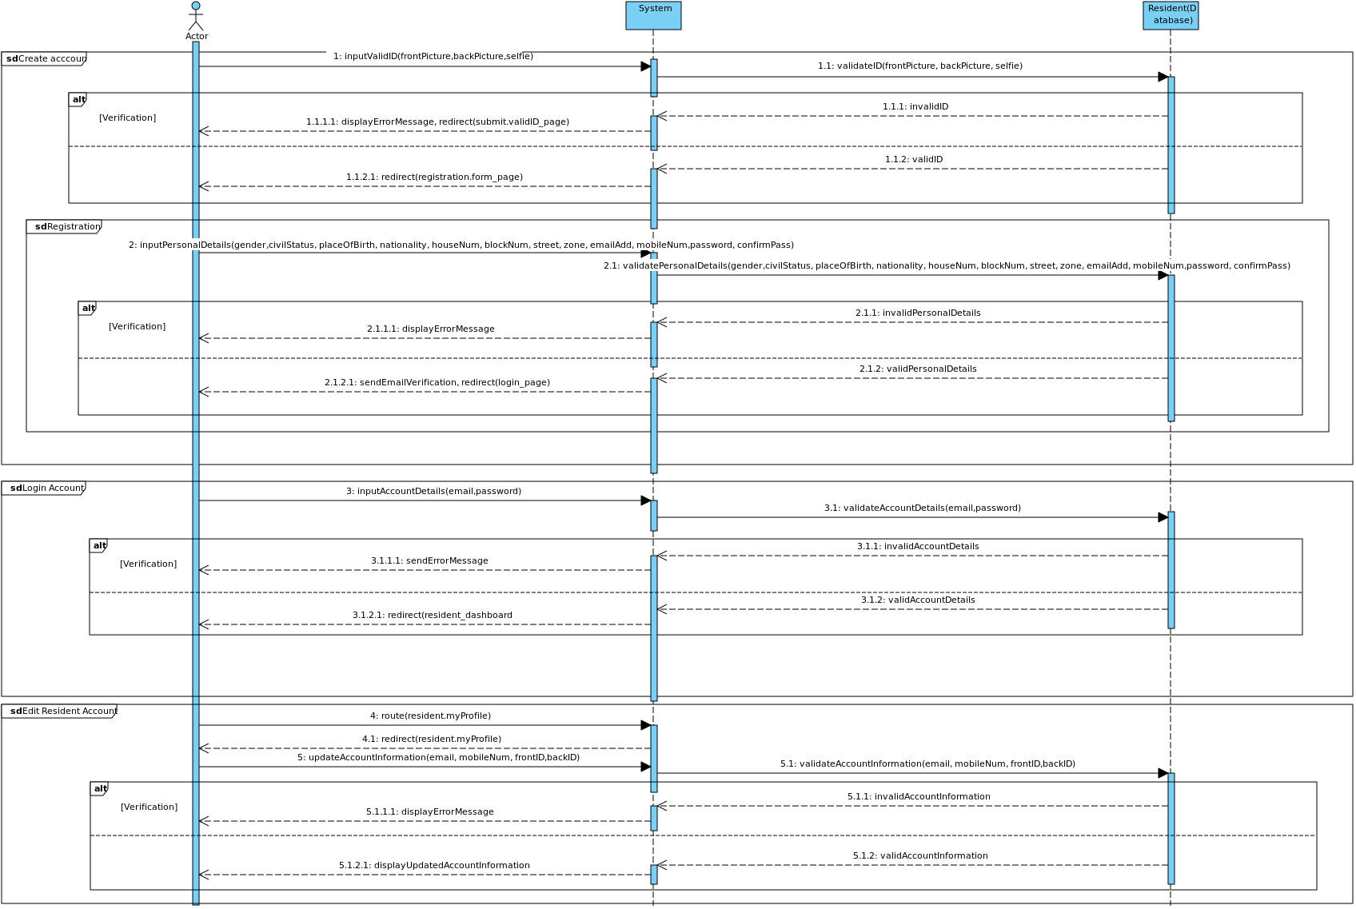

Fig. 18 Sequence Diagram: Manage Resident Account

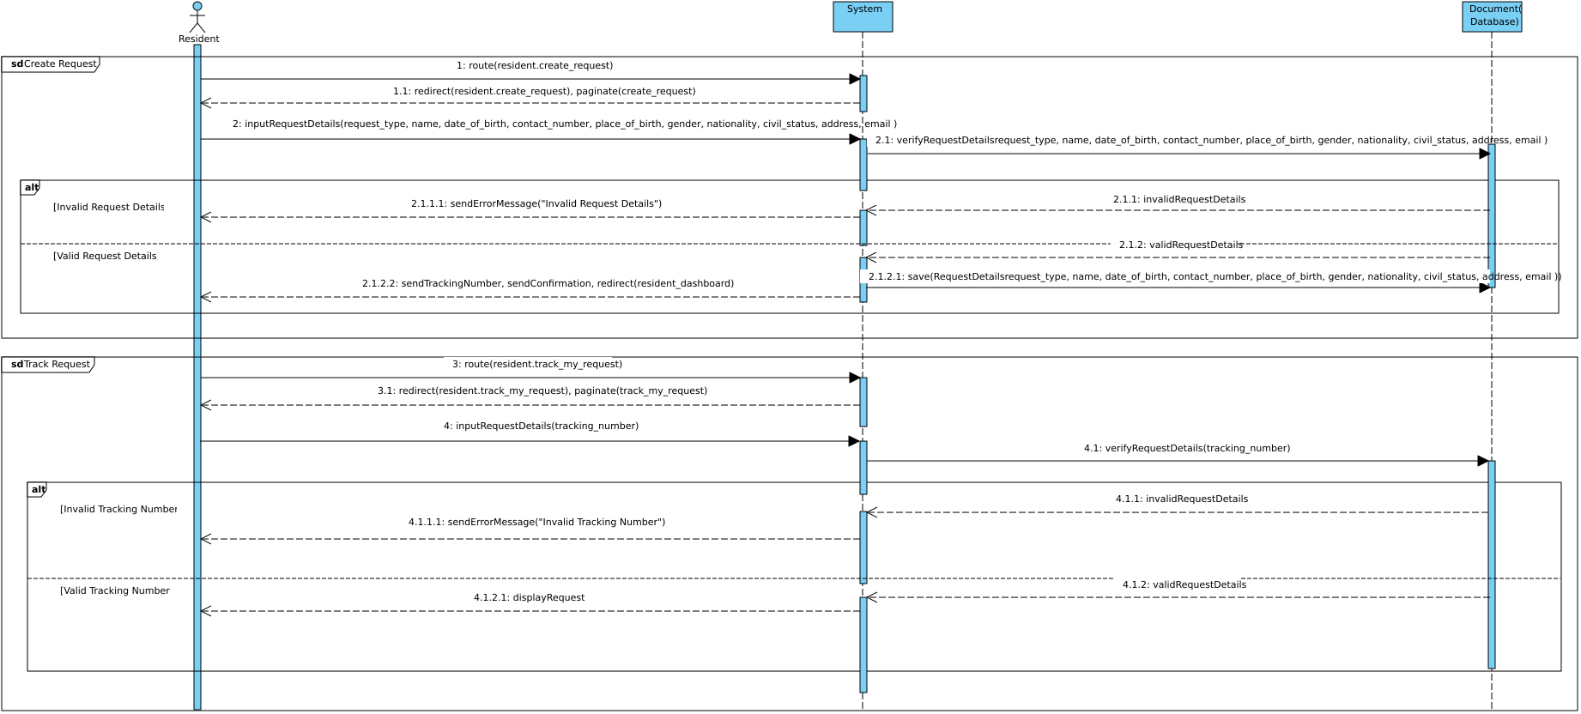

Fig. 19 Sequence Diagram: Manage Request

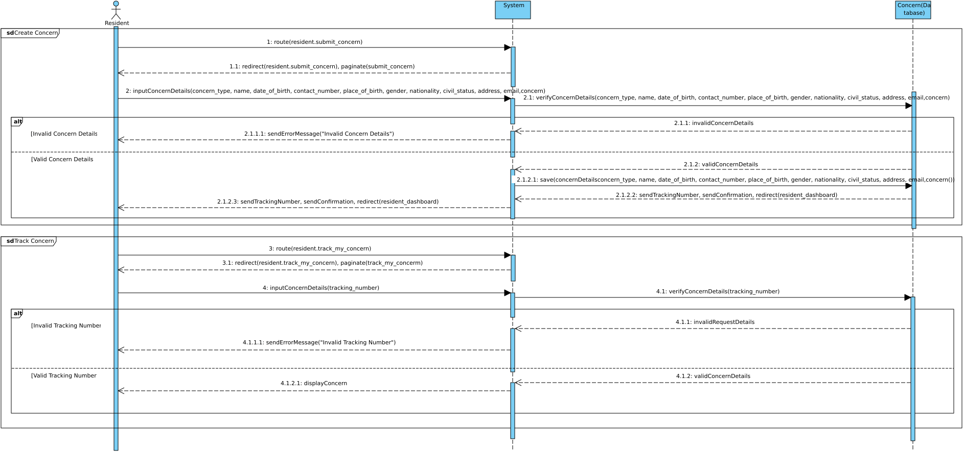

Fig. 20 Sequence Diagram: Manage Concern

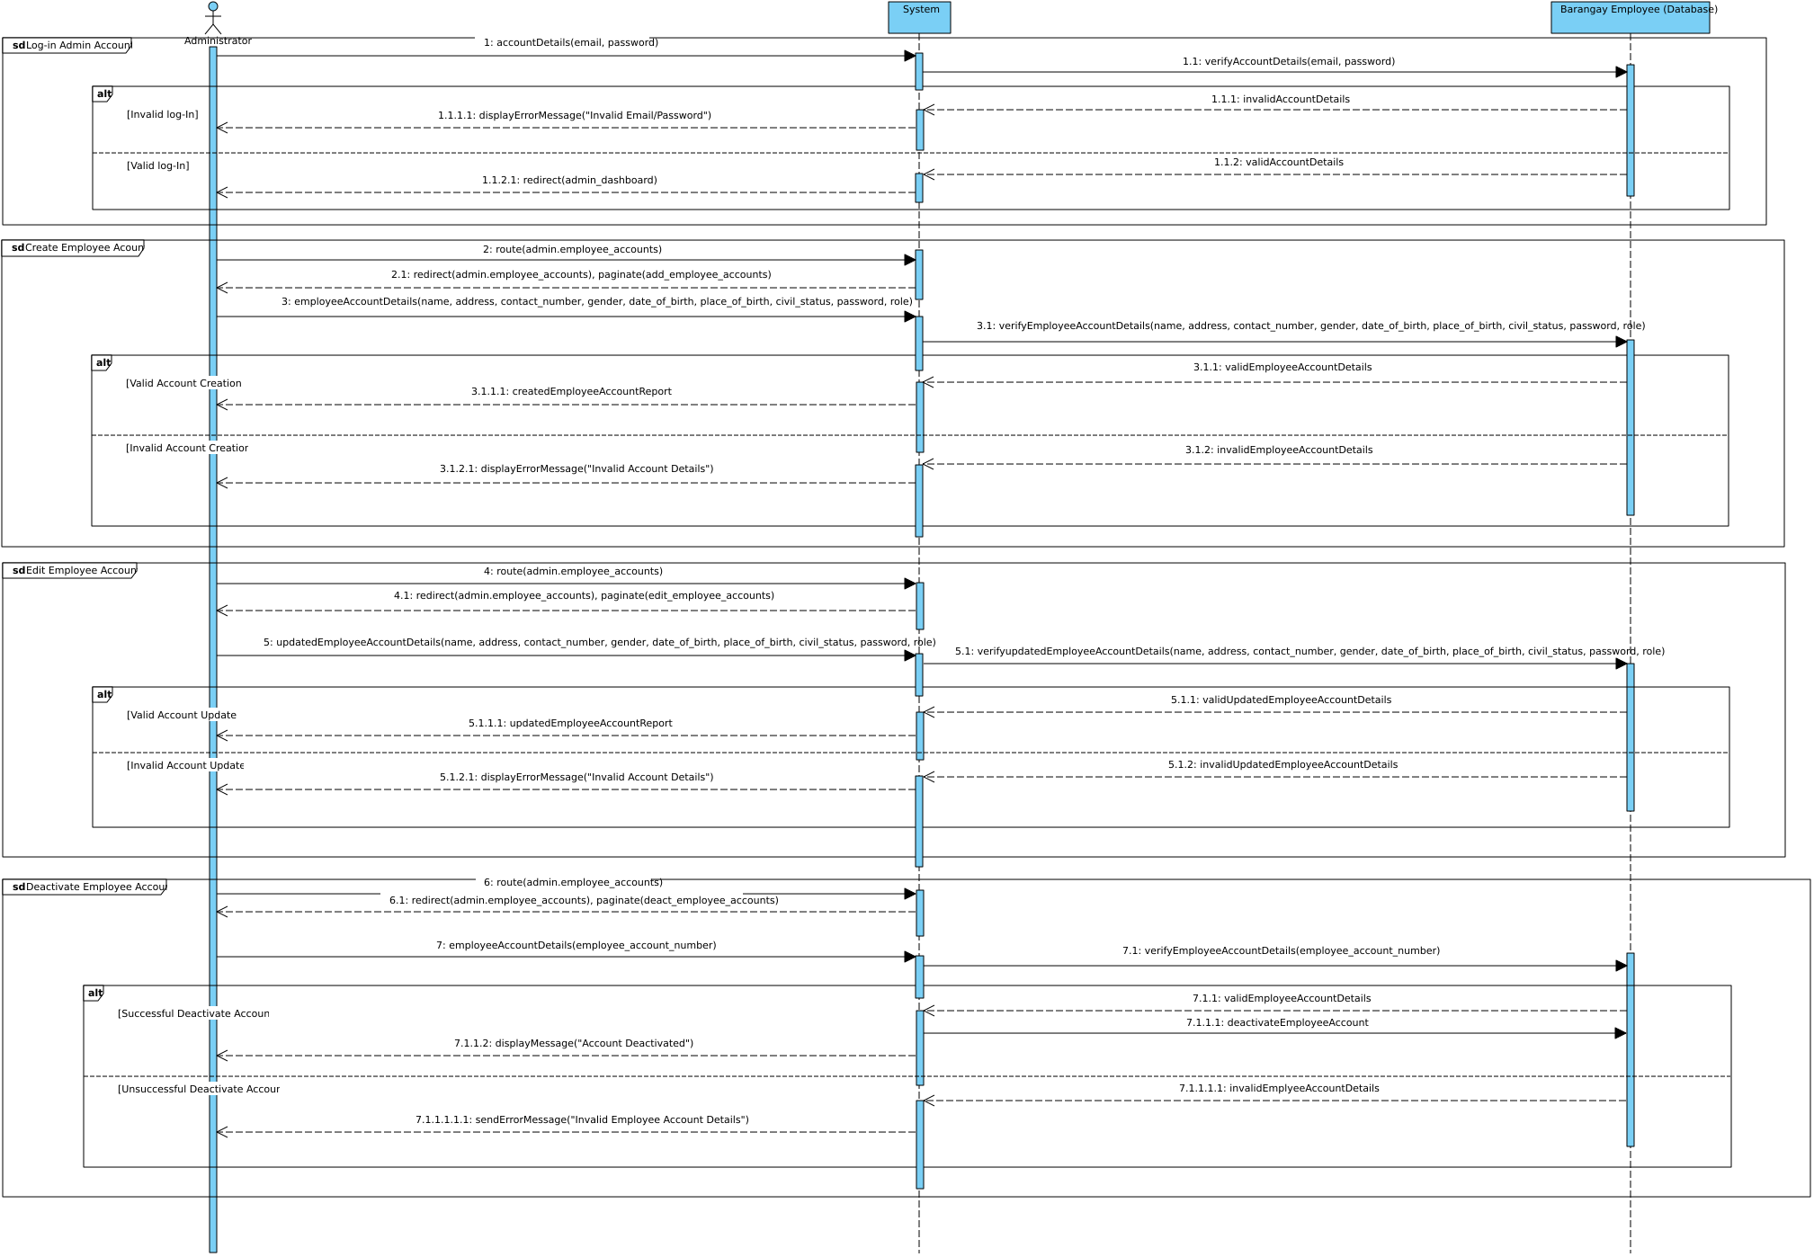

Fig. 21 Sequence Diagram: Manage Barangay Employee Accounts

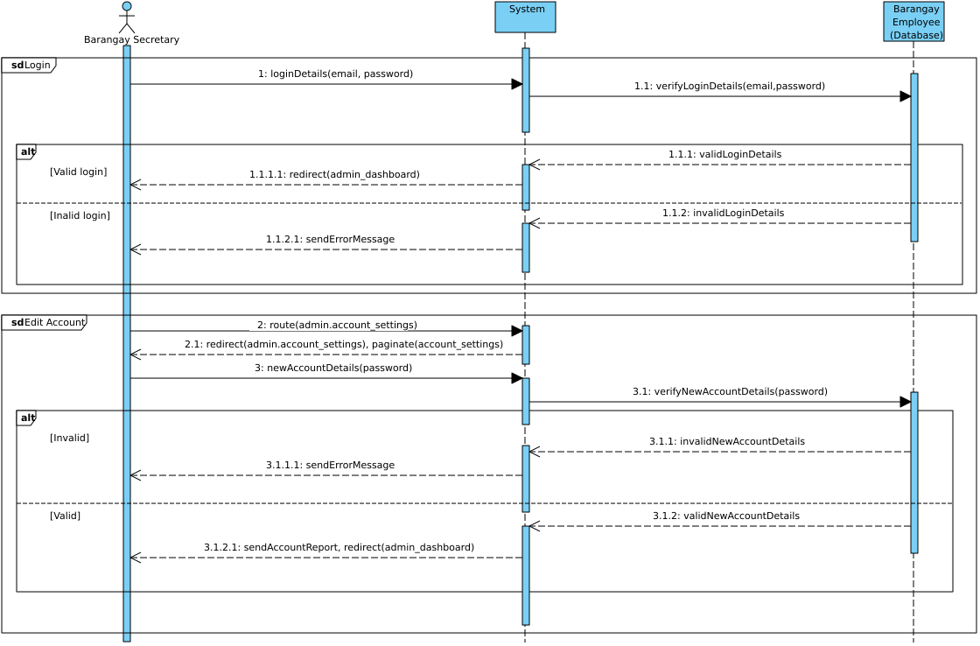

Fig. 22 Sequence Diagram: Manage Barangay Secretary Account

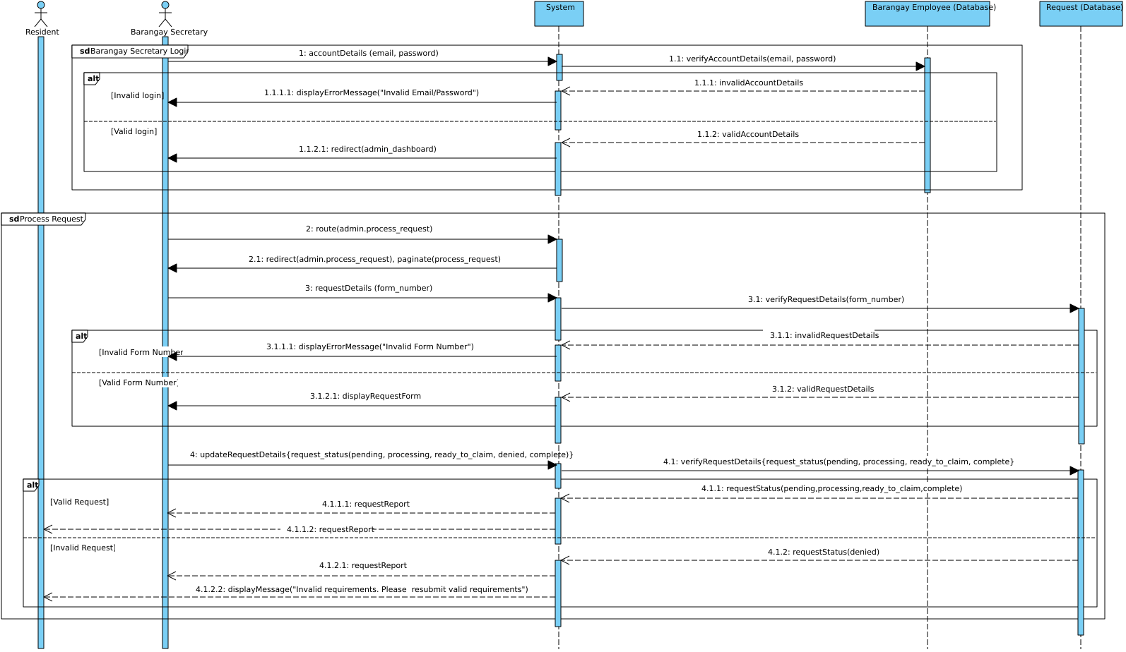

Fig. 23 Sequence Diagram: Process Request

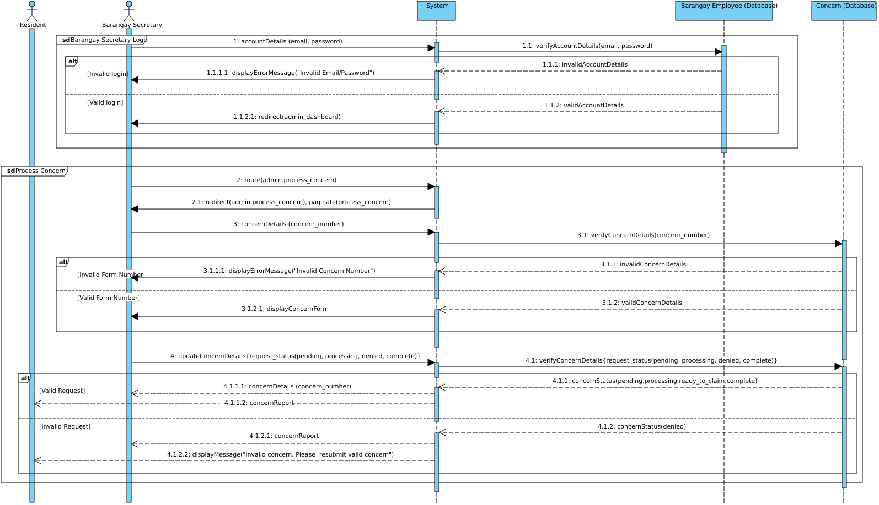

Fig. 24 Sequence Diagram: Process Concern

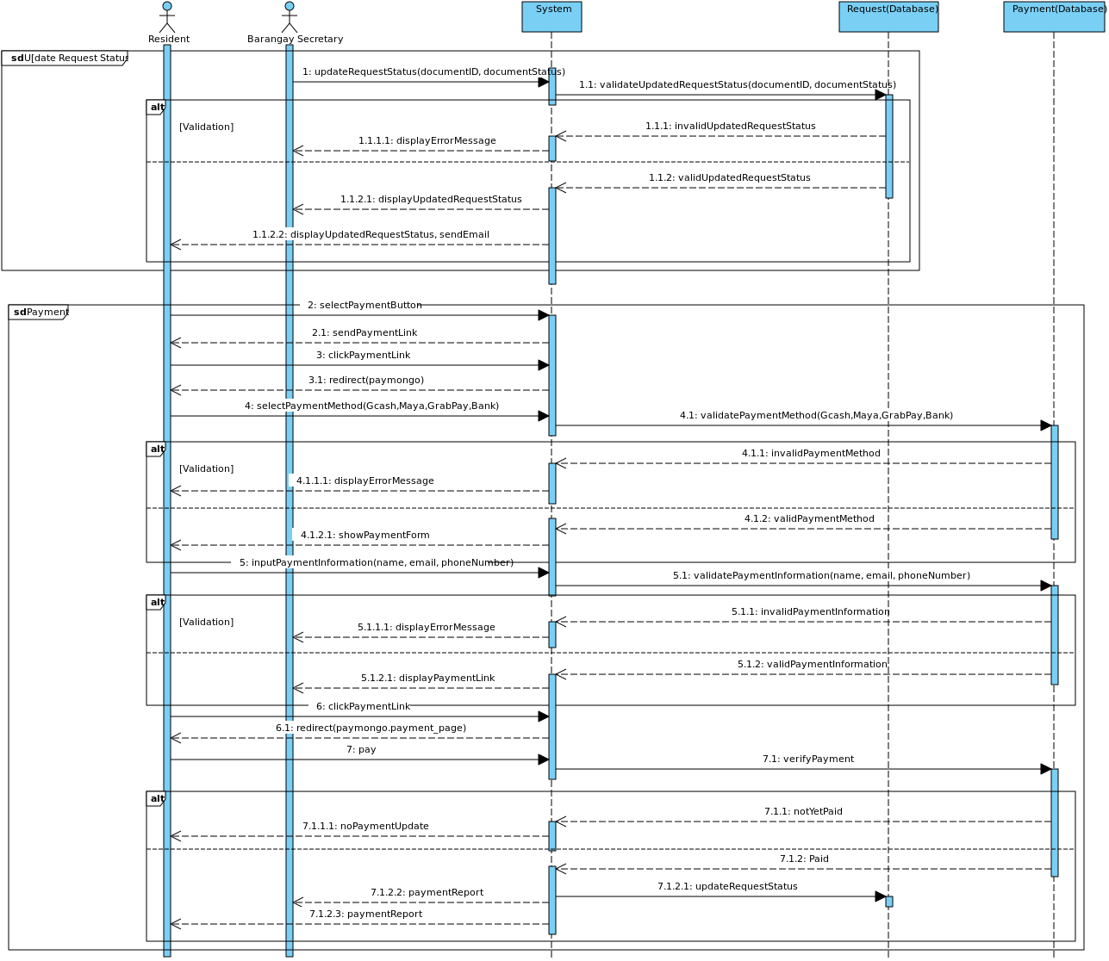

Fig. 25 Sequence Diagram: Online Payment

### State Diagram

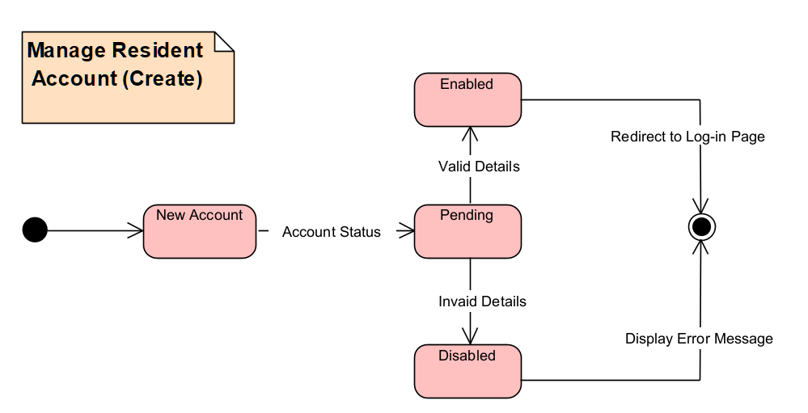

Fig. 26 State Machine Diagram: Manage Resident Account (Create)

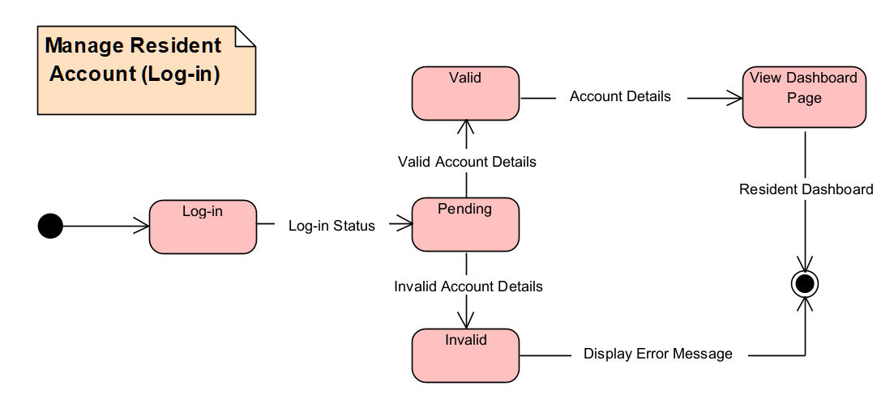

Fig. 27 State Machine Diagram: Manage Resident Account (Log-in)

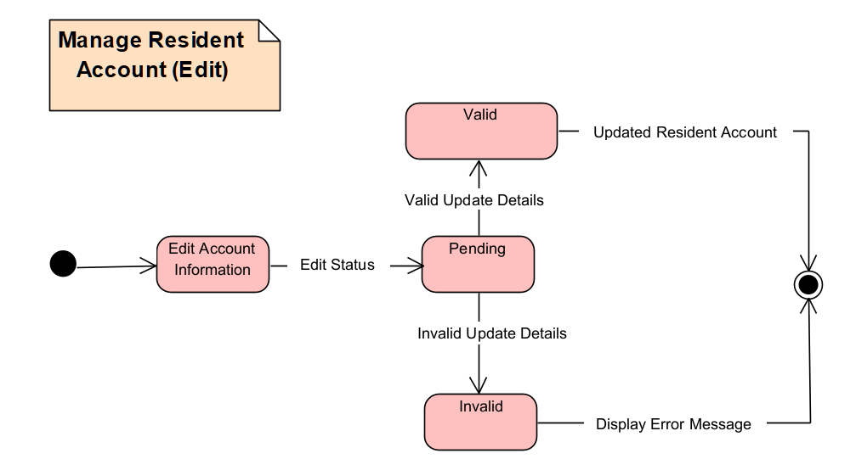

Fig. 28 State Machine Diagram: Manage Resident Account (Edit)

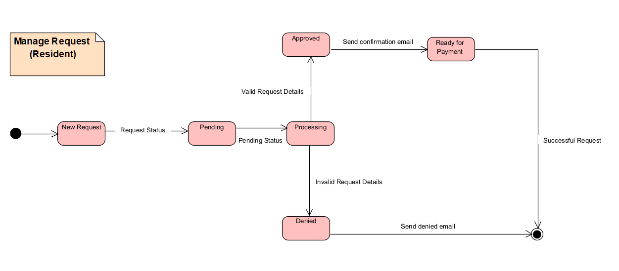

Fig. 29 State Machine Diagram: Manage Request

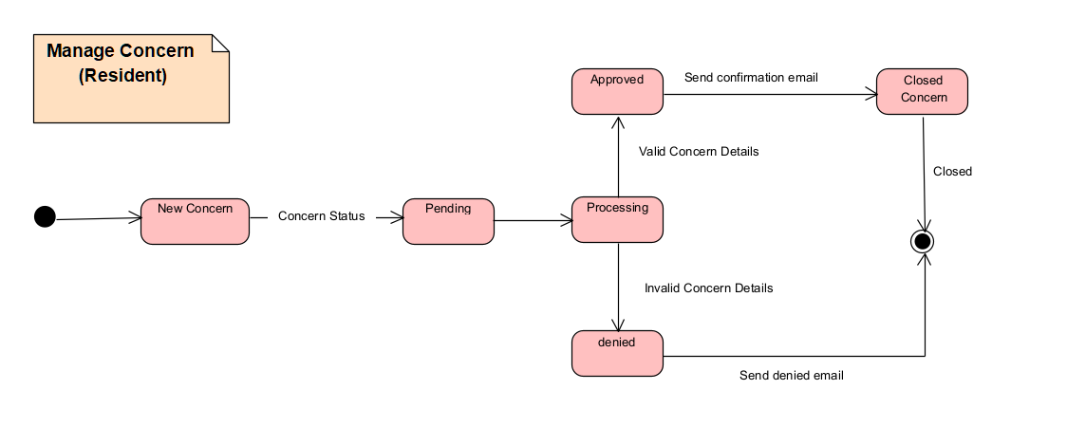

Fig. 30 State Machine Diagram: Manage Concern

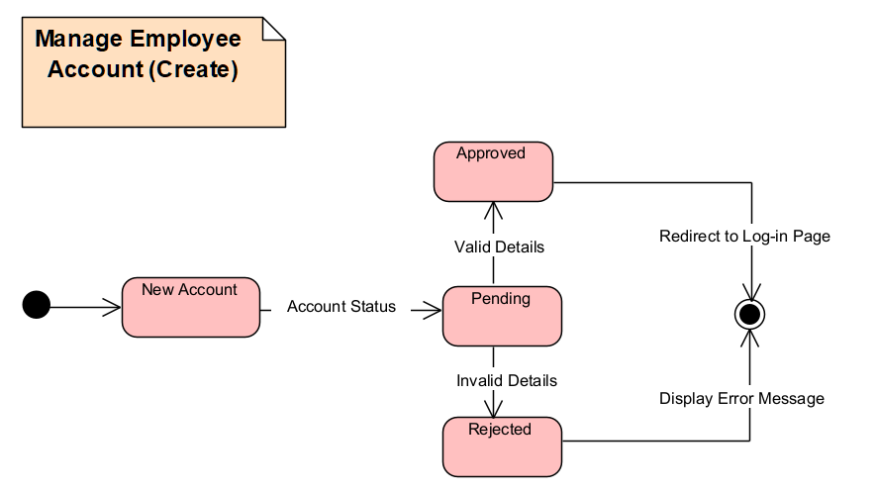

Fig. 31 State Machine Diagram: Manage Employee Account

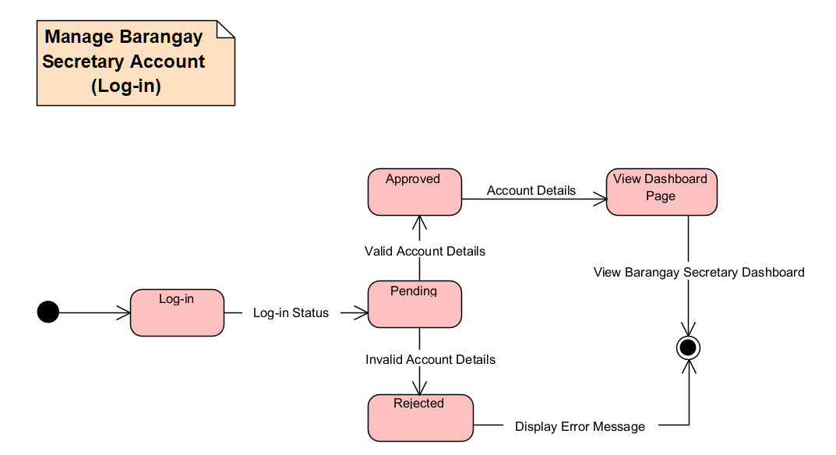

Fig. 32 State Machine Diagram: Manage Barangay Secretary Account.

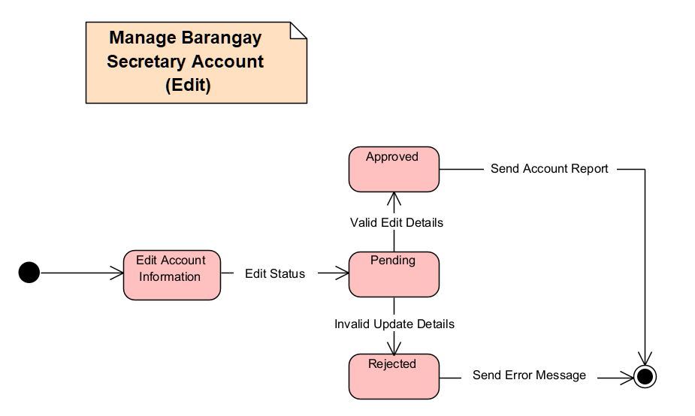

Fig. 33 State Machine Diagram: Manage Barangay Secretary Account Edit

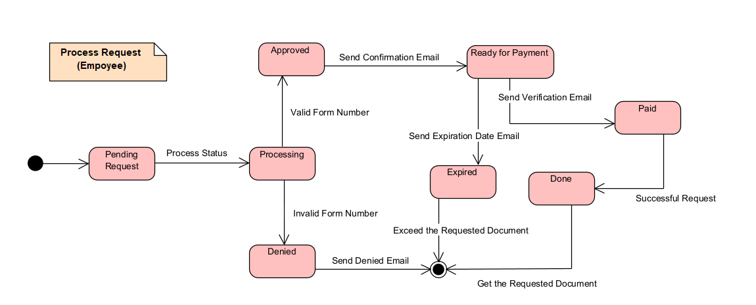

Fig. 34 State Machine Diagram: Process Request

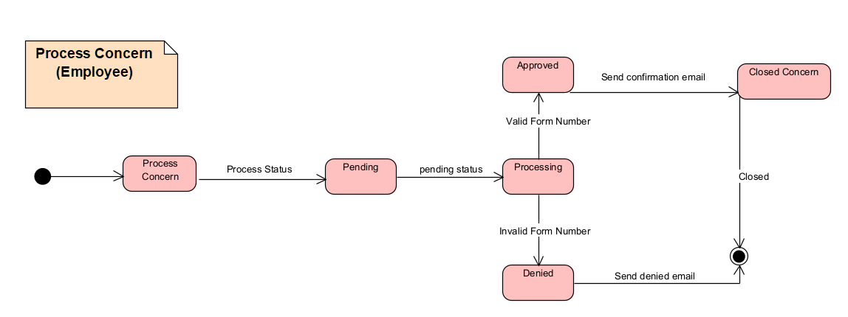

Fig. 35 State Machine Diagram: Process Concern

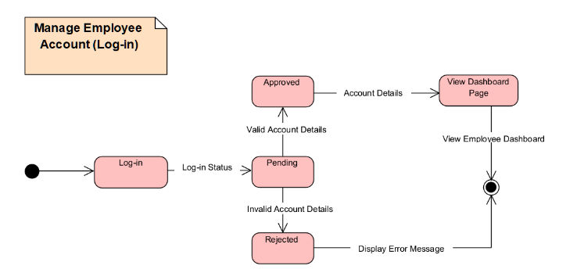

Fig. 36 State Machine Diagram: Manage Employee Account (Log-in)

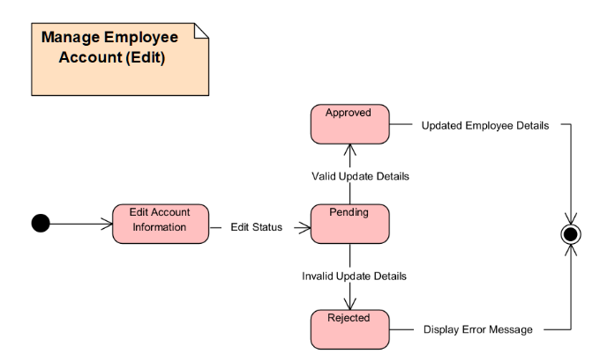

Fig. 37 State Machine Diagram: Manage Employee Account (Edit)

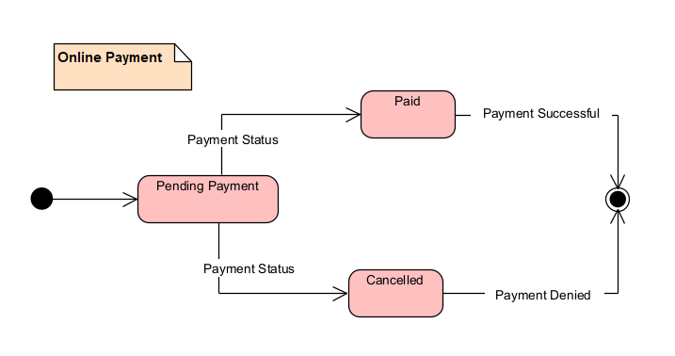

Fig. 38 Online Payment

### Use Case Package Diagram

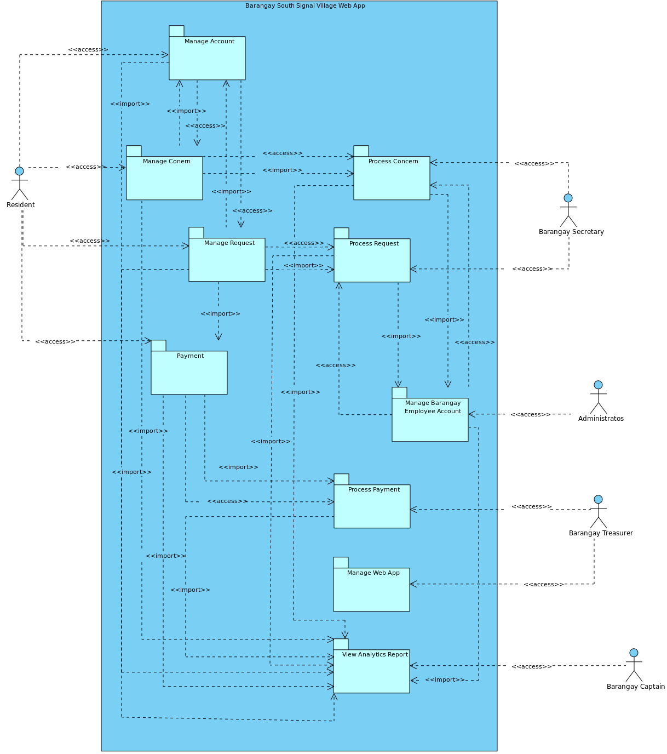

Fig. 39 Use Case Package Diagram

### Component Diagram

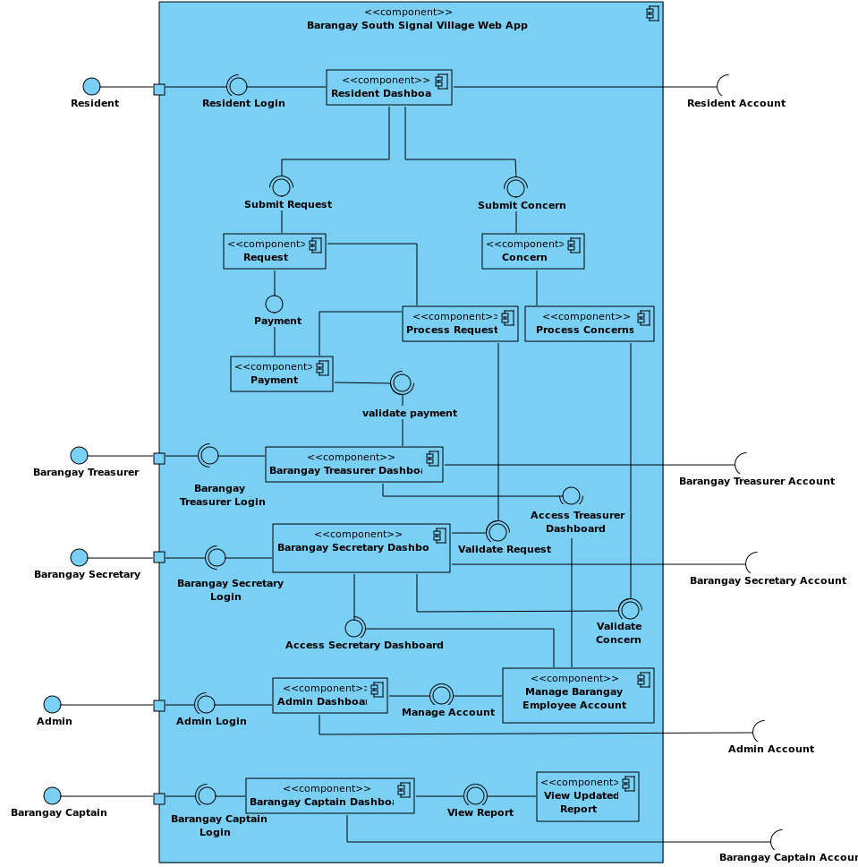

Fig. 40 Component Diagram

### Deployment Diagram

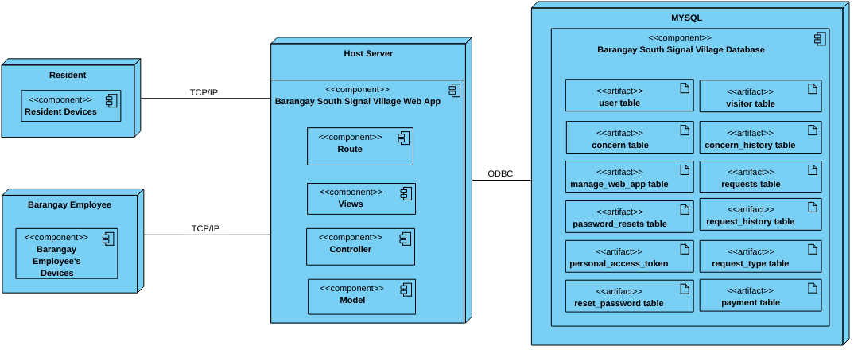

Fig. 41 Deployment Diagram

# Results and Discussion

This chapter will discuss what the team has accomplished so far. This chapter contains the progress and changes the team achieved and the plan and list of objectives that they will do next.

## Release Plan

**RELEASE 1**

* Residents can visit the website and view the home page, contact page, safety section page, and about us page.
* Residents can register on the web app.
* Residents can access their resident profile by logging in using email and password.
* Residents can edit the resident dashboard with his/her address, email, mobile number, and password.
* Administrators can add, view, and edit Barangay Employee accounts (Barangay Secretary, Barangay Request Manager, Barangay Concern Manager, and Barangay Captain).
* Barangay Employees (Barangay Secretary, Barangay Request Manager, Barangay Concern Manager, Administrator and Barangay Captain) can access their dashboard by logging in using email and password.

**RELEASE 2**

* Residents can request documents on their resident profile.
* Residents can receive tracking keys through email or text.
* Residents can track the status of their requests.
* The Barangay Secretary and Barangay Request Manager can receive document requests.
* The Barangay Secretary and Barangay Request Manager can view document requests.
* The Barangay Secretary and Barangay Request Manager can change the status (approved or denied) of the document requests.
* The Barangay Secretary can input the information into the database on their dashboard of all requested barangay documents done manually.

**RELEASE 3**

* Residents can submit concerns on their resident profile.
* Residents can receive notification about the submitted concerns.
* Residents can track the status of their submitted concerns.
* Barangay Secretary and Barangay Concern Manager can receive submitted concerns from the residents.
* The Barangay Secretary and Barangay Concern Manager can view, and process submitted concerns from the residents.
* The Barangay Secretary and Barangay Concern Manager can change the status of submitted concerns from the residents.
* The Barangay Captain can view the report.
* The Administrator can manage the web application.

**RELEASE 4**

* ReCAPTCHA added for login (Resident and Barangay employees).
* ReCAPTCHA added every type of request for residents.
* Integrate ID Analyzer API for registration.
* Added Tagalog translation for privacy notice and terms and conditions.

**RELEASE 5**

* The Barangay Treasurer has a dashboard where they can view all the lists of payments.
* The Barangay Treasurer can process on-site payments.
* The Barangay Treasurer can process online payments.
* Residents can pay online for requested documents.
* The Barangay Secretary can view the lists of paid requests.

## Prototype

1. **Barangay Resident Prototype**

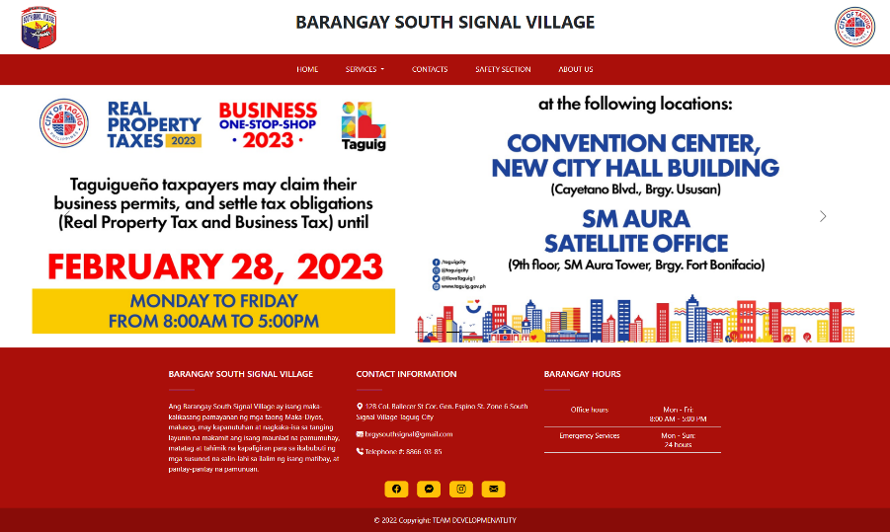

Fig. 42 Home Page

This is the homepage featuring a carousel, a slideshow component that cycles through images of announcements made by the barangay.

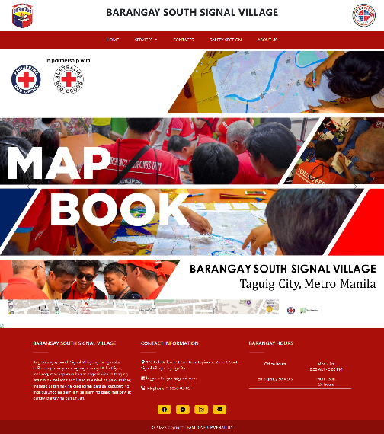

Fig. 43 Safety Section Page

The 'Safety Section' page presents a Red Cross Philippines base map with a legend of barangay infrastructure, a population density map, a vulnerability map, a land use map, a historical hazard map, and a flood hazard map with risk levels.

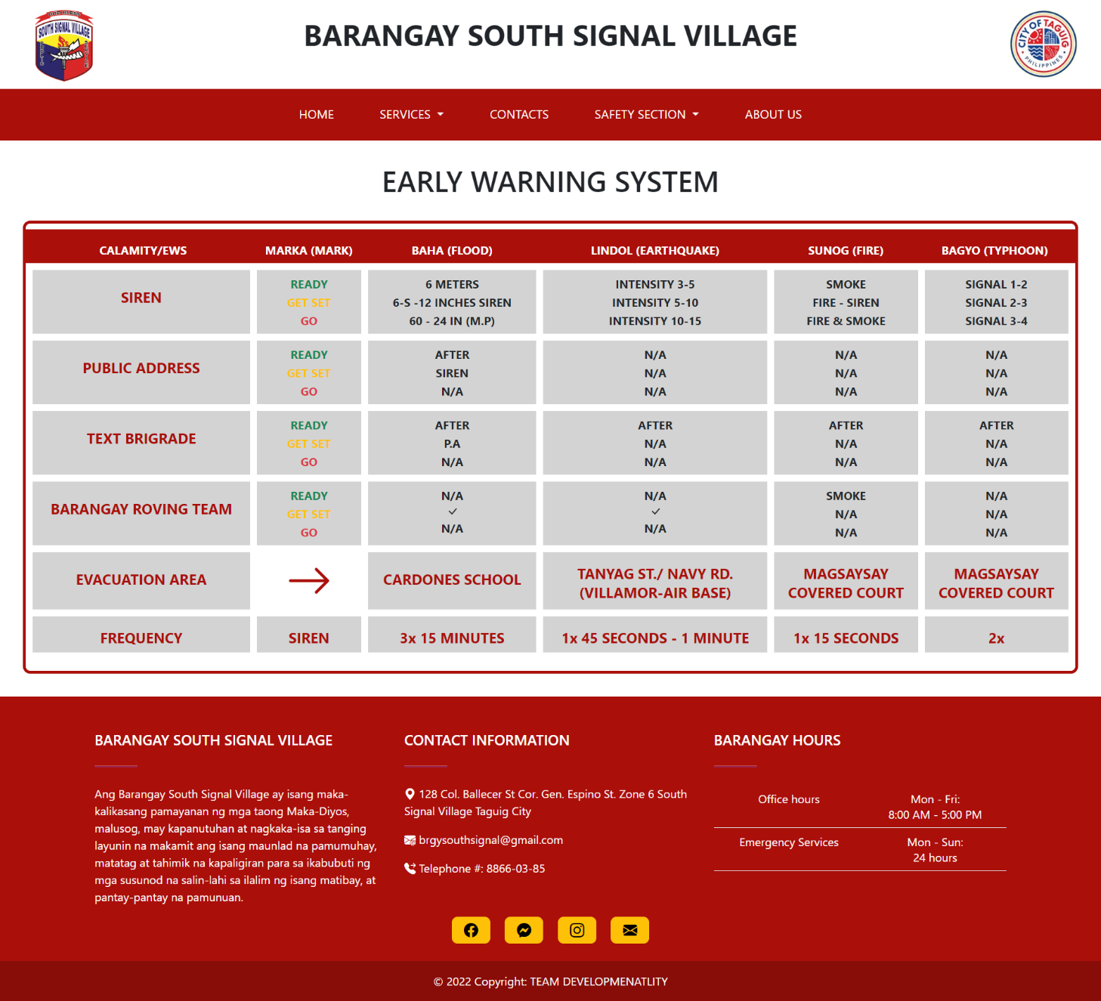

Fig. 44 Safety Protocol

The Safety Protocol Page is your comprehensive tool for overseeing and implementing safety measures. It offers a complete view of all safety protocols, incidents, and updates in your community, so you can ensure everyone's safety with ease.

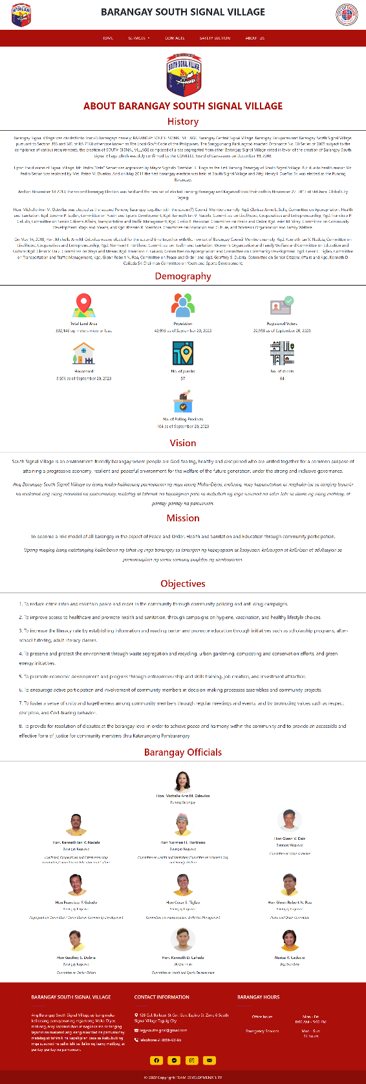

Fig. 45 About Us Page

The 'About Us' page contains the barangay profile, including its history, demographic information, vision, mission, objectives, and a list of the current barangay officials.

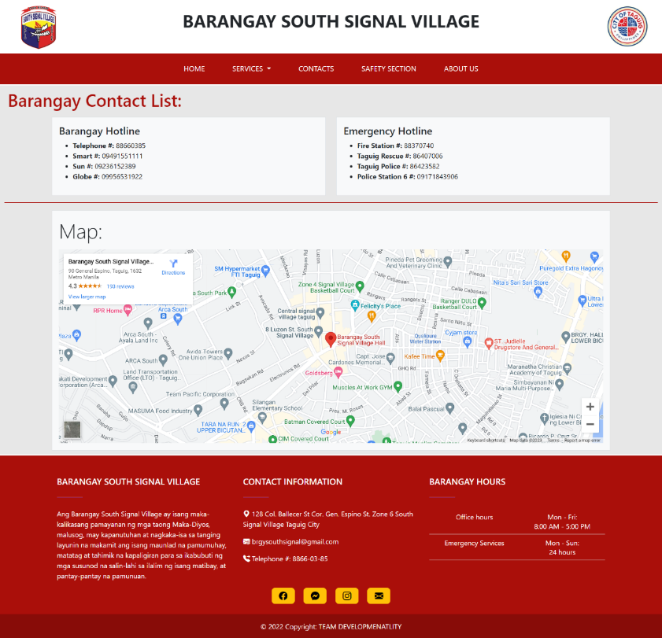

Fig. 46 Contact Page

The 'Contact' page lists various contact information and hotlines for residents to use and includes an embedded map of the barangay’s main office.

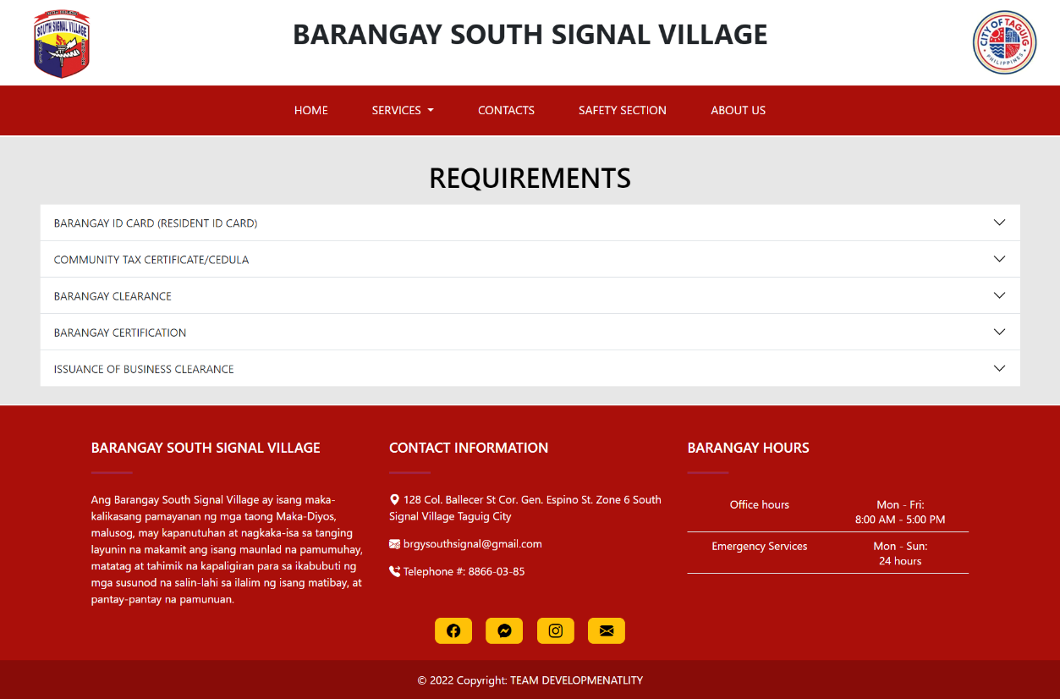

Fig. 47 Requirements Page

The 'Requirements' page displays the various documents available from the barangay, along with information on the fees, the process for obtaining the requirements, and the necessary supporting documents for each requirement.

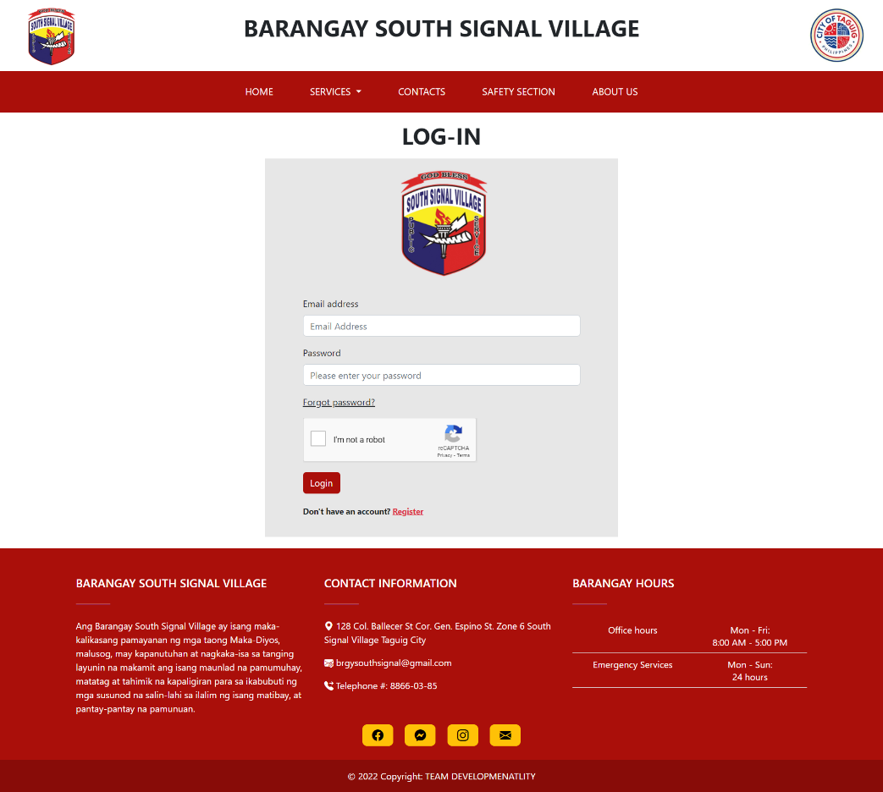

Fig. 48 Login Page

The 'Login' page allows residents with a resident account to securely access their account on the web app by entering their registered email and password.

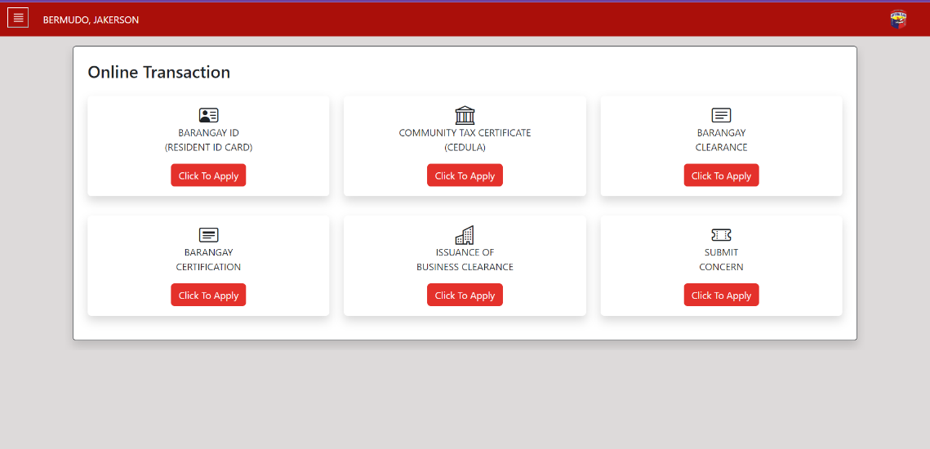

Fig. 49 Resident Dashboard

Upon successful login, the resident is taken to their 'Resident Dashboard' page. This page shows the various online transactions available on the web app for the resident to access.

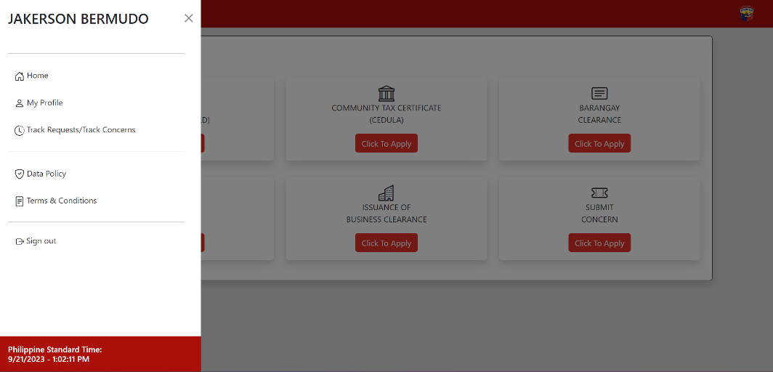

Fig. 50 Resident Dashboard (sidebar)

The sidebar of the resident dashboard features six tabs: Home, Profile, Transaction History, Data Policy, Terms and Conditions, and Sign-out.

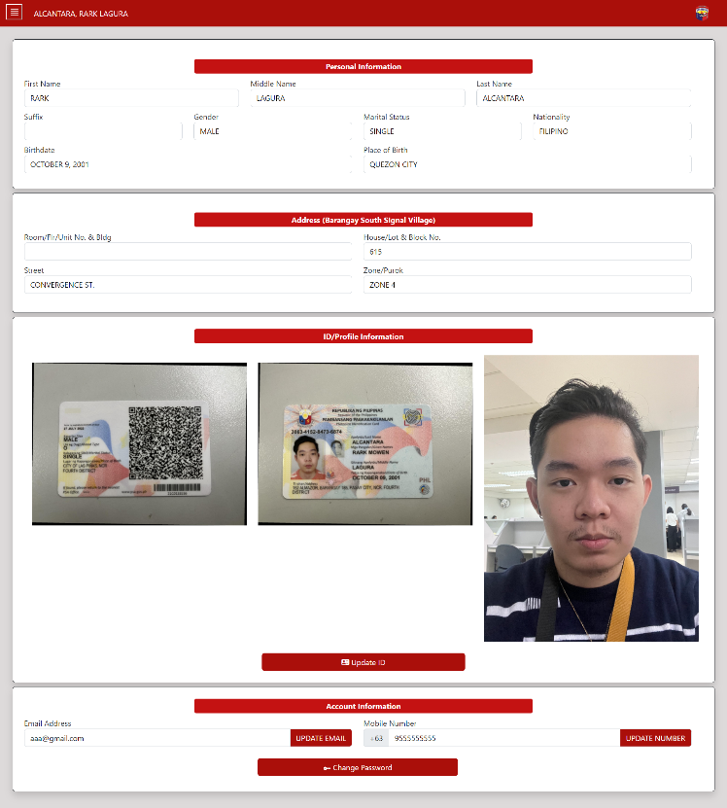

Fig. 51 My Profile Page (Resident Dashboard)

The 'My Profile' tab on the resident dashboard displays the residents’ personal information. The resident can update their valid IDs, email, mobile number, and password.

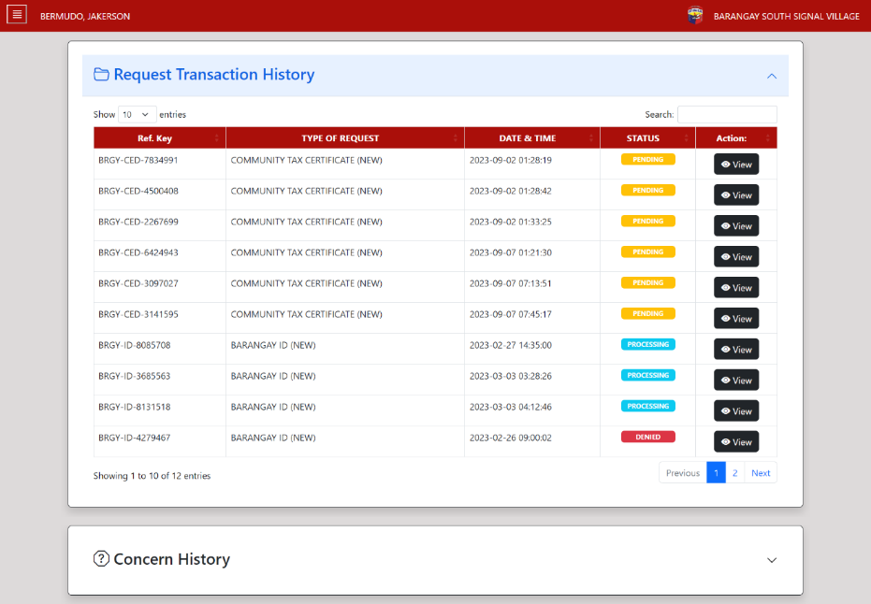

Fig. 52 Transaction Page (Request)

The 'Transaction History' tab on the resident dashboard displays a list of all the transactions that the resident has completed through the web app, including the date, type of transaction, and status.

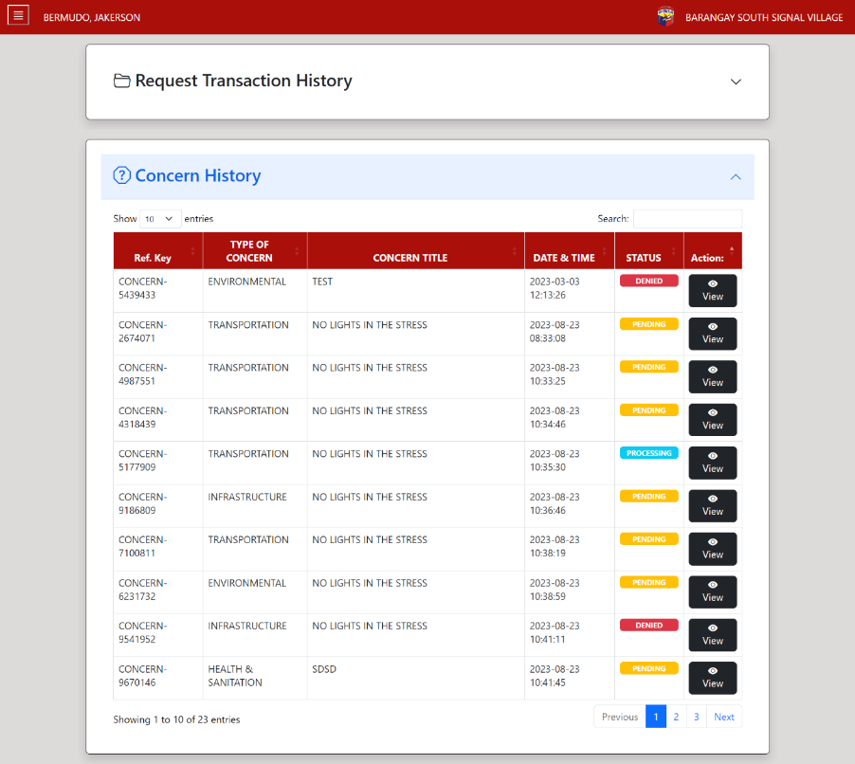

Fig. 53 Transaction Page (Concern)

"Concern History" offers residents a user-friendly platform to report concerns, track their status, and engage with their community.

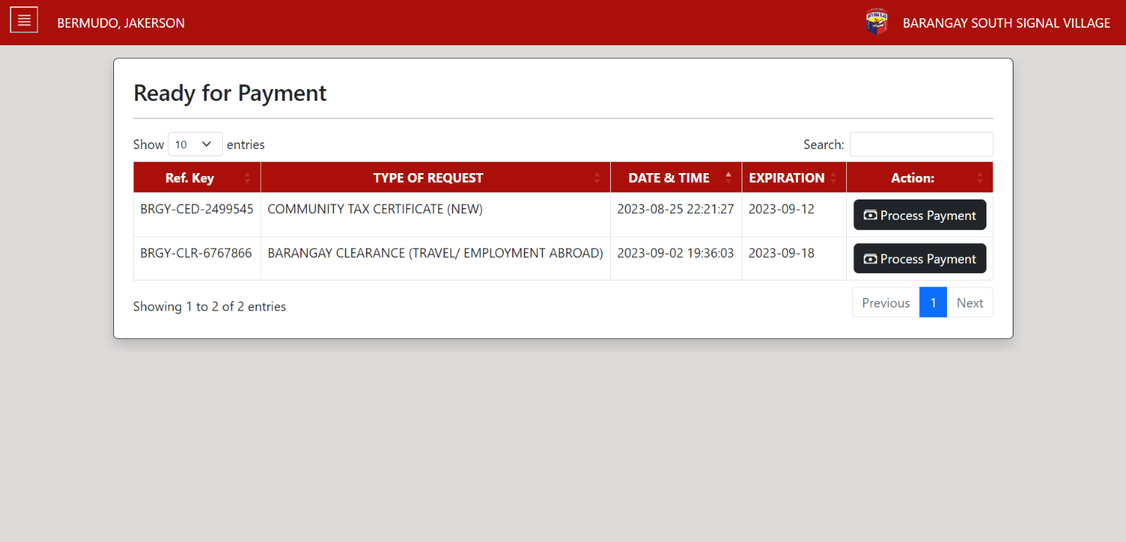

Fig. 54 Payment Page

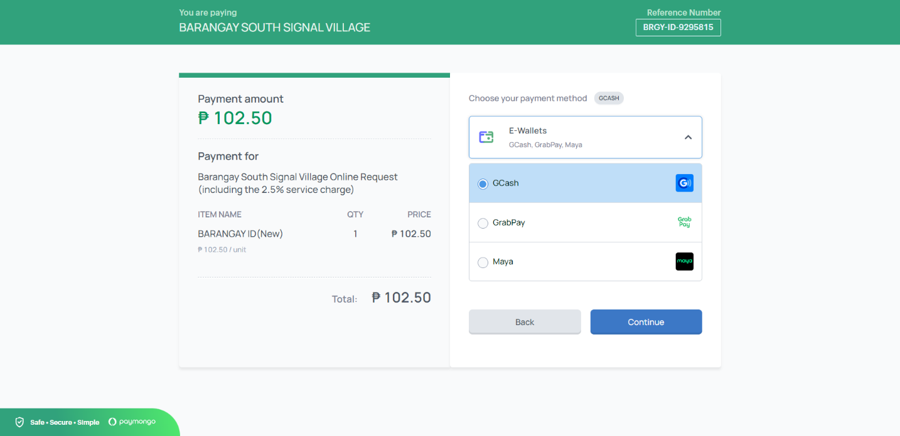

Fig. 55 Paymongo Gateway Interface

"The 'Payment' tab allows residents to view all 'Ready for Payment' requests and also enables them to process payments using the Paymongo gateway, utilizing various eWallets including but not limited to Gcash, Maya, and GrabPay."

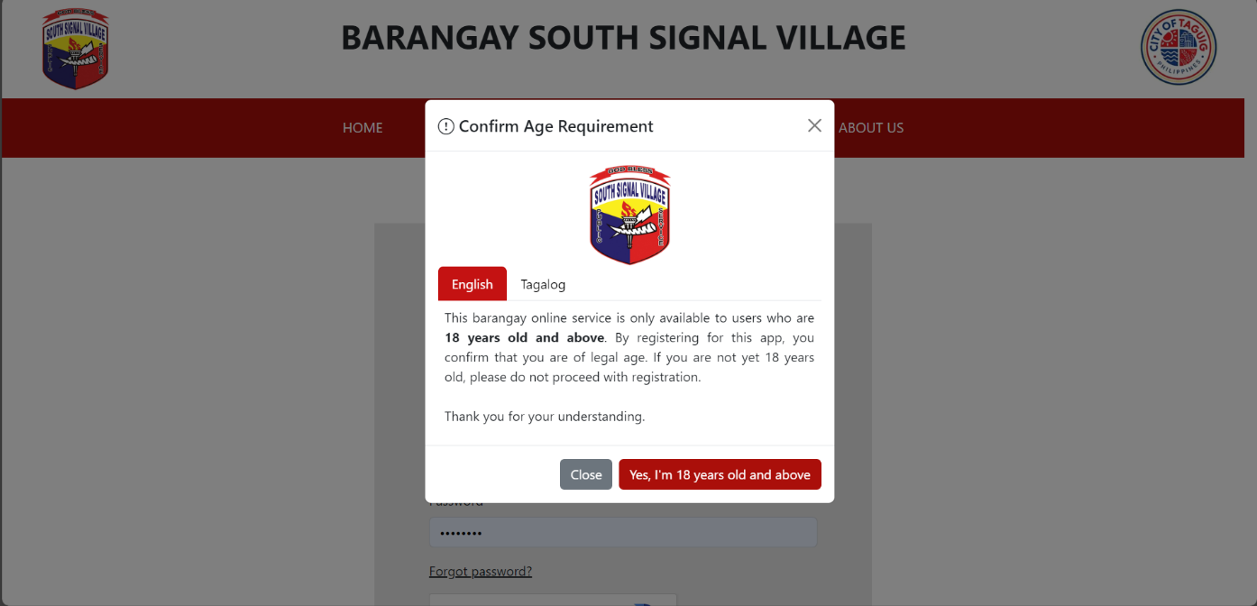

Fig. 56 Confirm Age Requirements Modal

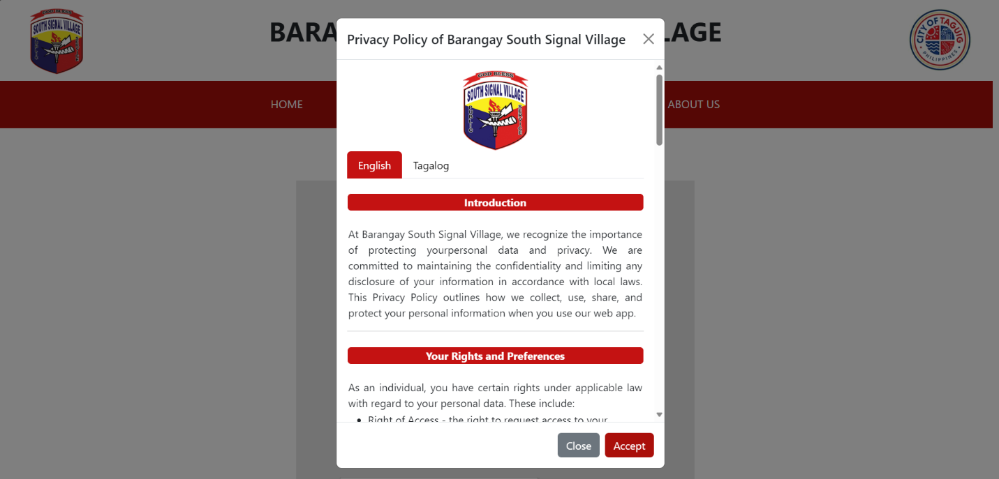

Fig. 57 Privacy Policy Modal

When a user tries to register for the web app, a pop-up window appears that displays the barangay's data privacy policy for resident information collected during the registration process.

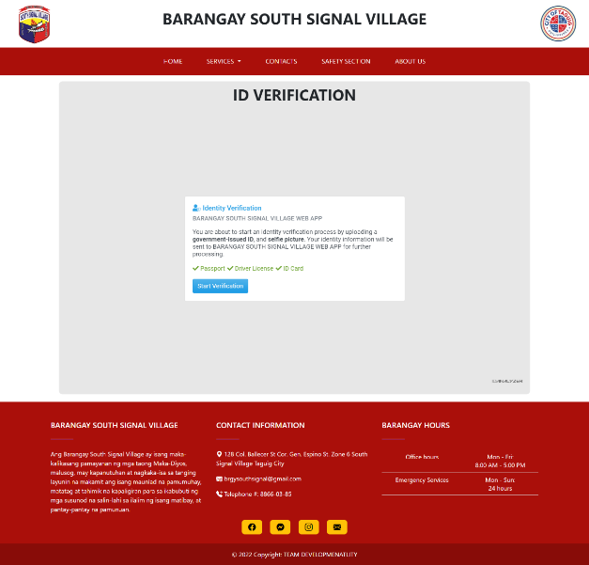

Fig. 58 Registration Page (Id Analyzer)

The registration process will display the ID verification to create a resident account on the web app. Residents must upload both the front and back of their ID, as well as a selfie photo.

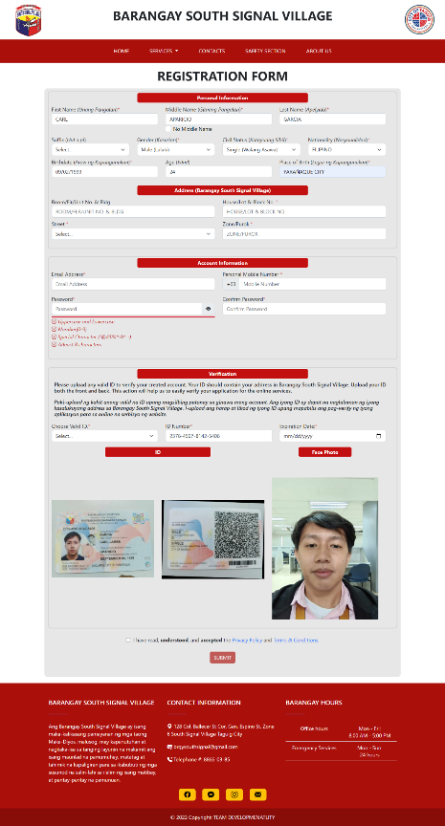

Fig. 59 Registration Page

The 'Registration' page is a form for residents to create a resident account on the web app. Residents provide personal information, addresses, account details, and upload valid identification for verification.

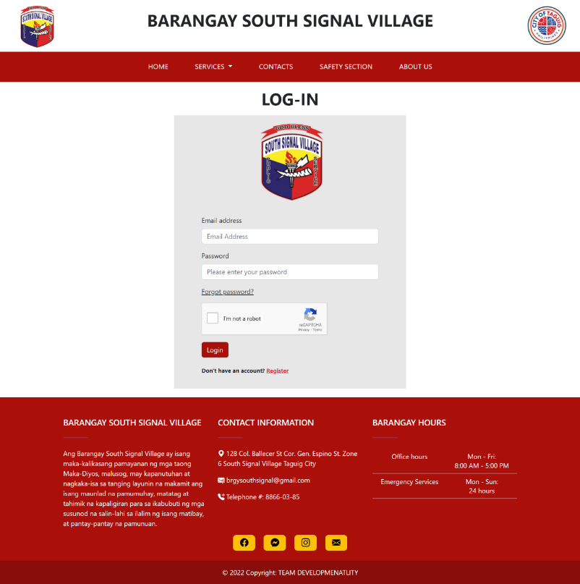

Fig. 60 Login Page

The 'Login' page allows residents with a resident account to securely access their account on the web app by entering their registered email and password.

1. **Barangay Employee Prototype**

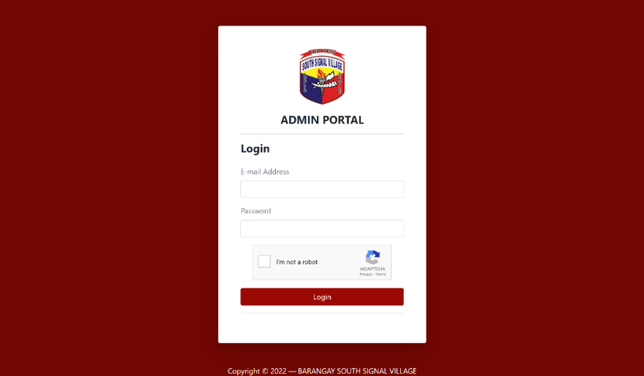

Fig. 61 Admin Portal Login Page

The admin portal is a separate login page specifically for Barangay Employees of the web app, allowing them to access and manage different functions and information within the web app.

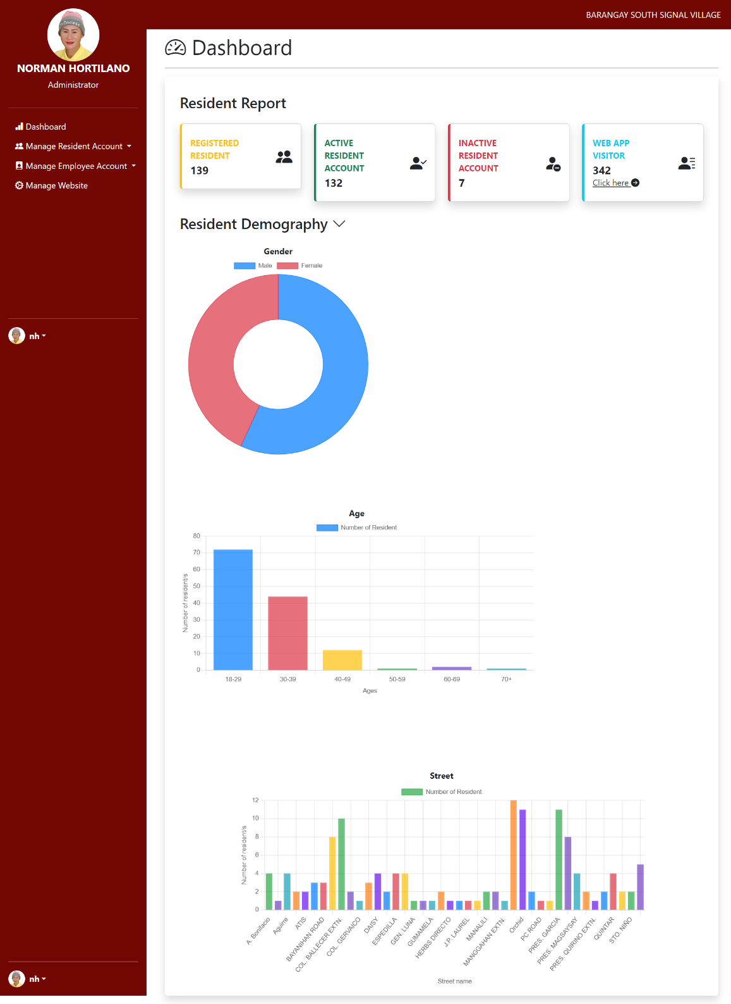

Fig. 62 Administrator Dashboard page

The Administrator Dashboard page is where the administrator can manage the barangay employees by adding, deactivating, and assigning roles to them. Additionally, the administrator can also manage the web app, including editing the carousel announcements on the home page, updating the information about the barangay officials on the 'About Us' page, and updating the barangay's demography.

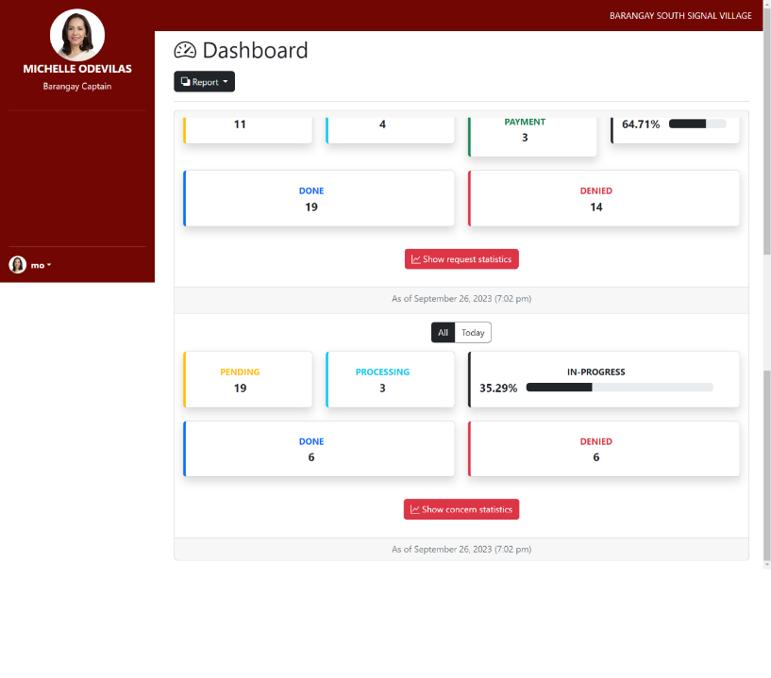

Fig. 63 Barangay Captain Dashboard

The Barangay Captain Dashboard provides a comprehensive view of the web app's report, lists of residents, employees, and requests, allowing the Barangay Captain to oversee all transactions within the web app.

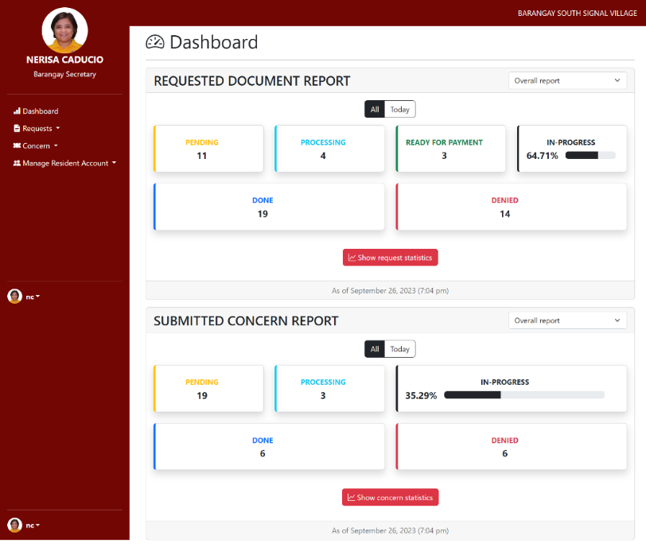

Fig. 64 Barangay Secretary Dashboard

The Barangay Secretary Dashboard allows the Barangay Secretary to handle and process requests and concerns from residents in the web app and have a comprehensive overview of all residents’ accounts.

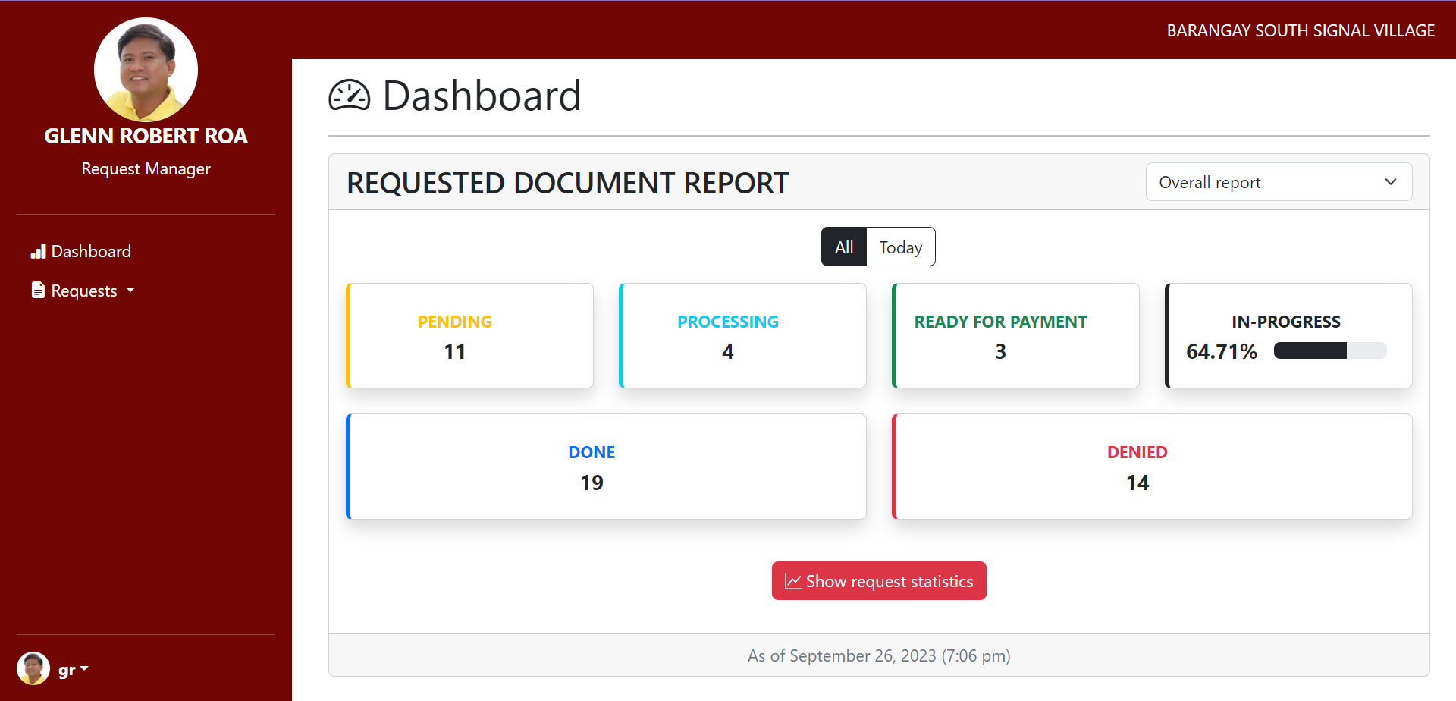

Fig. 65 Request Manager Dashboard Page

The Request Manager Dashboard allows the Barangay Request Manager to handle and process requests from residents in the web app.

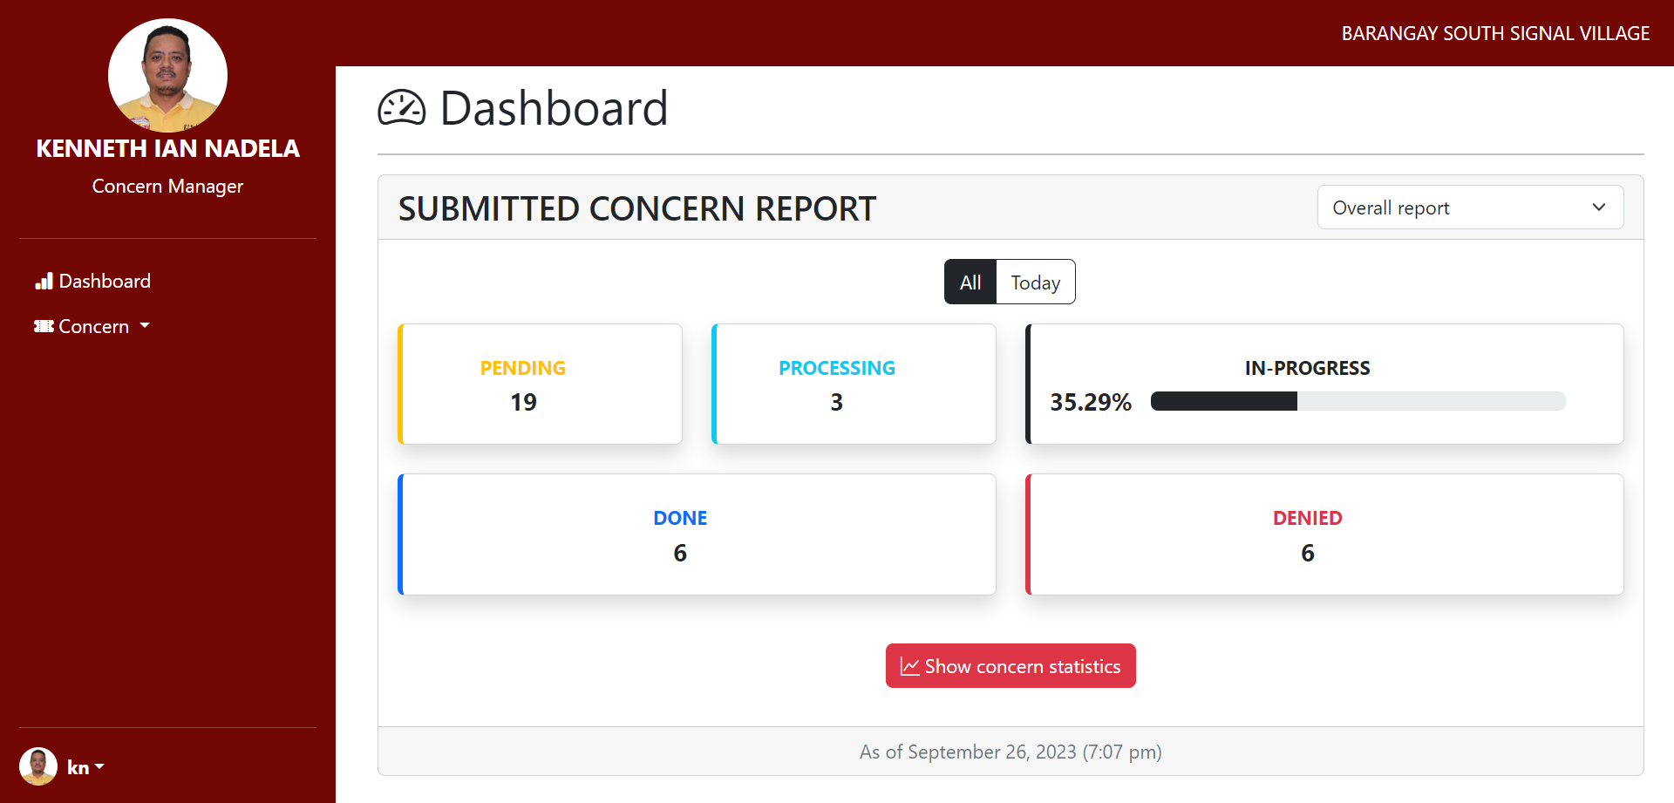

Fig. 66 Concern Manager Dashboard Page

The Concern Manager Dashboard allows the Barangay Concern Manager to handle and process concerns from residents in the web app.

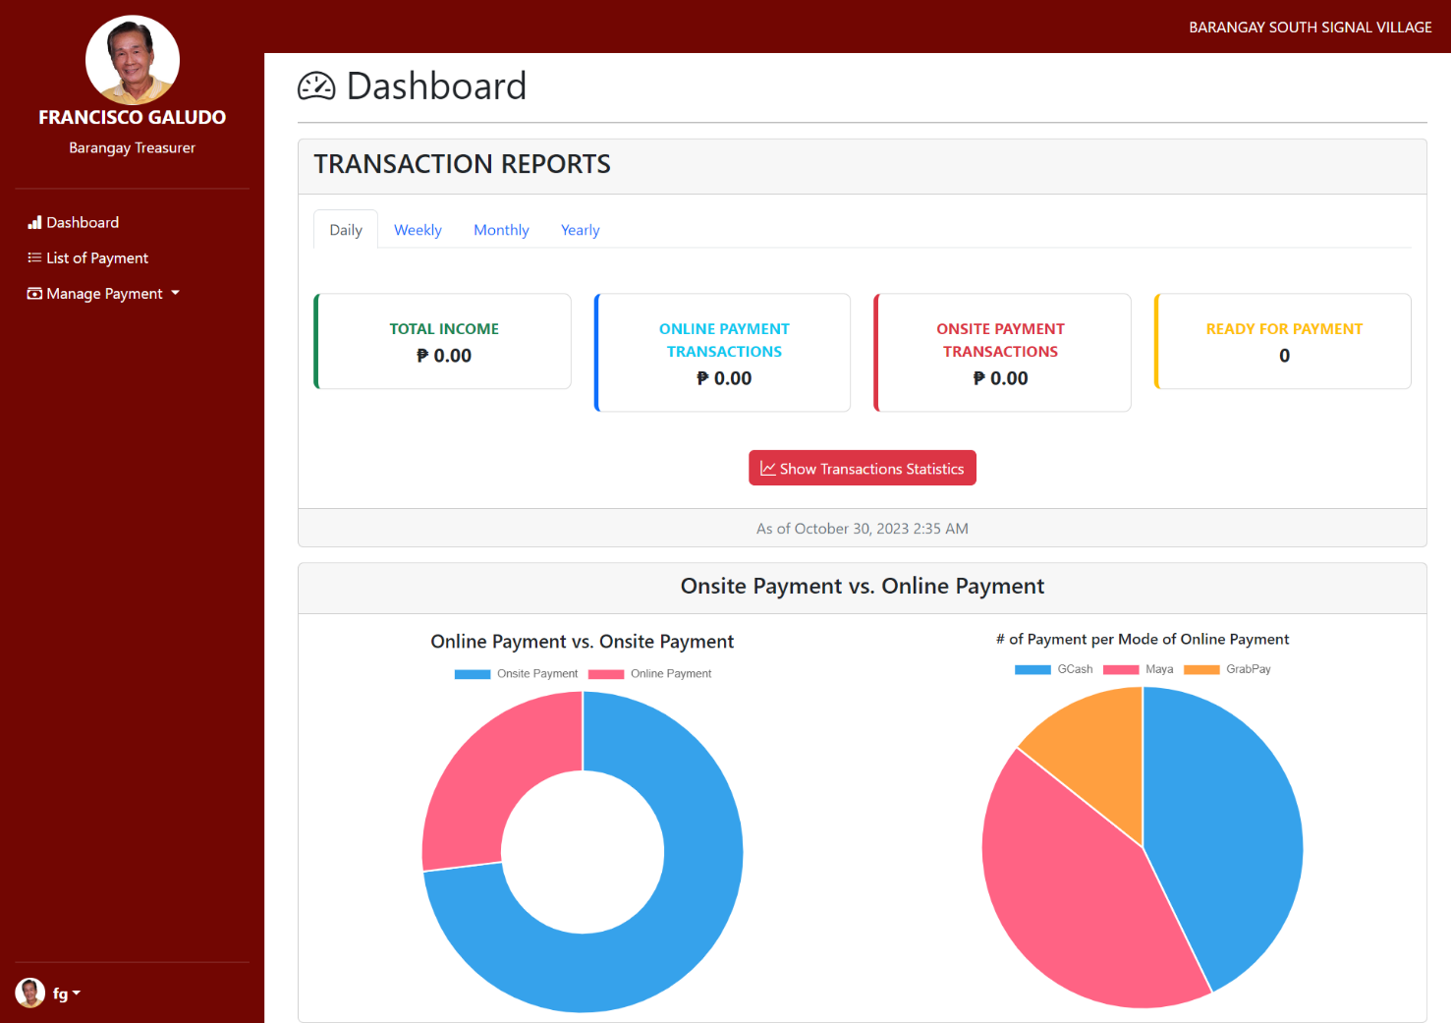

Fig. 67 Barangay Treasurer Dashboard

The Treasurer Dashboard is your all-in-one tool for managing resident payments. It gives you a complete view of all financial transactions in your community, from resident payments to expenses, so you can keep everything in check effortlessly.

## Use Classes and Characteristics

TABLE 36   
USE CLASSES AND CHARACTERISTICS

|  |  |
| --- | --- |
| *Roles* | *Description* |
| *Resident* | * This user is the primary visitor of the web app. * He/she is the one who can access and avail themselves of the services offered by the web app. |
| *Administrator* | * This user has the highest power over the web app. * He/she assigns roles to barangay employees. * He/she manages the web app. |
| *Barangay Secretary* | * This user handles and processes the requests and concerns created by the residents of the barangay. * He/she verifies the requirements given by the residents of the barangay. |
| *Barangay Captain* | * He/she views the report of the web app. |
| *Barangay Treasurer* | * This user confirms the payments of the residents, both online and onsite. * He/she verifies online payments. |
| *Barangay Concern Manager* | * He/she processes and manages the concerns created by the resident. |
| *Barangay Request Manager* | * He/she processes and manages the requests created by the resident. |

# Conclusion

In terms of accomplishments, the team progressed in many things, especially in identifying the web applications product backlog that contains short descriptions of all functionalities desired in the product. The team has also improved in developing the web application prototype and diagrams discussing the proposed system. The team progressed with the following features:

1. **Home/Main Page,** which contains information about the online services offered by the barangay.
2. **Online Document Request Page**, which shows the different documents and services, and the requirements and information about the different documents.
3. **The Data Privacy Notice Popup** informs the user about how and why personal data is being collected from them ​[21]​.
4. **A Generated Reference Key** allows residents to track requests provided after submitting the form.
5. **The Requirement Page** shows the requirements, such as the payment, the process of getting the requirements, and the required documents the user needs to present.
6. **The Barangay Contact List** shows the different lists of contacts and hotlines about the barangay for the residents to use.
7. **The About Us Page** contains information about the barangay profile, specifically its History, Demography, Mission & Vision, and Barangay Officials.
8. **Log-in Page,** wherein the residents can log in with their credentials.
9. **Track Concern/Request Page,** this page can help residents track their requests/concerns by pasting a tracking key that shows a table with five statuses: Pending, Processing, Ready for Payment Denied, and Done.
10. **Dashboard Report,** this page can give the Barangay Captain details of the resident’s accounts and Barangay employee’s accounts.
11. **Resident Personal Account Details,** this page shows the personal information of each resident in the database, which the residents are limited to edit information.
12. **Barangay Employee Details,** this page is handled by the administrator, who can create, edit, and deactivate the Barangay Employee Accounts.
13. **Interactive Map,** this page shows web-based maps with the ability to click, plan, and zoom for more information about the Barangay South Signal Village area.
14. **Manage Concern,** this page can assist the residents regarding their concerns on Barangay South Signal Village.
15. **Administrator Dashboard,** can add, view, and edit Barangay Employee accounts.
16. **Barangay Employee Dashboard,** can edit, manage, and check residents’ accounts.
17. **Resident Dashboard** is where the residents can view information and do their activities.
18. **The Register Page** allows the user to input information and be a Barangay South Signal Village member.
19. **The Log- n Page** allows users to access an application by entering their username and password.

The team has also succeeded in creating diagrams to assist the reader in visualizing the vision for the Barangay South Signal Village Web App:

1. **A Data Flow Diagram** is the flow of information through a process or system.
2. **An Entity Relationship Diagram** is a graphical representation of the relationships between people, objects, places, ideas, or events ​[22]​.
3. **Context Flow Diagram** demonstrates how a system interacts with other actors it intends to communicate with.
4. **A Use Case Diagram** is a graphic representation of potential user interactions with a system.
5. **Activity Diagram** is used by developers to gain a high-level understanding of program flow.
6. **An Object Diagram** is a channel of instances that includes objects and data values.
7. **Class Diagram** is the blueprint of your system or subsystem.
8. **Sequence Diagram illustrates** the sequence of messages between objects in an interaction.
9. **State Machine/Transition Diagram** used to represent a finite state machine.
10. **Package Diagrams** are used to depict how packages and their components are organized ​[23]​.
11. **Deployment Diagram** models a system’s physical structure.
12. **Component Diagrams** are unique types of UML diagrams utilized for various purposes.

The team has made significant progress in the SOFTDEV project, with the completion of the midterm deliverables marking a major milestone towards the project's success. The team has worked diligently to ensure that the project adheres to the Agile methodology, with regular sprints and weekly progress reports. The following are some of the key highlights of the project's progress so far:



Fig. 68 Product Backlog

# References

|  |  |
| --- | --- |
| [1] | Philippine Statistics Authorithy, "Barangay," 2 June 2020. [Online]. Available: https://psa.gov.ph/content/barangay-1. |
| [2] | P. Dennis S. Mapa, "2020 Census of Population and Housing (2020 CPH) Population Counts Declared Official by the President," Republic of the Philippines, Philippine Statistic Authority, 7 July 2021. [Online]. Available: https://psa.gov.ph/content/2020-census-population-and-housing-2020-cph-population-counts-declared-official-president?fbclid=IwAR3uNqwJWr_jlkncumwkLsFEDcqTFJsaeGlRtP80dKQh9RY2mtqbhwE_gdk#:~:text=The%20Philippine%20Statistics%20Authority%20. |
| [3] | United Nations, "Goal 8: Promote inclusive and sustainable economic growth, employment and decent work for all," 15 June 2020. [Online]. Available: https://unric.org/en/sdg-8/. [Accessed 24 April 2022]. |
| [4] | United Nations, "THE 17 GOALS," United Nations, 21 April 2018. [Online]. Available: https://sdgs.un.org/goals. [Accessed 24 April 2022]. |
| [5] | United Nations, "SDG 16: Promote peaceful and inclusive societies for sustainable development, provide access to justice for all and build effective, accountable and inclusive institutions at all levels," 13 June 2016. [Online]. Available: https://sdgcompass.org/sdgs/sdg-16. [Accessed 24 April 2022]. |
| [6] | J. Rogelio Bon. Intud, "Design and Implementation of a Hybrid Barangay Information Management System﻿," 30 May 2021. [Online]. Available: https://www.semanticscholar.org/author/Rogelio-Bon.-Intud%2C-Jr.%EF%BB%BF-Rogelio-Bon.-Intud%2C-Jr.%EF%BB%BF/2123668040. [Accessed 26 April 2022]. |
| [7] | Barangay Fort Bonifacio, "Barangay Fort Bonifacio," City of Taguig, 2020. [Online]. Available: https://www.barangayfortbonifacio.com/online-services. [Accessed 11 February 2023]. |
| [8] | City of Taguig, "Official Webite of the City of Taguig," City Government of Taguig, 2013. [Online]. Available: https://www.taguig.gov.ph/. |
| [9] | P. City, "Pasig City Government," Rakso CT, 2018. [Online]. Available: https://www.pasigcity.gov.ph/home. |
| [10] | M. J. P. Lado, M. I. Maloloy-on, G. C. Perez, P. K. M. Rizaldo and S. A. Tacocong, "COMPUTERIZED INFORMATION SYSTEM IN BARANGAY POBLACION, DANAO CITY, CEBU - CAPSTONE PROJECT," February 2017. [Online]. Available: https://www.slideshare.net/MarkJohnPerezLado/computerized-information-system-in-barangay-poblacion-danao-city-cebu. [Accessed 25 April 2022]. |
| [11] | J. P. Imus, E. D. Magleo, M. A. Soriano and R. L. Olalia, "Barangay Management Information System (BMIS) for Cities and Municipalities in the Philippines," 15 February 2018. [Online]. Available: https://www.semanticscholar.org/paper/Barangay-Management-Information-System-(BMIS)-for-Kevin-Elmer/ab07ab25cc65f702be70631feacf6ff364764ed1?fbclid=IwAR1_2bXDrPJ9pAe9LOQtPHx7hNGwSuCL0uUaV_O2oZzBXT34A18DseHG0Vg#references. [Accessed 26 April 2022]. |
| [12] | C. O. Carpio, "Barangay Management System," *International Journal of Multidisciplinary Research and Publications,* vol. 3, no. 2, pp. 26-32, 2020. |
| [13] | B. Jacobe, M. L. Pascua, B. J. Tumbali, M. C. Aquino and M. V. Gumabay, "Barangay Profiling System with Analytics," *International Journal of Advanced Trends in Computer Science and Engineering,* vol. 10, no. 4, p. 2697– 2700, 2021. |
| [14] | J. K. P. Imus, E. D. Magleo, M. A. A. Soriano and R. L. Olalia, Jr., "Barangay Management Information System (BMIS) for," *International Journal of Computer Applications,* vol. 180, no. 19, 2018. |
| [15] | I. A. A. Cristobal, C. K. O. Cruz, J. M. P. Dela Cruz, J. H. Manalansan, B. S. Fabito, R. L. Rodriguez and M. V. Octaviano, "Pasigueño Assistant: An E-Participation Mobile Application Framework for the City of Pasig, Philippines," in *TENCON 2018 - 2018 IEEE Region 10 Conference*, 2018, pp. 1807-1812. |
| [16] | P. R. Bringula, M. A. D. Vale, J. A. Napolis, F. P. Oliva and D. J. T. De La Serna, "E-Barangay: A Framework for a Web-Based System for Local Communities and Its Usability," *International Journal of Electronic Government Research,* no. 18, 2022. |
| [17] | J. E. L. Caubang, "Barangay Resident Record Management and Certificate Issuance System of Barangay Ticol Sorsogon City," 2017. [Online]. Available: https://www.academia.edu/31530757/Barangay_Resident_Record_Management_and_Certificate_Issuance_System_Of_Barangay_Ticol_Sorsogon_City. |
| [18] | R. &. V. M. &. N. J. &. O. F. &. S. D. Bringula, "E-Barangay: A Framework for a Web-Based System for Local Communities and Its Usability," *International Journal of Electronic Government Research. 18. 10.4018/IJEGR.288071.,* 2022. |
| [19] | C. J. S. Santiago, M. L. P. Ulanday, Z. J. R. Centeno and M. C. D. Bayla, "Access, Skills and Constraints of Barangay Officials towards the Use of Information and Communications Technology (ICT)," *International Journal of Knowledge Content Development & Technology,* vol. 11, no. 2, 2021. |
| [20] | I. Analyzer, "IDENTITY VERIFICATION WEB API," Id Analyzer, [Online]. Available: https://www.idanalyzer.com/index.html. [Accessed 21 September 2023]. |
| [21] | G. Developer, "What is reCAPTCHA?," Google Developer, [Online]. Available: https://developers.google.com/recaptcha/. [Accessed 21 September 2023]. |
| [22] | L. Chaudhary, "EDUCBA," Agile in SDLC, 16 September 2019. [Online]. Available: https://www.educba.com/agile-in-sdlc/. [Accessed 04 April 2022]. |
| [23] | A. Colemanse, "Creating a Basic Laravel 5 MVC Application in 10 Minutes," Selftaught Coders, 14 July 2015. [Online]. Available: https://selftaughtcoders.com/from-idea-to-launch/lesson-17/laravel-5-mvc-application-in-10-minutes/. [Accessed 25 September 2023]. |

# Appendices

## Appendix A: Project Vision

TABLE 37  
PROJECT VISION

|  |
| --- |
| Project Vision |
| FOR: Barangay South Signal Village Staff and Residents |
| WHO: wants to have an efficient and effective way to process requests, spread information to a large audience, and store, organize and maintain data. |
| THE: Barangay South Signal Village |
| IS: an online web application |
| THAT: would help the barangay residents have a new way to access public information about their barangay and provide an easier way to request barangay documents online without having to wait in line and spend time requesting at the barangay. |
| UNLIKE: manually processing transactions, and storing documents and data physically |
| OUR: system makes it easier and more efficient for both the barangay staff and barangay residents |

## Appendix B: Schedule

* 1. SCHEDULE TABLE

Schedule Table provides a comprehensive and organized overview of critical events, tasks, and activities for creating the Barangay South Signal Village Web App. This section presents a schedule table specifically designed for the team involved in the project's Planning, Analysis, Design, and Development Phase. It is an essential tool to keep track of important dates and deadlines, ensuring that the project stays on schedule and that all milestones are met.

TABLE 38   
SCHEDULE TABLE

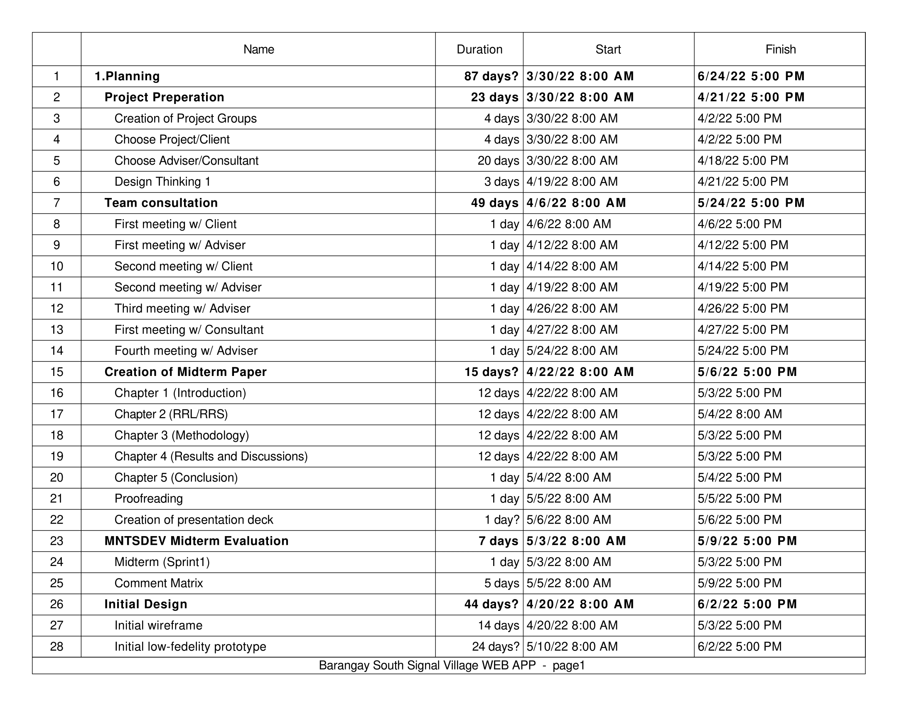

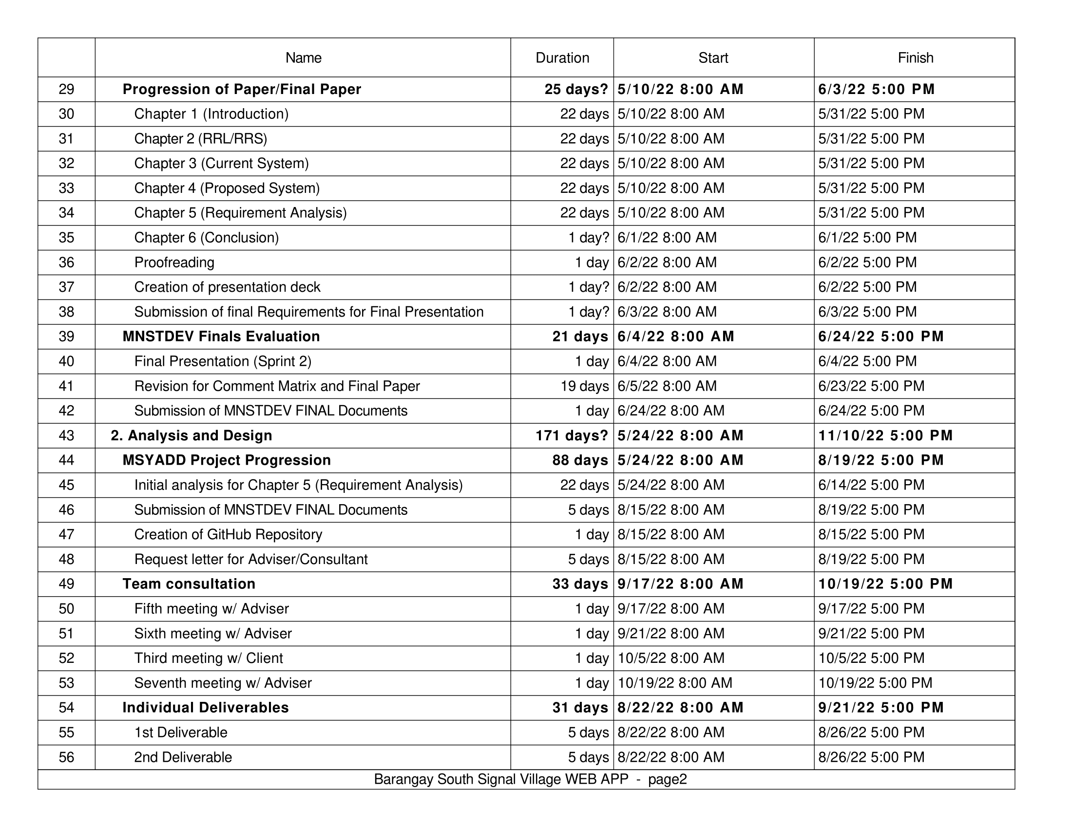

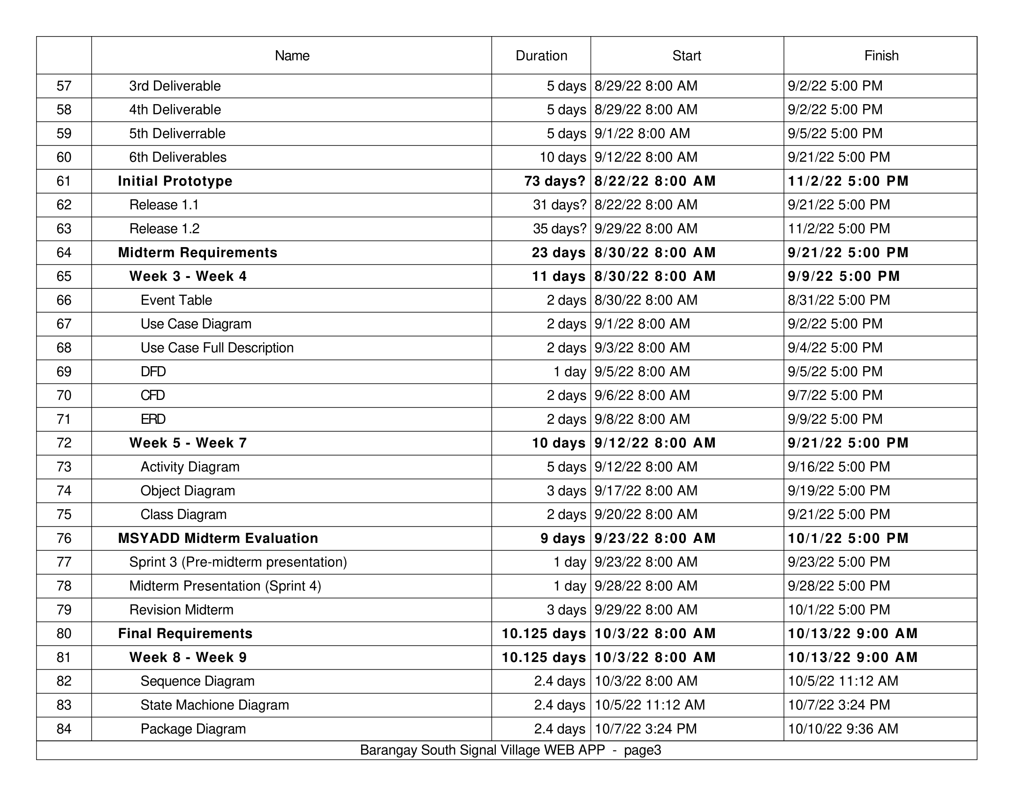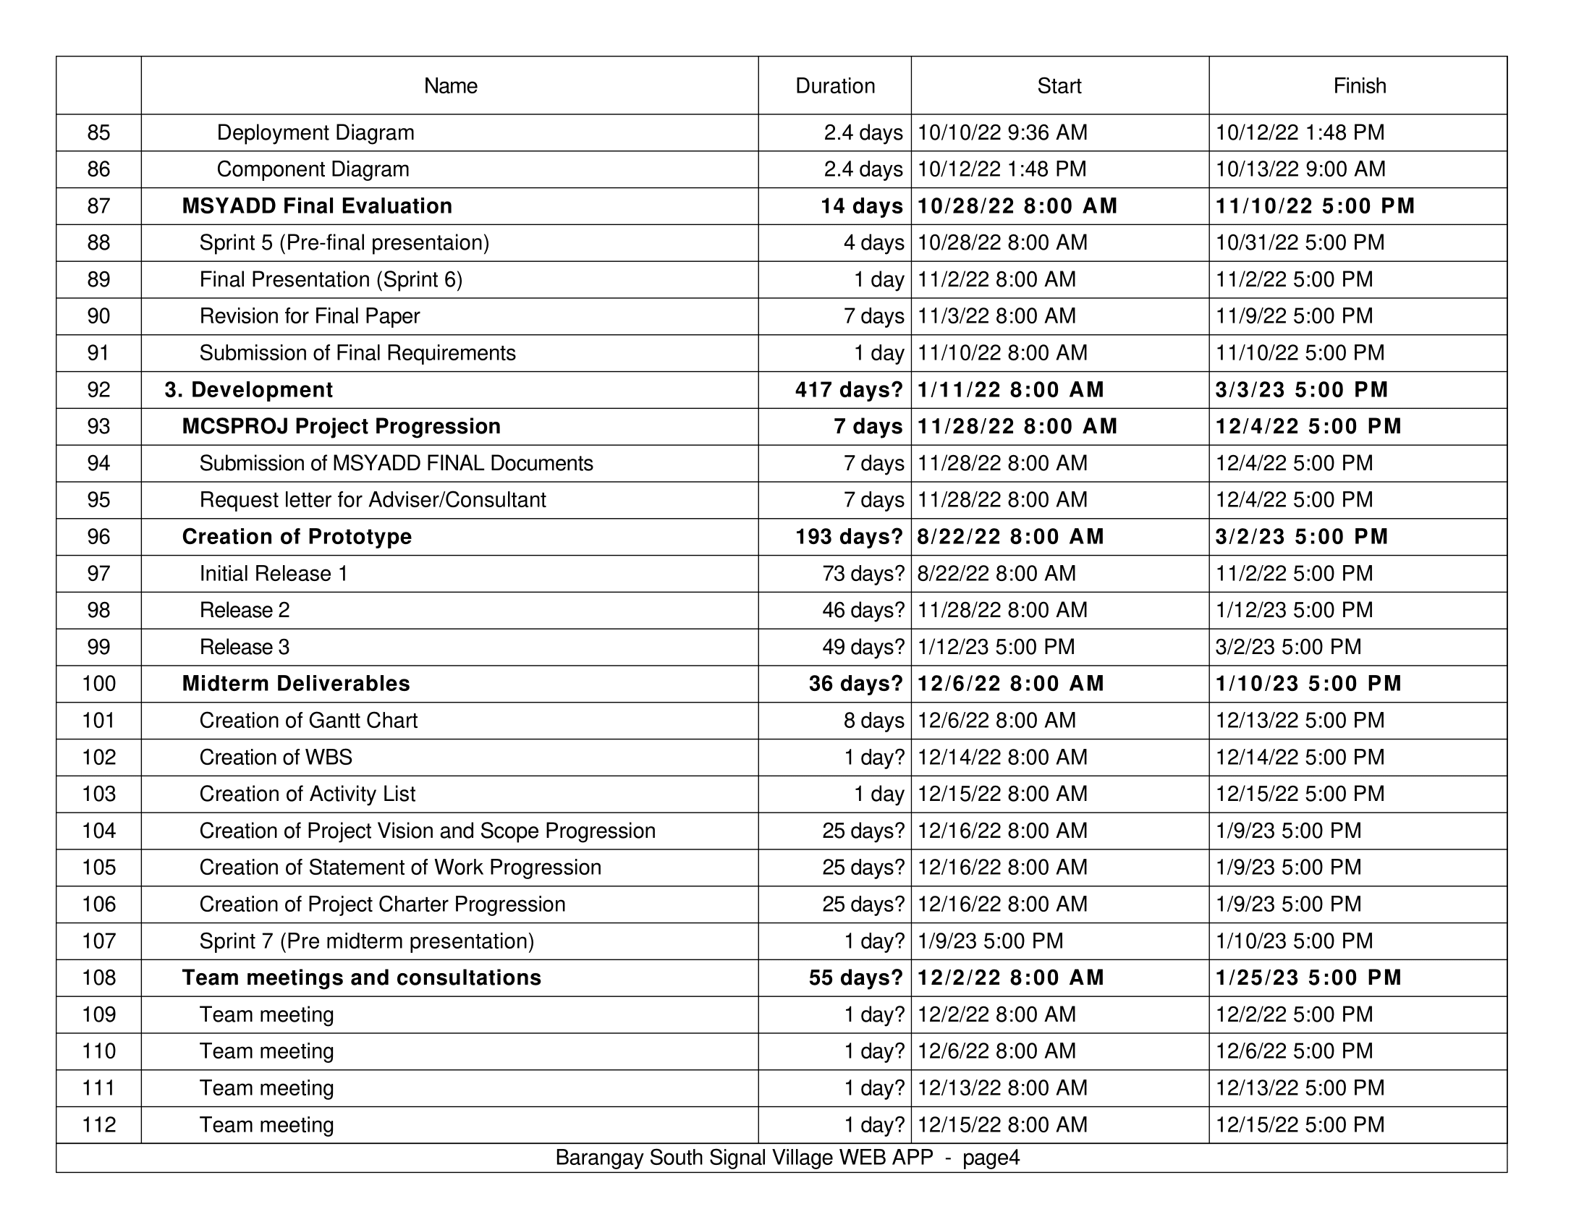B.

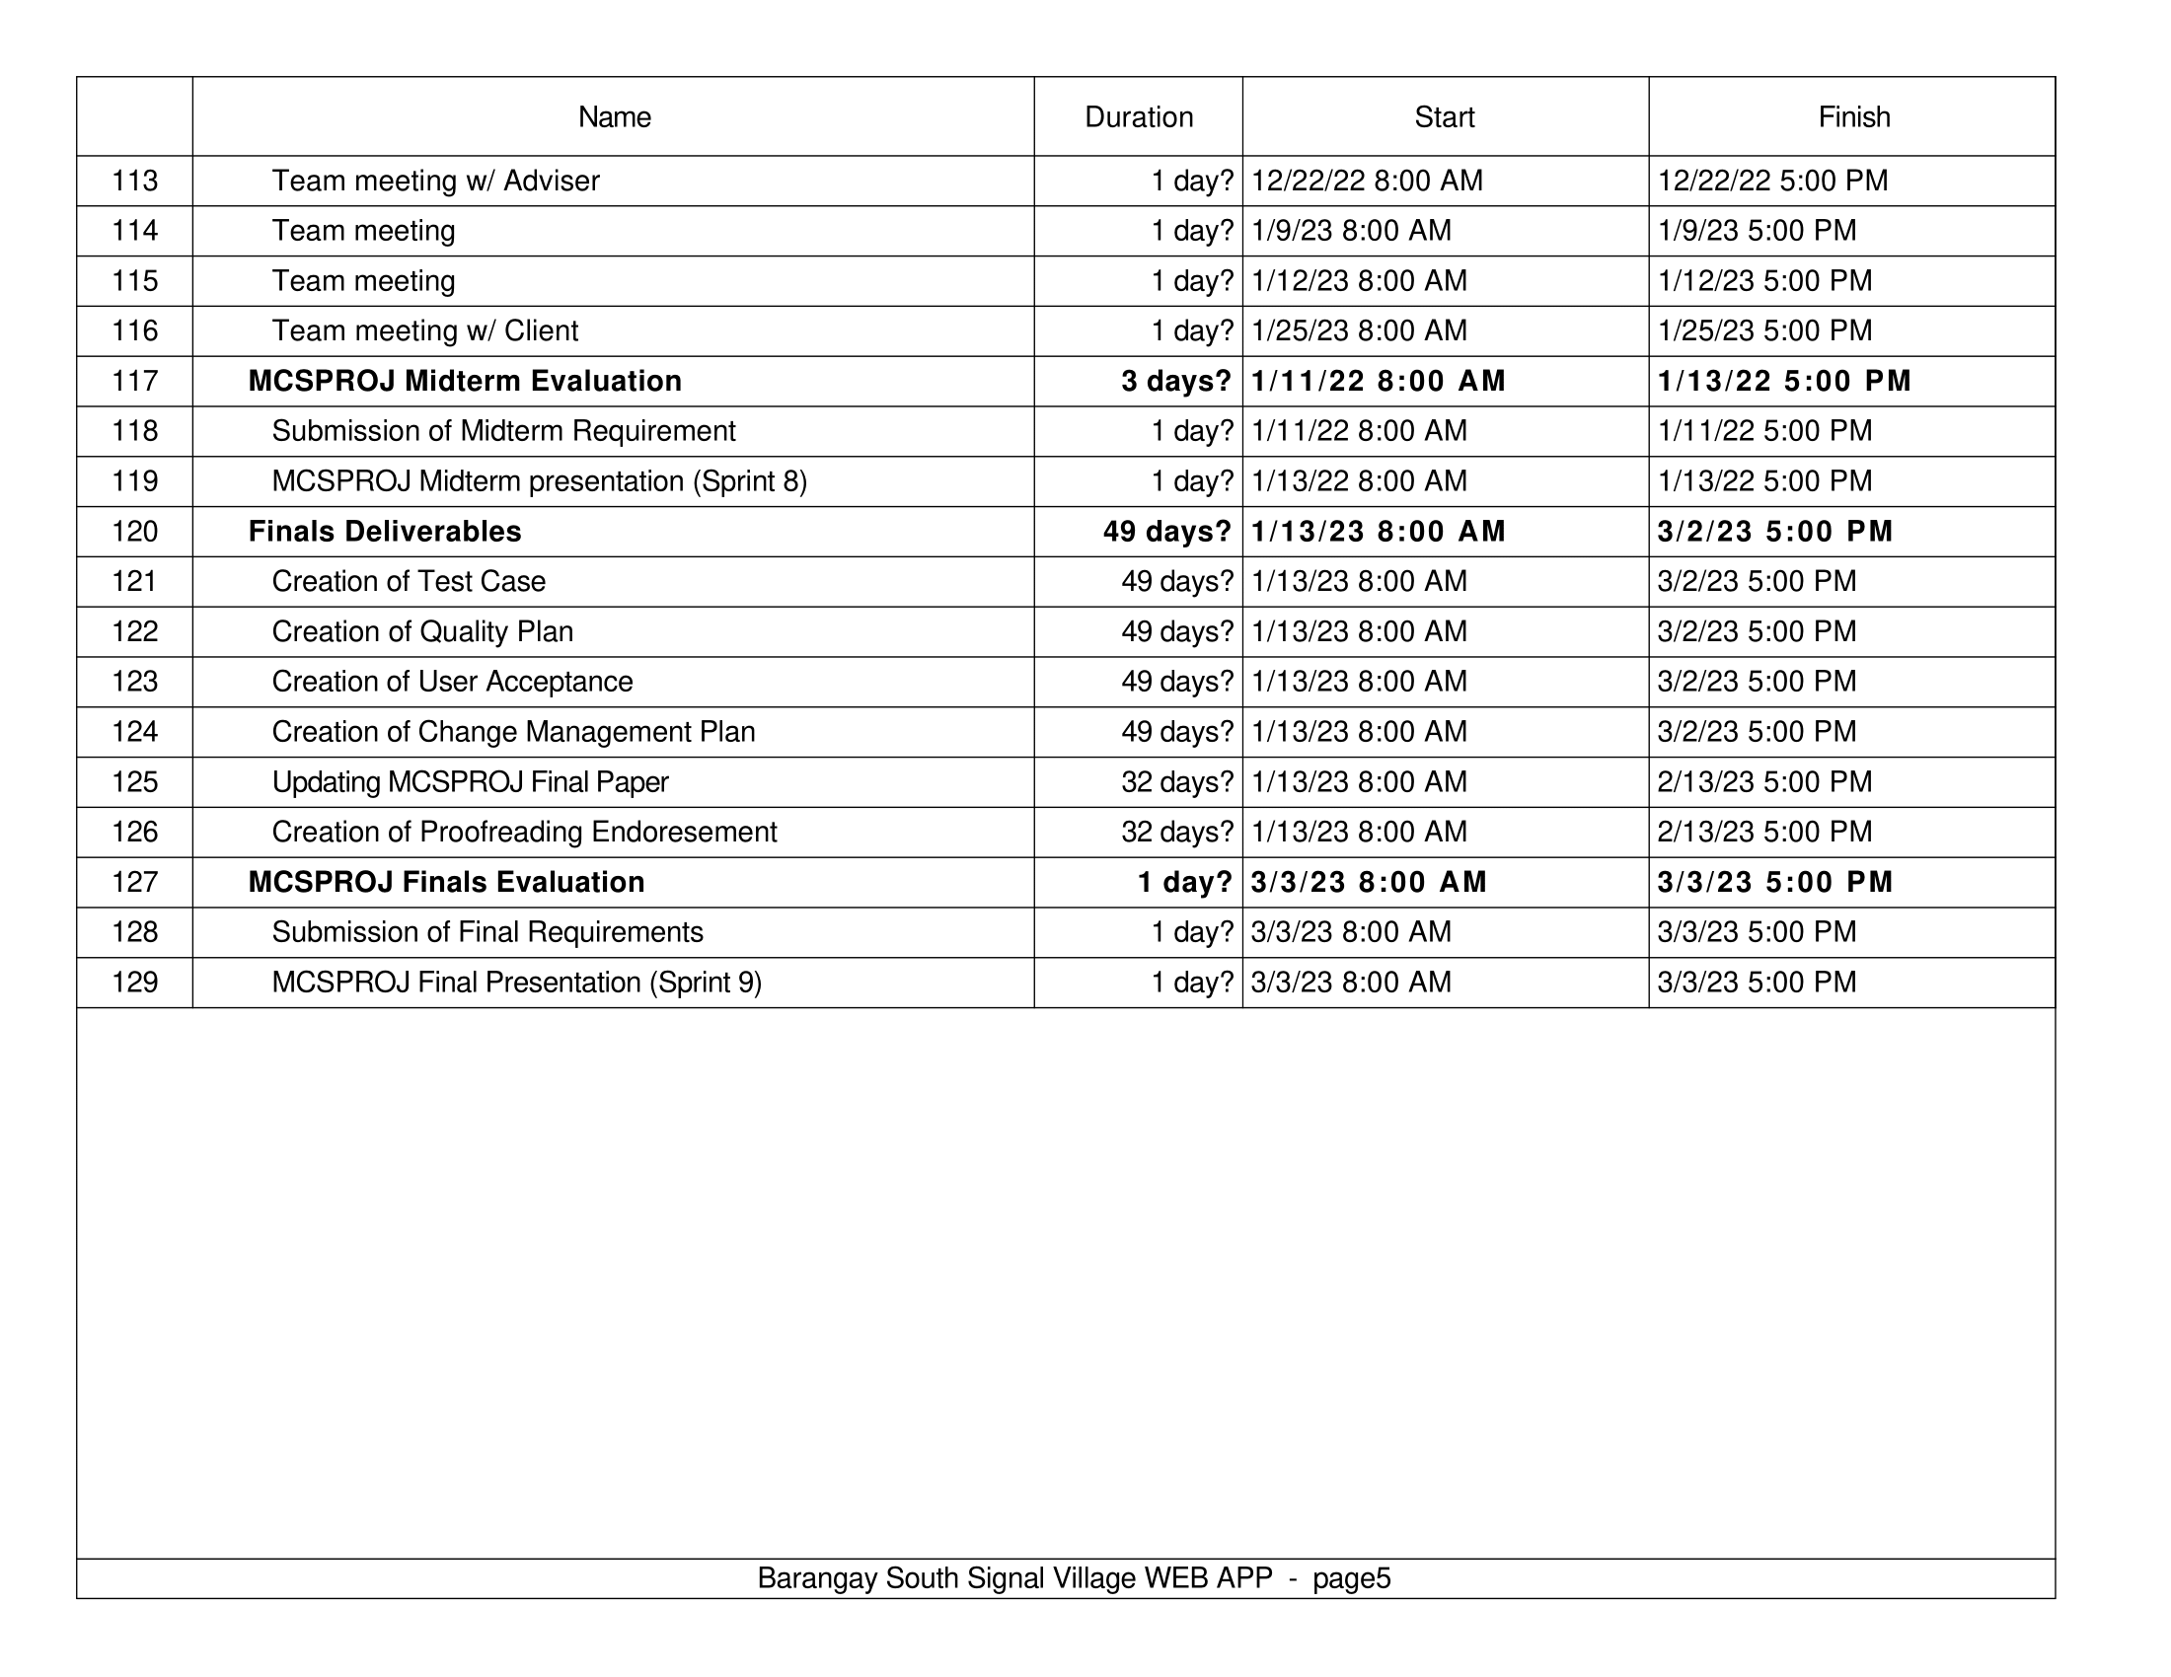

* 1. SPRINT BACKLOG - SOFTDEV



## Appendix C: Product Roadmap

TABLE 39   
PRODUCT ROADMAP

|  |  |  |  |
| --- | --- | --- | --- |
| **MNTSDEV** | **MSYADD** | **MCSPROJ** | **SOFTDEV** |
| **Pitch Presentation**   * Research Paper/ Documentation * Pitch video/ Product Teaser     **UI / UX Design**  Barangay South Signal Village Webapp | **Pitch Presentation**   * Documentation * Product Teaser   **UI / UX Design**   * Administrator Dashboard * Secretary Dashboard * Barangay Captain Dashboard   **Increment Release**   * Release 1 | **Increment Release**   * Release 2 * Release 3 | **Increment Release**   * Release 4 * Release 5 |

## Appendix D: Users’ Manual

Resident and Admin Manuals can be accessed in this link: [Barangay South Signal Village Web App User's Manual](https://asiapacificcollege.sharepoint.com/:w:/s/MCSPROJMI201202/EeLe-T6DDv9HjRutQ41mGcUBQNWQF5x8oOsYmWlfGLapsQ?e=fa7BDI&%3D%3D&sdata=RzVSNG1iZEYvbk9YdVc1bnkwclR2K3M4RjhOSUtBenBmVHZkdjNTbHcydz0%3D)

## Appendix E: Team Meetings

**DATE:** August 31, 2023

**TIME START:** 2:00 pm

**TIME END:** 3:30 pm

**MODERATOR:** Jakerson Bermudo

**MINUTES TAKER:** Princess Joy Ferrer

**ATTENDANCE:**

|  |  |  |
| --- | --- | --- |
| **Full Name** | **Email** | **Role** |
| **Mikedale Dellera** | [mbdellera@student.apc.edu.ph](mailto:mbdellera@student.apc.edu.ph) | Presenter |
| **Wilkins Caducio** | [wvcaducio@student.apc.edu.ph](mailto:wvcaducio@student.apc.edu.ph) | Presenter |
| **Carl James Garcia** | [cagarcia@student.apc.edu.ph](mailto:cagarcia@student.apc.edu.ph) | Presenter |
| **Rark Mowen Alcantara** | [rlalcantara@student.apc.edu.ph](mailto:rlalcantara@student.apc.edu.ph) | Presenter |
| **Princess Joy Ferrer** | [phferrer@student.apc.edu.ph](mailto:phferrer@student.apc.edu.ph) | Presenter |
| **Ludwig Marco Angeles** | [ltangeles@student.apc.edu.ph](mailto:ltangeles@student.apc.edu.ph) | Presenter |
| **Jakerson Bermudo** | [jbbermudo@student.apc.edu.ph](mailto:jbbermudo@student.apc.edu.ph) | Organizer |

**AGENDA:**

Discussion about the new features of the web app:

1. Introduction of the web app for the barangay council, Sangguniang Kabataan (SK), and other barangay staff.

1. Direct mode of payment through the web app and how to process it. When they make payments online, it will be confirmed, and the payment will go directly to the barangay's bank, deposited directly. Clearances will be emailed to them through a QR code. Memorandum of Agreement (MOA) between the barangay and the bank, as well as with GCash.

1. Handling matters outside of the web app will be managed by the barangay.

(Added features for the safety section)

1. Safety protocols - Early warning system/reminders. Added evacuation areas.

1. Facial recognition for verification to ensure that only the registered individual can use the account.

1. Adding a Tagalog translation for the data privacy policy and terms and conditions.

Resident dashboard:

1. Added the option to change the address.

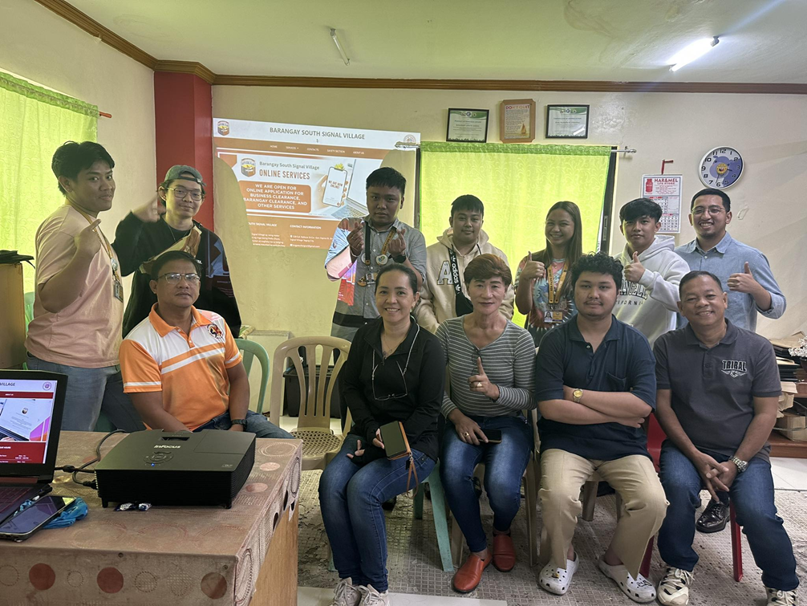

**DATE:** September 4, 2023

**TIME START:** 7:30 pm

**TIME END:** 4:37 pm

**MODERATOR:** Jakerson Bermudo

**MINUTES TAKER:** Princess Joy Ferrer

**ATTENDANCE:**

|  |  |  |
| --- | --- | --- |
| **AGE** | **Email** | **Role** |
| **Mikedale Dellera** | [mbdellera@student.apc.edu.ph](mailto:mbdellera@student.apc.edu.ph) | Presenter |
| **Wilkins Caducio** | [wvcaducio@student.apc.edu.ph](mailto:wvcaducio@student.apc.edu.ph) | Presenter |
| **Carl James Garcia** | [cagarcia@student.apc.edu.ph](mailto:cagarcia@student.apc.edu.ph) | Presenter |
| **Rark Mowen Alcantara** | [rlalcantara@student.apc.edu.ph](mailto:rlalcantara@student.apc.edu.ph) | Presenter |
| **Princess Joy Ferrer** | [phferrer@student.apc.edu.ph](mailto:phferrer@student.apc.edu.ph) | Presenter |
| **Jakerson Bermudo** | [jbbermudo@student.apc.edu.ph](mailto:jbbermudo@student.apc.edu.ph) | Organizer |

**AGENDA:**

* Setting UP GitHub
* Sprint 1 Deliverables
* Creation of Final project proposal
* Mural
* Creation of User Stories
* Action Priority Matrix
* Jira setup
* Product backlog
* Sprint backlog
* Weekly progress report
* Approved project adviser/consultant forms

**DISCUSSIONS:**

* Created new user stories and categorized them based on Action Priority.
* *As a resident, I want to view the safety protocols of the barangay online so that I have an information on what to do during emergencies and calamities.*
* *As a barangay captain, I want to have a captcha security system so that it can prevent bot attacks such as DDOS, breach in security, data loss and unauthorized access within the system.*
* *As a barangay secretary, I want to view the payment transaction history and the status of each payment so that I can verify the paid users.*
* *As a resident, I want to have an online payment option in requesting documents so that I do not need to fall in line the barangay to pay.*
* *As a barangay secretary, I want to have an ID and facial verification system so that there is more security and validation towards the resident's information.*
* *As a resident, I want to have a Tagalog translation for the data policy notice and terms and conditions so that I can understand it better.*

* Adding new features in the web app based on the user stories.
* ID Analyzer for login, registration and requesting docs.
* Online Payment
* New Safety Guidelines
* ReCaptcha

* We will have 4 sprints (2 for midterm and 2 for finals). Tentative dates per sprint:
* **Sprint 1**: September 4 – September 13
* **Sprint 2:** September 14 – September 22
* **Sprint 3:** September 25 – October 13
* **Sprint 4**: October 16 – November 9
* Follow-up by Wilkins Caducio about the additional information about the safety guidelines with the client.

* Deadline for Weekly progress report is on or before September 14, 2023.
* Waiting for Sir Alvin signature for project adviser forms.
* Jakerson Bermudo - create folder for deliverables and post it in the channel.

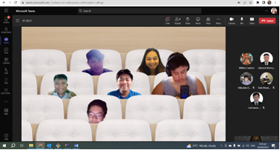

**DATE:** September 11, 2023

**TIME START:** 7:22 pm

**TIME END:** 7:36 pm

**MODERATOR:** Jakerson Bermudo

**MINUTES TAKER:** Carl James Garcia

**ATTENDANCE:**

|  |  |  |
| --- | --- | --- |
| **Name** | **Email** | **Role** |
| **Mikedale Dellera** | [mbdellera@student.apc.edu.ph](mailto:mbdellera@student.apc.edu.ph) | Presenter |
| **Wilkins Caducio** | [wvcaducio@student.apc.edu.ph](mailto:wvcaducio@student.apc.edu.ph) | Presenter |
| **Carl James Garcia** | [cagarcia@student.apc.edu.ph](mailto:cagarcia@student.apc.edu.ph) | Presenter |
| **Princess Joy Ferrer** | [phferrer@student.apc.edu.ph](mailto:phferrer@student.apc.edu.ph) | Presenter |
| **Jakerson Bermudo** | [jbbermudo@student.apc.edu.ph](mailto:jbbermudo@student.apc.edu.ph) | Organizer |
| **Rark Mowen Alcantara** | [rlalcantara@student.apc.edu.ph](mailto:rlalcantara@student.apc.edu.ph) | Presenter |

**AGENDA:**

* Weekly Scrum Report
* Checking the progress of the team
* Discussing our individual task
* Checking our sprint backlog and product backlog

**DISCUSSIONS:**

* Comments of Miss Joanna
* In your sprint backlog, kindly add a Start Date for Sprint 1.
* I noticed that the task "Adding Tagalog translation for Data Privacy Notice..." which you have identified as a Fill In (low value, minimal impact) was prioritized for Sprint 1. I would like to recommend that you include another higher-priority task for Sprint 1 to deliver maximum value to the client.

* Changes in Backlog
* Moving the Creating UI for uploading IDs and Selfie for the Residents Registration UI/UX from Sprint 2 to Sprint 1
* Changing the priority of Creating UI for uploading IDs and Selfie for the Residents Registration UI/UX from Medium to High
* Changing the priority of Updating registration form after integrating ID analyzer from Medium to High
* Swap the Sprint 3 and Sprint 4 issues.

**DATE:** September 20, 2023

**TIME START:** 6:00 pm

**TIME END:** 7:10 pm

**MODERATOR:** Jakerson Bermudo

**MINUTES TAKER:** Princess Joy Ferrer

**ATTENDANCE:**

|  |  |  |
| --- | --- | --- |
| **Name** | **Email** | **Role** |
| **Mikedale Dellera** | [mbdellera@student.apc.edu.ph](mailto:mbdellera@student.apc.edu.ph) | Presenter |
| **Wilkins Caducio** | [wvcaducio@student.apc.edu.ph](mailto:wvcaducio@student.apc.edu.ph) | Presenter |
| **Carl James Garcia** | [cagarcia@student.apc.edu.ph](mailto:cagarcia@student.apc.edu.ph) | Presenter |
| **Princess Joy Ferrer** | [phferrer@student.apc.edu.ph](mailto:phferrer@student.apc.edu.ph) | Presenter |
| **Jakerson Bermudo** | [jbbermudo@student.apc.edu.ph](mailto:jbbermudo@student.apc.edu.ph) | Organizer |
| **Rark Mowen Alcantara** | [rlalcantara@student.apc.edu.ph](mailto:rlalcantara@student.apc.edu.ph) | Presenter |

**AGENDA:**

* Project Updates and Progress

**DISCUSSIONS:**

* Diagrams: reported that they have edited and completed some of the diagrams assigned to them.
* Web App Terms & Conditions: informed the team about ongoing work to improve the responsiveness of the terms and conditions in the web app.
* ID Analyzer API Integration: stated that they are almost done with integrating the ID Analyzer API within the registration module.
* Routing: mentioned that they are working on fixing some routing issues in the hosted environment.
* Privacy Policy and Terms & Conditions: shared that they have finished the modal for both the privacy policy and terms & conditions and have completed the design for the English translation of the Privacy Policy.
* ReCAPTCHA Testing: reported that they have successfully tested the ReCAPTCHA for the login module and for sending requests and concerns.
* Midterm Deliverables: has started working on some of the midterm deliverables.

The meeting concluded with a discussion of the progress made and a plan for future tasks and milestones.

**DATE:** October 12, 2023

**TIME START:** 6:00 pm

**TIME END:** 7:10 pm

**MODERATOR:** Jakerson Bermudo

**MINUTES TAKER:** Princess Joy Ferrer

**ATTENDANCE:**

|  |  |  |
| --- | --- | --- |
| **Name** | **Email** | **Role** |
| **Mikedale Dellera** | [mbdellera@student.apc.edu.ph](mailto:mbdellera@student.apc.edu.ph) | Presenter |
| **Wilkins Caducio** | [wvcaducio@student.apc.edu.ph](mailto:wvcaducio@student.apc.edu.ph) | Presenter |
| **Carl James Garcia** | [cagarcia@student.apc.edu.ph](mailto:cagarcia@student.apc.edu.ph) | Presenter |
| **Princess Joy Ferrer** | [phferrer@student.apc.edu.ph](mailto:phferrer@student.apc.edu.ph) | Presenter |
| **Jakerson Bermudo** | [jbbermudo@student.apc.edu.ph](mailto:jbbermudo@student.apc.edu.ph) | Organizer |
| **Rark Mowen Alcantara** | [rlalcantara@student.apc.edu.ph](mailto:rlalcantara@student.apc.edu.ph) | Presenter |

**AGENDA:**

* Project Updates and Progress

**DISCUSSIONS:**

* Privacy Policy and Terms & Conditions: aided in editing and arranging the privacy policy and terms and conditions.
* The privacy policy and terms and conditions in both English and Tagalog were finalized.
* Payment Module: worked on adding the payment module (resident) into the hosted system.
* A payment details page for online and onsite payments was created.
* Assistance was provided in adding the payment module (resident).
* Online Payment Process: A process for the online payment module for the Barangay Treasurer was created.
* Terms and Policy Page: A page for terms and policy was created.

The meeting concluded with a discussion of the progress made and a plan for future tasks and milestones.

**DATE:** October 19, 2023

**TIME START:** 6:00 pm

**TIME END:** 7:10 pm

**MODERATOR:** Jakerson Bermudo

**MINUTES TAKER:** Princess Joy Ferrer

**ATTENDANCE:**

|  |  |  |
| --- | --- | --- |
| **Name** | **Email** | **Role** |
| **Mikedale Dellera** | [mbdellera@student.apc.edu.ph](mailto:mbdellera@student.apc.edu.ph) | Presenter |
| **Wilkins Caducio** | [wvcaducio@student.apc.edu.ph](mailto:wvcaducio@student.apc.edu.ph) | Presenter |
| **Carl James Garcia** | [cagarcia@student.apc.edu.ph](mailto:cagarcia@student.apc.edu.ph) | Presenter |
| **Princess Joy Ferrer** | [phferrer@student.apc.edu.ph](mailto:phferrer@student.apc.edu.ph) | Presenter |
| **Jakerson Bermudo** | [jbbermudo@student.apc.edu.ph](mailto:jbbermudo@student.apc.edu.ph) | Organizer |
| **Rark Mowen Alcantara** | [rlalcantara@student.apc.edu.ph](mailto:rlalcantara@student.apc.edu.ph) | Presenter |

**AGENDA:**

* Project Updates and Progress

**DISCUSSIONS:**

* Onsite and Online Payment: created the design for onsite payment.
* A module for the list of payments, which includes sending a copy of the receipt to the email, was developed.
* The process for both onsite and online payment modules was completed.
* Front-End Design: created the front-end design for the onsite payment dashboard and the online payment dashboard.
* Treasurer Dashboard: successfully created the treasurer dashboard.
* List of Payments Module: played a crucial role in developing and implementing the list of payments module, including sending receipts to emails.

The meeting concluded with a discussion of the progress made and a plan for future tasks and milestones.

## Appendix F: Test Plan and Test Cases

|  |  |
| --- | --- |
|  |  |
| **TEST PLAN** | [BSSV - Test Plan.docx](https://asiapacificcollege.sharepoint.com/:w:/s/QUALITYMI201MI203T12023-2024/EeoBLGbGHFlFodFyW6oUcX8B8qsEbh-Pn_YqPdIhJp-u-Q?e=qgZ7Ed) |
| **TEST CASE** | [BSSV - Test Cases - Iteration 1 - Existing Feature.xlsx](https://asiapacificcollege.sharepoint.com/:x:/s/QUALITYMI201MI203T12023-2024/EYJd7BdccW5HtomGQu_mDmoBo4_xFe1gvvRlf9ciRM2Vgw?e=ZeLDJ1)  [BSSV - Test Plan.docx](https://asiapacificcollege.sharepoint.com/:w:/s/QUALITYMI201MI203T12023-2024/EeoBLGbGHFlFodFyW6oUcX8B8qsEbh-Pn_YqPdIhJp-u-Q?e=hzzprZ) |

## Appendix G: Source Code

[APC-SoCIT/APC_2023_2024_T1_BARANGAY-SOUTH-SIGNAL-VILLAGE-WEB-APP (github.com)](https://github.com/APC-SoCIT/APC_2023_2024_T1_BARANGAY-SOUTH-SIGNAL-VILLAGE-WEB-APP)

[jakerson-xi/barangay_app (github.com)](https://github.com/jakerson-xi/barangay_app)

## Appendix H: Project Sway

[Barangay South Signal Village Web-App (o .ffice.com)](https://sway.office.com/0DU2H53SsI2J7Mpv?ref=Link&loc=mysways)

## Appendix I: Data Dictionary



















## Appendix J: Contingency Plan



## Appendix K: Curriculum Vitae

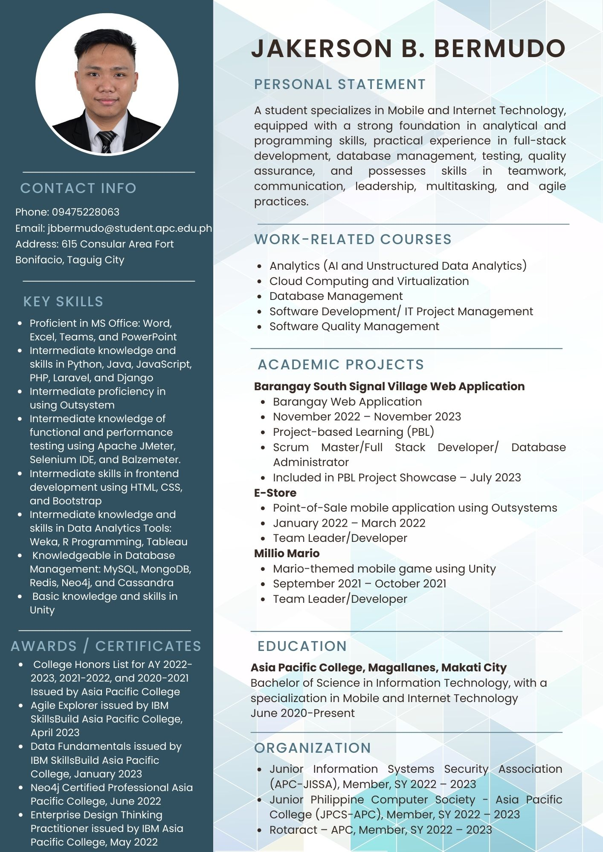

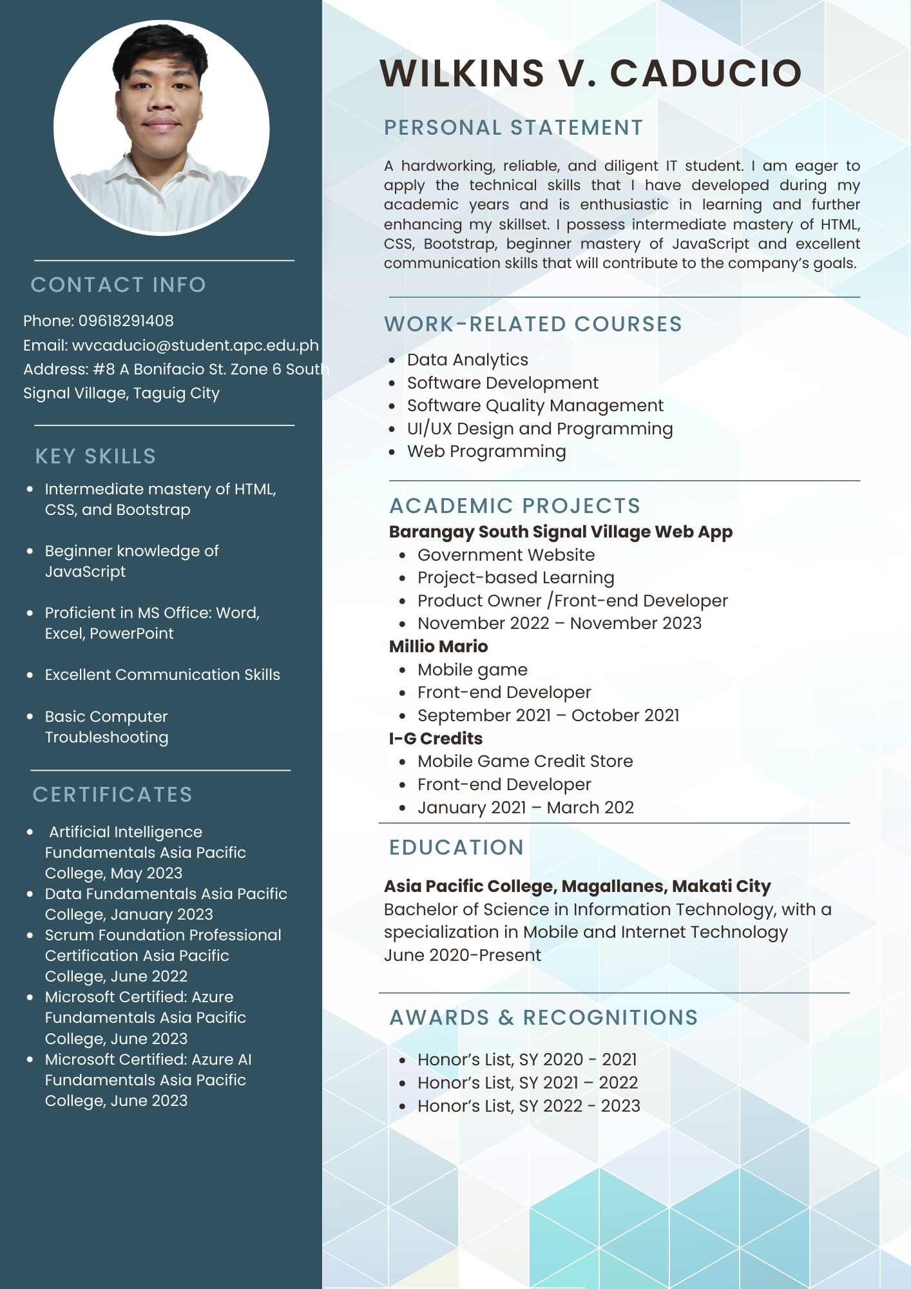

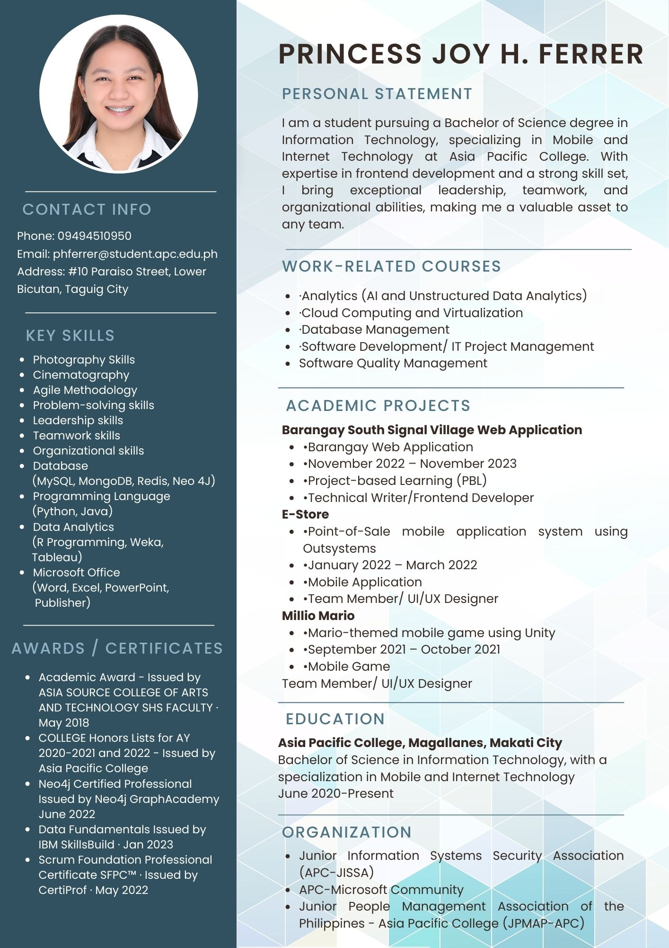

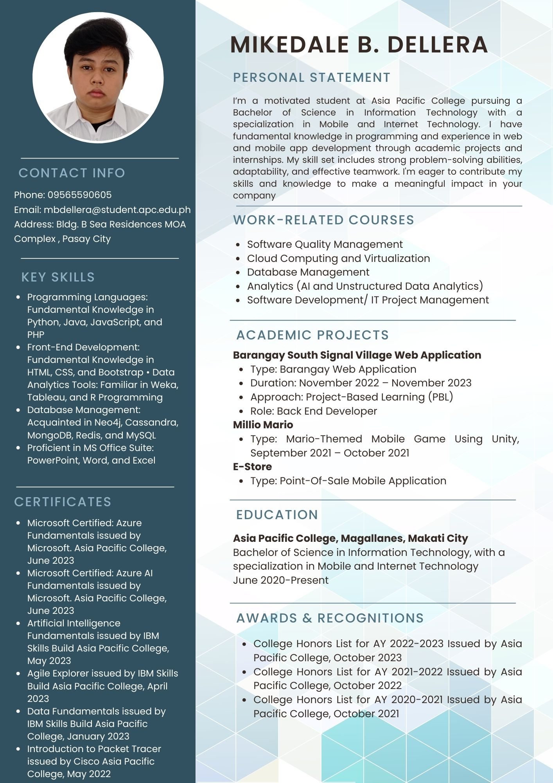

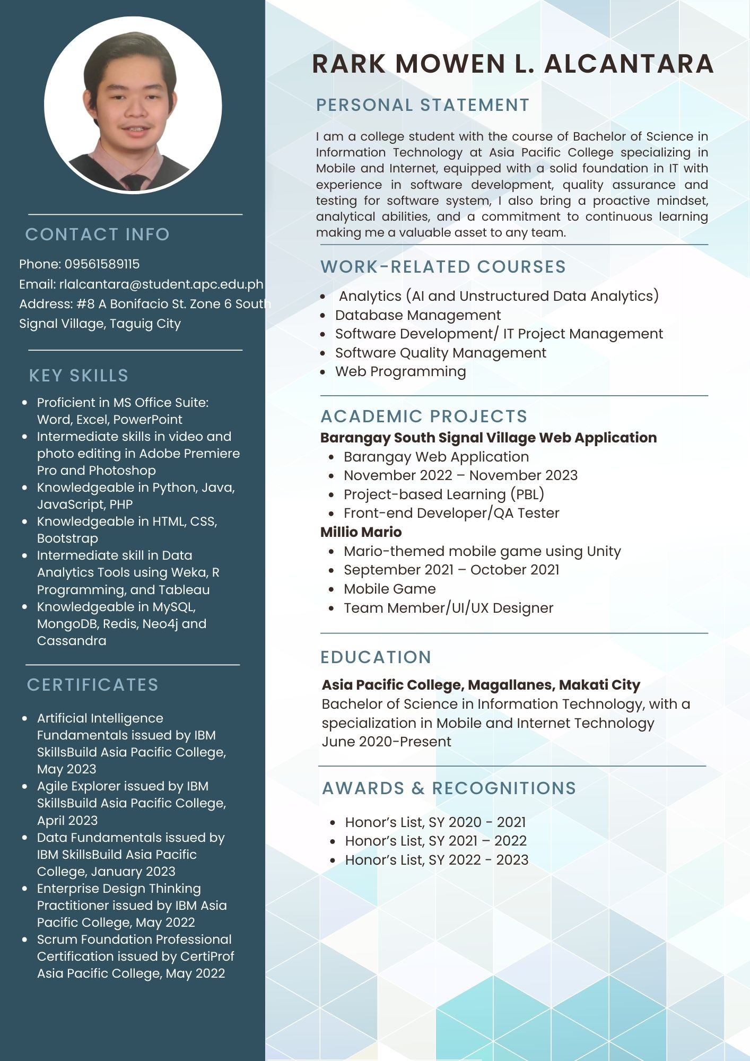

## Appendix L: Project Hosting

|  |  |
| --- | --- |
| **PAGE** | **LINK** |
| Resident Page  Landing Page | <https://socitcloud.apc.edu.ph/barangay/home> |
| Barangay Employee Login Page | <https://socitcloud.apc.edu.ph/barangay/adminportal> |